jhttps://www.edx.org/course/analytics-edge-mitx-15-071x-3?source=aw&awc=6798_1504195526_c70b6ac473d8e7a99920666c025296df&utm_source=aw&utm_medium=affiliate_partner&utm_content=text-link&utm_term=301045_https://www.class-central.com/

IMPORTANT NOTE

If you downloaded and installed R in a location other than the United States, you might encounter some formatting issues later in this class due to language differences. To fix this, you will need to type in your R console:

Sys.setlocale("LC_ALL", "C")

This will only change the locale for your current R session, so please make a note to run this command when you are working on any lectures or exercises that might depend on the English language (for example, the names for the days of the week).

C:\Program Files\R\R-3.4.1 is where R was downloaded to for this course.

_____________________________________________________________________________________

**Analytics:** The science of using data to build modelsthat lead to better decision-making that adds value to an individual, company, etc.

R is a programming language and software for statistics that is easy to use.

In the R console (the window that opens up after clicking the icon on the desktop) commands are typed after the >.

**Exponent**: ^

The [1] is just R's way of labeling outputs.

If you don't finish a command and press 'enter' then R will put + on the next line; you can continue your command here without repeating the part that was already written. You can also press esc to return to >.

You can scroll through previous commands after a > by using the up/down arrows.

**Square root**: sqrt()

**Absolute value**: abs()

Get help on a function: enter the command by putting a question mark before the function the, eg. ?abs

Save the output of a function to a variable: eg. SquareRoot2 = sqrt(2); this defines the variable SquareRoot2 and its value is sqrt(2). To check the current value of a variable type its name then enter. We could have chosen any other name than SquareRoot2. A variable name should not have spaces; we can separate words in a variable for example by using capital letters or periods. A variable name also should not start with a number. Variable names are case-sensitive.

**List** of **all variables** in current R session: ls()

**Vector**: A series of symbols or characters stored as the same object, which you can create using the c function which stands for 'combine'. Eg. if you type LifeExpectancy = c(73, 71, 80,) then enter this creates a vector; if you then type LifeExpectancy followed by enter it will display 73, 71, 80.

When typing characters (rather than numbers) in the definition of a vector or variable we need to use quotations. Eg countries = c("Canada", "Argentina", "Vietnam") and when you type countries then enter it produces "Canada" "Argentina" "Vietnam". Note that a vector can only accept one type for its slots, so in particular if you try to create a vector with both country names in some slots and numbers in others then it will treat the numbers instead as characters (which is bad because you can't perform mathematical operations on them); you'll see this when you type the vector name and hit enter because the number will also have quotations around it.

If you want to display one of the slots of a vector you can write the variable name followed by the slot number in square brackets. Eg countries[2] would output "Argentina".

For creating the **arithmetic sequence** of all numbers that starts at a and are less than or equal to b with common difference d we can write seq(a,b,d). Eg. seq (7, 14, 3) would output 7, 10, 13.

**Creating a data frame**: We can create a data frame with 2 columns by giving it a name followed by = and putting data.frame(first vector, second vector), but the vectors need to have the same number of slots. Eg. CountryData = data.frame(countries, LifeExpectancy) would show:

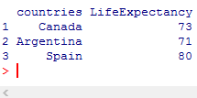

More vectors means more columns. Suppose we want to add another column to our already-existing data frame. To do this write the data frame name, followed by $, followed by the new vector/column name, followed by = c() and the definition of that new vector. So above if we want to add the populations of the countries we could put CountryData$PopulationInMillions = c( 35, 20, 73) and then when we enter CountryData it will now output:

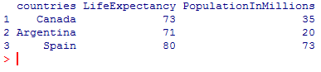

Suppose now we want instead to add more rows to an existing data frame; this is done by creating a new data frame and then joining the two using the **rbind** function; the second will be placed below the first. For example we want to add the countries Brazil and Turkey who have life expectancies of 75 and 68 respectively and populations of 97 million and 12 million respectively. We need to create new vectors for countries, LifeExpectancy and PopulationInMillions: countries = c("Brazil", "Turkey"), LifeExpectancy = c(75, 68), PopulationInMillions = c(97, 12) and then create a new data frame, call it NewCountryData = data.frame(countries, LifeExpectancy, PopulationInMillions). Then we combine the two by making a new data frame name, followed by = then rbind(the first data frame, the second data frame), eg. **TotalCountryData = rbind(CountryData, NewCountryData).** Now TotalCountryData would output:

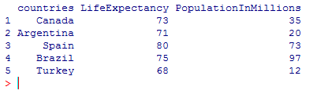

It is important when rbinding data frames that the column names are exactly the same in both or the program will return an error.

____________________________________________________________________________________

In this course we work with csv files (comma separated value files), which is a common format for data files. **To read a data file** find it by going to File -> Change dir in the R window and navigating to it. Consider the WHO.csv file that was included in this course. Nothing should show up after you open it, but if you type **getwd()** which stands for **Get Working Directory** then enter it should show the path to where the dataset is saved. You can then copy the data in the data file to a data frame in R by creating a variable name, then =, then read.csv("nameofdatafile"), then enter, example **WHO = read.csv("WHO.csv")** creates a data frame whose name is WHO from the data file WHO.csv.

To look at our data from the csv file there are two important commands:

i) **The str function is the structure function** which works by putting str(data frame), eg. str(WHO) which then outputs the data frame in the R Console window. (Note this works for any data frame - it doesn't have to be pulled from a csv file first). It gives a list of the variables (eg. Population, Country, FertilityRate, etc.) and then a description of the types of each variable as well as the first few values of each variable.

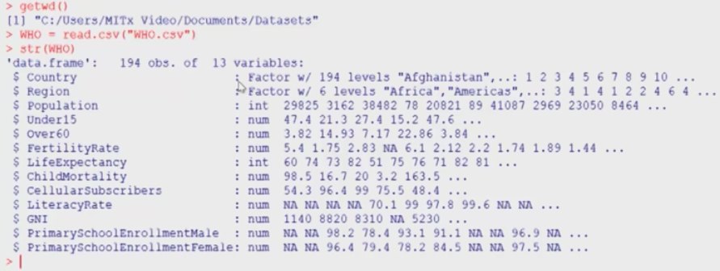

ii) **The summary function** which is used by entering summary(data frame) into the R Console eg. summary(WHO). This gives a numerical summary of each of the variables in the data frame WHO.

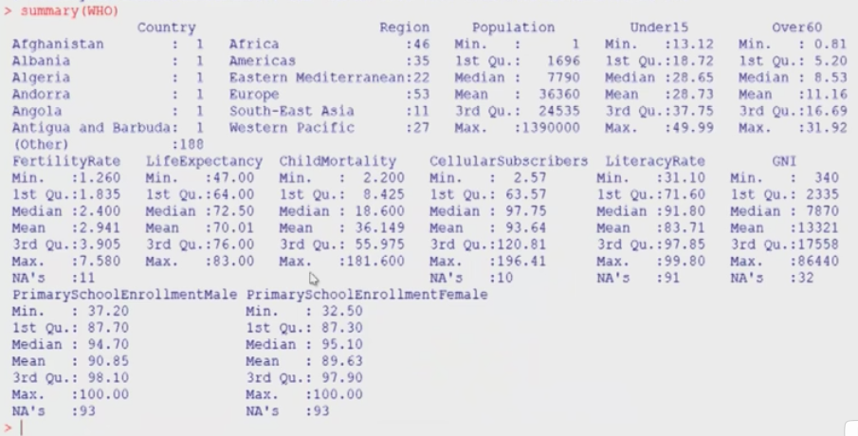

This tells us there are 46 countries in Africa, 35 in Americas, etc. The countries each have 1 because there is only one of each. NA's counts the number of observations of data for a given variable that are missing, eg. NA's 11 under FertilityRate means 11 of the countries were missing their data for their fertility rate. (Other) specifies how many more instances of the given variable there are which aren't displayed in the chart.

Taking a **subset of a data frame**: create a name for the new data frame, then =, then subset(original data frame, variable name == specific value of variable we want to restrict ourselves to) eg. WHO_Europe = subset(WHO, Region == "Europe"). The == means exactly equals and when we put str(WHO_Europe) this outputs a similar table to the first table above but now with 53 obs. of the same 13 variables, which corresponds to the 53 observations of the Europe variable as seen in the second table.

If we want to **save** WHO_Europe to a csv file you can use **write.csv** to do that: write.csv(WHO_Europe, "WHO_Europe.csv"). Here WHO_Europe is the name of the data frame we are saving and WHO_Europe.csv is the name of the data file. Once you hit enter you should now have that file saved. At this point we can remove the data frame from our current session in R.

To **remove a variable** type rm(variablename) and press enter.

As shown in the picture above we can use the summary function to tell us the mean, median, min, max, 1st quartile, 3rd quartile of a variable.

Note that variables as shown by ls() seem to come in many forms; ex. data frames are themselves variables and vectors too.

**To retrieve a variable from a data frame** we need to write nameofdataframe$nameofvariable so for example WHO$Under15. We can compute the mean by typing **mean**(WHO$Under15), similarly for **median** or sd (for **standard deviation**). We can also get a summary of a variable in a data frame similar to how we got a summary for the entire data frame, by typing summary(WHO$Under15), which gives mean, median, min, max, 1st quartile and 3rd quartile. 1st quartile is the value for which 25% of the data is below it, 3rd quartile is 75%. If we want to know the **location of the minimum observation of a variable** (that is, the smallest slot in the vector) then type **which.min(variable)** ex. which.min(WHO$Under15), which returns 86; this does not return the value of the slot itself but which slot number the min is in (can do similiar with which.max). If we want to know which country this corresponds to then we take the WHO$Country variable and put [86] after: WHO$Country[86] returns Japan. Similarly we can do the same for max. We can **plot two variables** from the data frame against each other by putting plot(WHO$GNI, WHO$Fertility) or in general plot(variable1, variable2). When we see something like x = c(1,2,3) we can think of this as one variable with 3 observations (3 particular values this variable takes). So if we also have y = c(2,4,6) then plot(x, y) outputs a plot with points (1,2), (2,4), (3,6).

Suppose we want to take a subset of points from a plot, for example outliers. We do this in the same way as we showed we take the subset of a data frame: nameofsubset = subset(dataframe, x > a & y > b) for example Outliers = subset(WHO, GNI > 10000 **&** FertilityRate > 2.5). Here we can write GNI and FertilityRate instead of WHO$GNI and WHO$FertilityRate as before (because as part of the definition of "subset" it already specifies WHO in the first slot). We can then type nrow(Outliers) which outputs how many countries have both GNI > 10000 and FertilityRate > 2.5, that is, the size of the subset Outliers of the data frame WHO. In general **nrow**(dataframe) tells you how many slots the variables in your data frame have, that is how many rows when looking at it in data frame form, that is how many observations in the data frame, so nrow(WHO) = 194.

When we want to extract **just a few variables from a data set and write it in data frame form (as a table)**: dataframename[c("variable1", "variable2", ...)] so for example Outliers[c("Country", "GNI", " FertilityRate")] would output

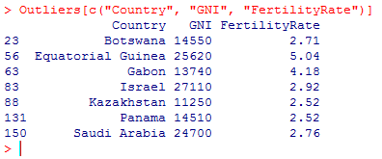

We could also write str(Outliers[c("GNI", "FertilityRate")] to put it in string form or give this new data frame a name say Outliers_somevariables = Outliers[c("GNI", "FertilityRate")] which could then be plugged into str as str(Outliers_somevariables) for example.

**Box and whisker plot:** Useful for getting a view of the range of a variable. **Outliers** are any points that are at least Q3 + 1.5 IQR or at most Q1 - 1.5IQR, where IQR = Q3 - Q1 is the **interquartile range**, Q1 and Q3 are the 1st and 3rd quartiles respectively. Q2 is the median. The quartiles divide the data into four equal sized chunks and the lines outside the box are drawn to extend to the extreme values in the data which don't include outliers. Outliers are drawn as circles. In R you type boxplot(variable) to create a boxplot. In our WHO example we can choose to further separate our boxes by region using **~**. The following are created by boxplot(WHO$LifeExpectancy) and boxplot(WHO$LifeExpectancy ~ WHO$Region) respectively.

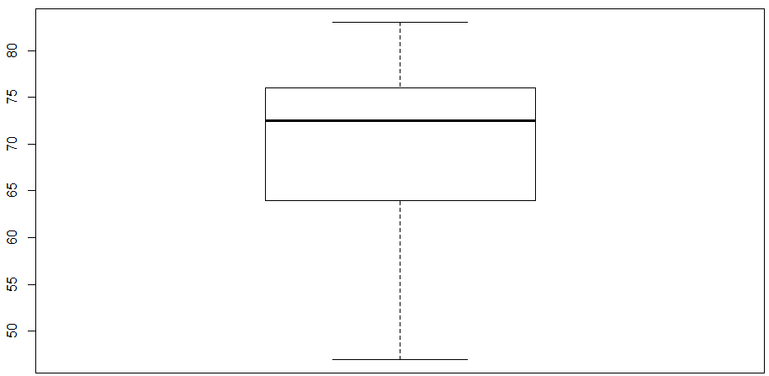

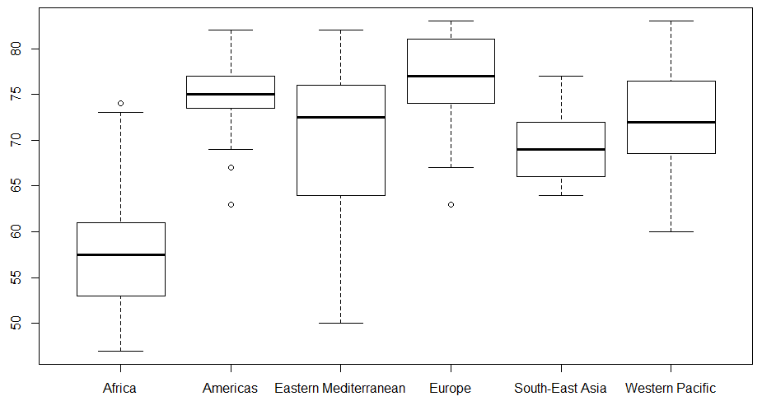

If we want to **label the axes** we can add xlab = "axisname", ylab = "axisname" in the boxplot definition, and if we want to **add a title** for the boxplot main="nameoftitle" for example boxplot(WHO$LifeExpectancy ~ WHO$Region, ylab="Life Expectancy", main="Life Expectancy By Regions"). "lab" is short for "label"

If we'd like to **produce a table in R for a variable x's** frequency we can type **table(x)**. This outputs in table form all of the values that x takes along with each value's frequency. Eg. if x = c(2,2,2,2,4,5,8,8,1,3,3) then table(x) outputs 1 2 3 4 5 8 on the top row and 1 4 2 1 1 2 on the bottom row.

**Histogram:** A graph for representing the distribution of a variable. Along the horizontal axis we start with the smallest value of the variable and end with the largest, choosing an appropriate increment size. Along the vertical axis we have "Frequency". We draw rectangles above each horizontal increment up until the frequency with which our variable falls into that increment. The right bound is an inclusive inequality, the left is exclusive, with the exception of the left-most rectangle, in which both bounds are inclusive. In R enter **hist**(variable). The following is for the variable kids = c(1,1,2,4,7).

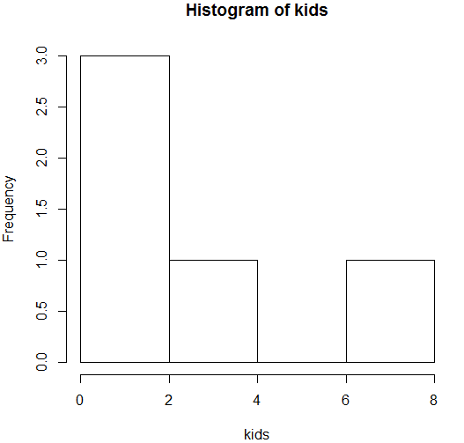

We can see **information about numerical values** **by breaking it into subsets** by using the **tapply** function: tapply(WHO$Over60, WHO$Region, mean) splits the observations by region to compute the mean Over60 percentages for each region. So tapply splits the information by the second argument to apply the third argument function on the first argument (for each group in the split).

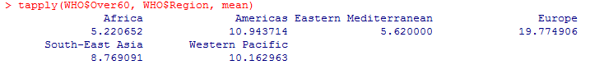

If in the second argument we instead used a statement that can be evaluated as true or false, for example using inequalities or equality, then it would separate the data into two groups, TRUE and FALSE.

When **computing min or max over a variable**, if some values are missing i.e. **NA** then max or min will also return NA. To work around this we can compute over just the observations that aren't NA by adding in na.rm=TRUE. For example we found min(WHO$LiteracyRate) returns NA because it has 91 NA values itself, but min(WHO$LiteracyRate, na.rm=TRUE) returns 31.1.

Another example: tapply(WHO$LiteracyRate, WHO$Region, min) returns NA under each of the 6 regions, but tapply(WHO$LiteracyRate, WHO$Region, min, na.rm=TRUE) returns the proper values for the 6 mins.

To **save work** so that you can easily rerun commands you can use **a script file** by clicking File -> New Script in the R Console. Here you can copy and paste any commands from the R Console. If you highlight a command in the script file and press control+r it will run the command in the R Console. If you save the script file and reopen it the next time you run R Console then you have easy access to these commands (provided you have opened the WHO.csv file or relevant files in R Console beforehand). Its often a good idea to write your commands in script files rather than in the R Console so that they are always saved. You can add **comments in the script file** by putting # in front of the comment; when you highlight it and press control+r it shows in the R Console exactly as written in the script file (including the # in front) and the R Console recognizes it as a comment. This would be good for example for creating a heading for the list of commands you have in the script file.

If you want to save the output of your R session in your console just save it as a text file by going to File -> Save to File. Unlike the script file however you won't be able to easily rerun this in the R Console. When you close R it will ask if you want to **save your workspace; click no** and make sure what you want is saved in the script file instead.

_____________________________________________________________________________________

getwd() is for get **working directory** and str() is the **structure** function.

If we want to clear the R Console display (to clean things up) but without getting rid of the information in that session you can go to Edit -> Clear Console. If you press the up/down arrows you will see the information is still there.

If we have x = (1,2,3) we can think of (1,2,3) as a vector associated with the variable x.

Note we can take subsets of variables/vectors, not just data frames.

**names(dataframename)** e.g. names(USDA) gives the **names of all variables** in the data frame.

**match(observationvalue, variable**) tells us the index of the slot in the variable in which that particular observation value occurs.

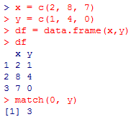

Convenient way to switch **between R console and other screens in R** such as plots and scripts **is ctrl+tab.**

To **change the color of the points in a plot** you can use col = "nameofcolor" as one of the arguments along with xlab, ylab, main, e.g. col = "green".

If we want to **limit the range of an axis** say the x-axis for example we add in the argument **xlim = c(lowerlimit, upperlimit**) so for example xlim = c(0,100) makes the x-axis range from 0 to 100 and gets rid of data outside that range in the plot.

To decide **how many sections an axis is divided into** use **breaks = #ofbreaks** so for example breaks = 100. Note that the size of each interval is determined by breaking the original axis into that number of breaks, not the axis determined by xlim.

**TRUE/FALSE** are called **logicals**, which is a type.

If x and y are vectors with the same number of slots which are number entries, **then x>y is itself a vector** with nrow(x) =nrow(y) slots but whose entries are TRUE or FALSE. Note that y itself could furthermore just be a constant; what is important is that each slot in x has a value on the RHS of the inequality to compare itself to.

To convert **TRUE/FALSE** to **1/0** use the **as.numeric** function.

In general if we want to **add a new variable (column) to a data frame** then we write **dataframename$nameofnewvariable = definitionofnewvariable**. So it's as though we are defining the variable as usual but putting dataframename$ in front.

Note that the table function can take more than one variable, ex table(x, y) but becomes complicated beyond two variables because we are working on a 2D screen.

If we have two variables in our table function say table(x,y) then the values for the rows (written vertically on the left) correspond to the possible values of x and the values for the columns (written horizontally on top) correspond to the possible values of y. For particular observations i for x and j for y the corresponding entry is how many times (i,j) occurs as an observation of (x,y) we comparing slot by slot.

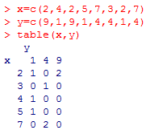

**tapply**(argument1, argument2, argument3) means group argument1 by argument2 and apply argument3.

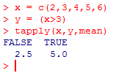

It appears that = is for **assignment** whereas == is for **equality**.

The table function is good when you want to count the number of observations in which two conditions must hold true ("and").

If we want to **sort table(x)** so that it orders the observations in order of how many occurrences there are of each observation we can type **sort(table(x));** so rather than ordering by the values of x we order by the occurrences of x. If the observations of x were **letters** instead the ordering in table(x) would have been **alphabetical**.

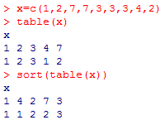

Note that **&** is the **and** symbol and **|** is the **or** symbol.

Note if we want subset(mvt, region == "abc" | region == "xyz") we have to do it this way, not subset(mvt, region == "abc" | "xyz") because "abc" | "xyz" has no value and therefore cannot be assigned to region.

Suppose your data frame has a lot of **extraneous information** you want to remove because you wish to look at just a **subset**, for example if mvt$LocationDescription has 78 levels and we only want to look at information regarding 5 of those levels. We can create our new subset, call it Top5 for e.g., in the usual way Top5 = subset(mvt, mvt$LocationDescription == "aaa" | mvt$LocationDescription == "bbb" | mvt$LocationDescription == "ccc" | mvt$LocationDescription == "ddd" | mvt$LocationDescription == "eee") where aaa, bbb, ccc, ddd, eee are the names of the levels as specified in mvt, or by creating five individual subsets by subset(mvt, mvt$LocationDescription = "aaa") etc. and then using rbind to combine them. When we do this Top5 will have a lot of extra information because it remembers the categories of LocationDescription from the original data set mvt, not Top5. To fix this we use the **factor** function: Top5$LocationDescription = factor(Top5$LocationDescription), which leaves us with just the LocationDescriptions that appear in Top5; that is, it removes all the categories in Top5$LocationDescription which have value 0.

**Changing the date format**: the **as.Date()** **function** can convert a date stored as a **factor** **variable** into a **date variable** that R can read, namely in form **"yyyy-mm-dd"**. So as.Date(datevariable, currentformofdatevariable), where if for example datevariable = IBM$Date and the date is originally in m/d/y form then currentformofdatevariable would be represented as "%m/%d/%y" and so we would write as.Date(IBM$Date, "%m/%d/%y"). We can use this to overwrite our original date variable IBM$Date, e.g. we could write IBM$Date = as.Date(IBM$Date, "%m/%d/%y"), which would save IBM$date in the new format "yyyy-mm-dd". Somehow in the example in Stock Dynamics near the end of Unit 1 it knows that it should be "%m/%d/%y" and not for example "%a/%b/%c", but it's not clear to me why (possibly the way the Stock Dynamics data was defined).

When we have dates in yyyy-mm-dd form it seems that they are ordered in the way we would expect dates to be ordered (earlier dates come first).

Note that plot(x,y) will plot the points as circles; if we want to instead **draw the plot as a continuous line** (i.e. curve) add the argument **type = "l"**, so plot(x,y,type="l"), where l is for line.

Suppose we want to **plot two continuous lines (curves) on the same graph**; plot the first one as usual and with the plot open enter the command **lines(xvariableofsecond, yvariableofsecond)**. The two curves will appear as the same colour, so you can fix this by adding a col argument in both plot and lines.



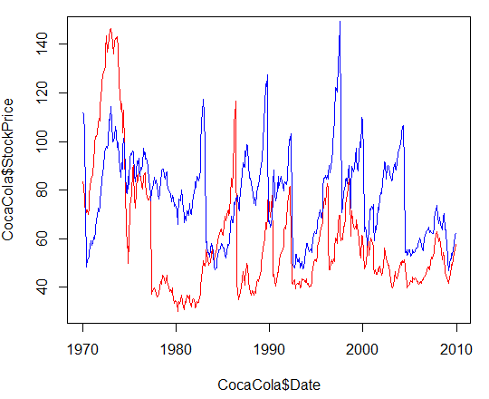

We could change the x and y axis names by using xlab and ylab in the plot definition.

Recall that x[3] outputs the observation in the 3rd slot. Furthermore **x[3:5]** would output the observations in the 3rd, 4th and 5th slots. So we can use this when defining a plot and only want the variables to look at certain observations, ex. plot(GE$Date[3:5], GE$StockPrice[3:5]). I'm guessing we used this instead of xlim = c(3,5) in the example in the homework because the years 1970, etc. may not be the right type (i.e. they may not be of type num or int).

The **months** function: When a variable is of type date and written in the form that R can read, "yyyy-mm-dd", then inputting this variable into months() outputs the name of month with quotations. However "yyyy-mm-dd" is a string so to convert it to type date we first need as.Date(). So for example months("1987-01-23") has no output but months(as.Date("1987-01-23")) outputs "January".

The function **is.na(x)** outputs TRUE or FALSE for each of the observations of x; TRUE for any slot equal to NA, FALSE otherwise.

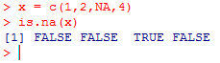

Note that **mean(TRUE) = 1** and **mean(FALSE) = 0**, e.g. mean(c(TRUE, FALSE, FALSE, FALSE)) = 0.25, so it returns **the proportion of TRUE values**. We can conveniently use this with the **tapply function** when we want to find the proportion of TRUE/FALSE separated by regions, e.g. tapply(Education == "graduated", Country, mean) would tell us the proportion of students who graduated, sorted by country.

We can also use **sum** on TRUE/FALSE values, which counts **the total number of TRUE values**, e.g. sum(c(TRUE, TRUE, FALSE, TRUE)) = 3

**Not equals** is given by **!=**

By using the table() function on two variables we can see how they are related.

Note that we can use **max()** to find the **maximum value of a table**.

The **jitter()** function randomly selects numbers close to the original observation numbers

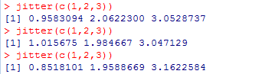

This is convenient when we have a plot in which many duplicate points exist (i.e. overlap) and we want to see them separately (rather, approximate versions of them); we can jitter the x and y variables.

_____________________________________________________________________________________

**Unit 2: Linear Regression**

**Linear Regression**: A simple but powerful method to analyze data and make predictions. It predicts an *outcome/dependent variable* based on a set of *independent* variables.

**One-variable** linear regression means there is one independent variable to predict the dependent variable.

The **goal of linear regression**: to create a predictive line through the data.

**One-variable linear regression model**:

* **yi = B0 + B1xi + ei**
* xi  and yi are the independent and dependent variables for the ith observation.
* ei is the **error** associated with the ith observation (usually written as epsilon, also called a **residual**); that is, how far the predicted value (given by the regression line) for the ith value of y is from the observed value yi; that is, the actual value minus the prediction, yi - (B0 + B1xi).
* B0 is the **intercept coefficient**.
* B1 is the **regression coefficient** for the independent variable, i.e. the slope of the line.
* The best model (choice of coefficients) has the smallest error terms.

One measure of the quality of a regression line is the **sum of squared errors (SSE),** which we want to be **minimal**. Call the number of observations n. The first weakness with SSE is that it scales with n; a larger n is likely to lead to a larger SSE, thereby suggesting it is a worse model (which isn't likely true; rather, more data would suggest a better model). The second weakness is that the units of the error will be in squared units for the y variable, which often makes no interpretive sense.

For the two above weaknesses, we often instead use **root-mean-square error** **(RMSE)**, that is **RMSE = sqrt(SSE/n)**, which takes the average squared error and fixes the problem of the squared units by taking sqrt().

The **baseline model** for a linear regression is the horizontal line **y=mean(observations of dependent variable)**, which predicts the average value for the dependent variable. The **SSE for the baseline model** is more specifically known as the **total sum of squares, SST.**

Another common error measure for linear regression is **R2 = 1 - (SSE/SST)**, which compares the best model (that is, the **minimal SSE** value) to the baseline model.

* If R2 = 0 then SSE = SST, which means the baseline model is also optimal, in other words our model as calculated by the SSE offers no predictive improvement over the baseline model.
* If R2 = 1 then SSE = 0, which means our model as calculated by SSE is a perfect model; that is, all of our observations are collinear.
* R2 is a measure of the value added by using the minimal SSE model over the baseline model; the larger R2 is, the more value is added. A value close to 1 represents a model that is close to perfect.
* Note that 0 ≤ R2 ≤ 1 because SSE ≤ SST due to the minimality of SSE.
* R2 is nice in that it has no units and is therefore interpretable between problems.
* Good models for easy problems have R2 approximately equal to 1.
* However good models for hard problems can still have R2 approximately equal to 0.

Suppose we have multiple independent variables that could be used to predict a dependent variable, one at a time. To decide which is the best predictor we could compute the R2 value for each and choose the one which is highest. However, **multiple linear regression** allows us to use multiple independent variables at once.

**Multiple-variable linear regression model:**

**yi = B0 + B1x1i + ... + Bkxki + ei**

* yi is the ith observation for the dependent variable yi.
* xji is the ith observation for the independent variable xj.
* ei is the error associated with yi.
* B0 is the intercept coefficient.
* Bj is the regression coefficient for independent variable xj.

The best model is selected as in the one variable case. When we add in another variable we are guaranteed to have an R2 value that is at least as good as the original, because for example the 1-variable case is just a subset of the 2-variable case by letting B2 = 0. The improvement however is with diminishing returns; the more variables added, the less improvement in R2 each one adds. Therefore, we shouldn't always use all available variables because more variables means a more complicated model that requires more data. Overly complicated models can often cause **overfitting**, which occurs when a model has a high R2 value but bad performance on unseen data.

**lm()** is the function in R for **linear model**, which is the function we use any time we want to build a **linear regression model**. If we wish for the dependent variable of our linear regression to be Price and the independent variable to be AGST and the data is being pulled from the data frame wine then we can write model1 = lm(Price ~ AGST, data = wine), so it will be saved as "model1". If we type summary(model1) then we receive various pieces of information:

i) the residuals (errors), that is min, max, Q1, Q3, median

ii) the coefficients B0 and B1, that is the intercept -3.4178 and regression coefficient 0.6351.

iii) The **Multiple R-squared** is as we have calculated R2 up until now; it increases as the number of independent variables increases.

iv) The **Adjusted R-squared** adjusts the R2 value according to the number of independent variables relative to the number of data points, but decreases if you add in an independent variable that doesn't help the model. This is a good way to determine if an additional variable should be incorporated into the model or not. Ideally both R2 and adjusted R2 should be high.

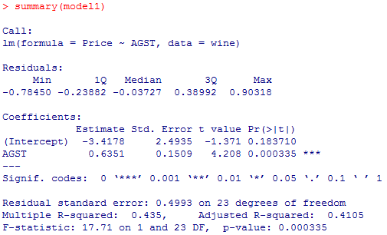

* The **residuals** are stored as **model1$residuals** and the **coefficients** as **model1$coefficients**.
* We can compute SSE by taking sum(model1$residuals^2)
* If we want to create a linear regression model with more than one independent variable then we separate them with +, e.g. model2 = lm(Price ~ AGST + HarvestRain , data = wine)
* If a particular coefficient estimate is equal to 0 then its variable is not affecting our prediction of the dependent variable, so we should probably remove variables whose coefficients are approximately 0.
* The **Std. Error** column measures how much the coefficient is likely to vary from the estimated value.
* The **t value** **= Estimate / Std. Error**; its sign is determined by the sign of Estimate. The larger the |t| is the more likely our Estimate is to be significant, so we want independent variables with a large |t|.
* **Pr(>|t|)** gives the probability that our coefficient is actually 0, given the data used; the smaller this value is, the less likely it is that the coefficient is actually 0. So if |t| is small then Pr(>|t|) will be large. We want large |t| values and therefore small Pr(>|t|) values.

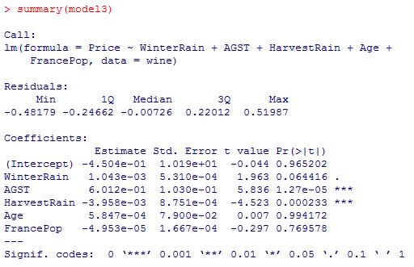

* Notice the . and *** at the end of some of the rows in Coefficients. The easiest way in R to **determine if a variable is significant** is by looking at these, which correspond to ranges for the Pr(>|t|) value of that row. *** means Pr(>|t|) < 0.001 and therefore the variable is very significant; ** is also very significant and means 0.001 ≤ Pr(>|t|) ≤ 0.01; * is significant and means 0.01 ≤ Pr(>|t|) ≤ 0.05; the period . means the variable is almost significant and 0.05 <Pr(>|t|) ≤ 0.1. If there is nothing at the end of the row then the variable is not significant. In a problem we usually only include ***, ** and *. By removing the insignificant variables from our linear regression we can see that the significance of the remaining variables can be promoted.

**Correlation** is the linear relationship between two variables:

* +1 means a perfect positive linear relationship.
* 0 means no linear relationship.
* -1 means a perfect negative linear relationship.
* Two variables are highly correlated if the absolute value of their correlation is close to 1.
* In R we use the **cor(x,y) function.**
* To find the correlations between all pairs of variables in our data set wine we can type cor(wine) and it will output a table.
* **Multicollinearity**  means two independent variables are highly correlated. When creating a linear regression model with multiple independent variables we **do not want** multicollinear independent variables. A high correlation is good between an independent variable and the dependent variable.
* When we have multicollinearity amongst our variables, we want to remove one of the two variables from the linear regression model one at time (so not both). Which should be removed may be obvious in the context. For example, in the wine example we find Age and FrancePop are highly correlated. It would make sense to remove FrancePop rather than Age to predict Price because we would expect the age of wine to be more highly correlated with price because older wines are generally more expensive. If it isn't clear which one would be more appropriately removed then we can try removing one at a time and see which gives higher respectable R2 and adjusted R2 values.
* There is no definitive value for what makes a correlation between two independent variables too high, but typically if its magnitude is at least 0.7 then it is a cause for concern.

The R2 value tells us how accurate our model is for the data used to construct it. However, we want a model that will also be good at making predictions for new data it hasn't seen yet so that it can be used at a later date. The data used to build a model is called **training data**, and the new data is called **test data**. The accuracy of the new test data is called **out-of-sample accuracy­.**

To predict the outcome values associated with new test data using an existing model we can use **predict(existingmodel, newdata=nameofdatasetwithtestdata**) e.g. predict(model4, newdata=wineTest). This outputs the predicted outcomes for each of the test data according to their independent variable values as defined in the existing model.

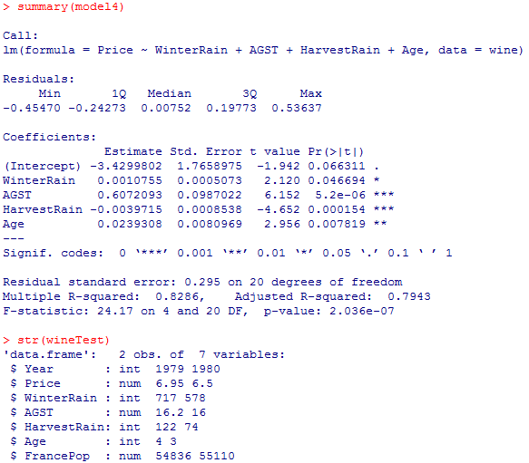

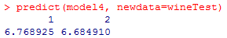

We can see the above predicts 6.769 and 6.685 for the Price for the two new data points, given their respective values for WinterRain, AGST, HarvestRain, Age and FrancePop using the model model4 built from the training data. These two values are quite close to their actual values, which were reported to be 6.95 and 6.5.

We can compute the **out-of-sample accuracy of a test** set by manually computing the R2 = 1- SSE/SST. The SSE and SST are computed using the lines from the training data. So we calculate the difference between the predicted values in the test set according to the SSE line in the training data and the observed values, then square, then sum; we calculate the mean from the SST line in the training data and again find the difference between each of the observed values in the test set and this mean, then square, then sum. The higher this R2 value the more accurate our out of sample data. However, the size of our test set should be taken into account. If it is built upon a small number of test set points then its accuracy is not reliable. Although it is not possible for a model R2 to be negative, **a test set R2 can be negative.** It is also **not true** that for the test set **adding more independent variables increases the test set R2.** When selecting our model **we want** one with both **a** **high model R2 and a high test set R2**.

____________________________________________________________________________________

Moneyball

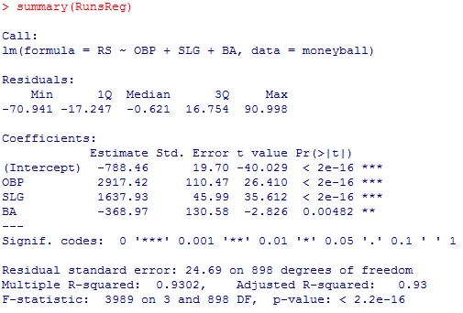

The above is from the moneyball example and we are trying to predict runs scored (RS) from on-base% (OBP), slugging% (SLG) and batting average (BA) and we see from the high R2 values that these three variables do a good job. Notice however that the regression coefficient for BA is negative, which is counterintuitive, as it suggests that a higher batting average corresponds to less runs scored. This is due to a case of multicollinearity. So we rerun the prediction with BA removed and get:

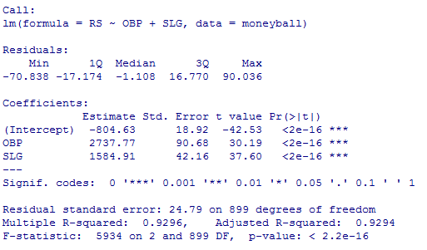

So the R2 values are approximately the same (they dipped by a negligible amount) and in return we have a simpler model that has only two independent variables instead of three, so overall it's a better model. Moreover, since the correlation coefficient for OBP is larger than that of SLG and both are on about the same scale, OBP is probably more important in predicted RS. So our analysis using linear regression has showed us that BA is overvalued in predicting RS, SLG is important and OBP is the most important.

We can repeat the above for defensive statistics to get a linear regression model of RA = -837.38 + 2913.6*OOBP + 1514.29*OSLG with an R2 value of 0.9073.

**These examples show that sometimes just a small number of independent variables amongst a wealth of variables can be enough to accurately predict a dependent variable.**

In this example we used **wins** to predict whether or not a team would make it to the **playoffs**. (We predict this rather than whether or not the team will win the World Series because the season is long and offers a large sample size of games through which skill shines, whereas the World Series is short and so luck is a larger factor). By looking at a graph for the 1996-2001 seasons we saw that usually when a team wins at least 95 of their 162 games, they make the playoffs. We then saw using R that to predict number of wins we can use just the variable **runs difference = runs scored - runs allowed**. We then saw using R that to predict runs scored we can use **OBP** and **SLG**, and to predict runs allowed we can use **OOBP** and **OSLG.** In summary, We used the 2001 team stats OBP, SLG, OOBP and OSLG to predict runs scored and runs allowed, and therefore runs difference, and therefore wins for 2001.

But what if we want to predict wins for 2002 before the 2002 season begins? The team will be different than it was from the previous year so we can't merely use 2001 stats. Instead we can look at individual player stats from 2001 to use as estimates for the OBP, SLG, OOBP and OSLG stats (by averaging?) for the 2002 team and work up from there plugging into our linear regression equations determined above until we get our prediction for wins.

Our formulas from the linear regression model are:

RS = -804.63 + 2737.77*OBP + 1584.91*SLG

RA = -837.38 + 2913.60*OOBP + 1514.29*OSLG //RD = RS-RA

W = 80.881375 + 0.105766*(RD)

_____________________________________________________________________________________

Notice in the following data frame that there is an X in front of 2P, 2PA, 3P and 3PA. However if you look at the original data set in NBA_train.csv there is no X. This is because R does not like when variable names begin with a number, so it automatically adds the X in front.

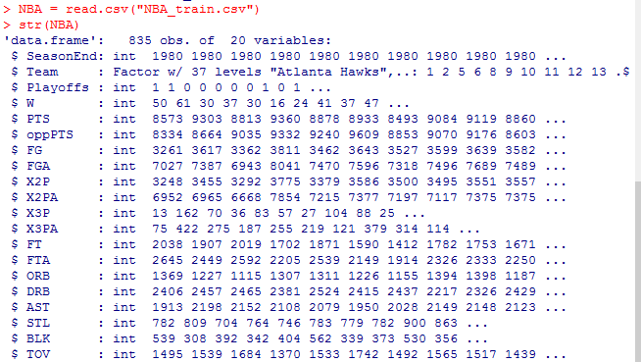

In our NBA example we want to create an analysis that is similar to our moneyball analysis. Recall that in the moneyball analysis we started by choosing a reasonable minimal number of wins that a team would need to make it to the playoffs, and this was done by looking at a plot and seeing that historically it was usually the case that when a team won at least 95 games they made it, so we chose to create an analysis in which we aimed to win at least 95 playoff games. In our NBA example we obtain a similar estimate, but this time by creating table(NBA$W, NBA$Playoffs) and seeing that the turning point is around 42 games, so we choose that.

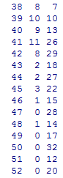

If we want to test whether or not there is a strong linear relationship between an independent variable and a dependent variable and therefore whether or not a linear regression is appropriate we can first make a plot. We could also just use lm() and look at the R2 value.

For our NBA example we define:

NBA$PTSdiff = NBA$PTS - NBA$oppPTS

WinsReg = lm(W~PTSdiff, data = NBA)

From the summary of WinsReg we get that W = 41 + 0.03259*PTSdiff. If we use our estimate that a team should win at least 42 games to have a good chance of making it into the playoffs then PTSdiff should be at least 31.

When removing independent variables from a linear regression model we usually do so one at a time. We can start by looking at the ones without the ***, **, * and in particular the one with the highest Pr(>|t|) value. We can also look for other clues for variables which should be eliminated. For example, perhaps a variable's regression coefficient is negative although intuitively we would believe that the dependent variable should be positively correlated with this variable. As we remove variables we observe in particular the shift in the R2 value; if it has barely changed then removing the variable was a good idea, as it made the model simpler without significant or any cost. Note that this process of removing variables is not well-defined; we have to use some judgment.

The **step(linearregressionmodel)** function in R automates the process of trying out different combinations of independent variables of a linear regression model to determine which would be the most appropriate to predict the dependent variable by weighing the various R2 values against the various independent variables; its output is itself a linear regression model. (Recall: ideally we want high R2 values, which is achieved by having more independent variables, but more independent variables increases model complexity, which we don't want.) The tradeoff is formalized by the **Akaike Information Criterion (AIC)**.

The **na.omit(dataframe) function** outputs a data frame which omits any observations from the input data frame in which at least one variable has an NA value.

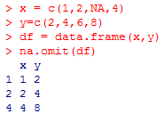

**Factor variables** are variables that take on a discrete set of values and have no natural ordering. An **ordered factor variable** has a natural ordering between the levels (e.g. "small", "medium", "large" or days of the week). When we create a linear regression model from a data frame which has a factor variable, the linear regression model treats/writes each level as a variable except for the reference level. E.g. if we have the variable "race" in our data frame which consists of levels "White" and "Black" and a reference level, then our linear regression model will have raceWhite and raceBlack as variables, but not the reference level or race, as seen in summary(model).

To include unordered factor variables in a linear regression model we select one level as the **reference level**, typically the most common level in the set, and add a binary variable for each of the remaining levels. So a factor variable with n levels is replaced by n-1 binary variables; the reference level won't appear in the regression model as one of the independent variables (for ex if we type summary(modelname) it doesn't appear in the list of variables). For example if our unordered factor variable "color" consists of levels "red", "green", "blue" and we decide "green" is our reference level, then the model adds binary variables "colorred", "colorblue" but doesn't have "color". All red examples would have colorred=1, colorblue=0; all blue examples would have colorred=0, colorblue=1; all green examples would have colorred=0, colorblue = 0.

When a variable with text is loaded in R then it is read as a factor variable. By default R selects the reference level by choosing the first level that occurs when arranged alphabetically. We can select the reference level by: **dataframe$variablename =** **relevel(dataframe$variablename, "levelname").**

For a linear regression model from a data set, if we want to **use** **all of the remaining variables** as independent variables once the dependent variable Y has decided we can use the short hand notation of **lm(Y~., data=dataset)** rather than manually typing out each of the independent variables.

A variable that is **skewed right** means that if you draw its histogram the frequency is high only at the left end; **skewed left** is the opposite. Whenever we have a skewed variable it's often a good idea to **predict the logarithm** of the variable instead; this prevents the small number of unusually small or large observations from having too large an effect on the SSE in predictive models.

In R **log()** is the natural logarithm function, so base **e**. Also **exp()** is base **e.**

If we want to know the **slot number of a variable x** that corresponds to a particular **observation k** then we can write **which(x == k)**.

A **time series model** is one in which consecutive weekly (or some consistent unit of time?) measurements of dependent and independent variables are measured. The **zoo** package provides a number of helpful methods for dealing with time series models. A package consists of many functions not built into R and needs to be installed and loaded into R. To install a package we use the command **install.packages("zoo")**  (we only need to install a package once) and to load the package in the R console for the current session we use the command **library(zoo)**. The **lag()** function is useful for time series models in that it allows us to take previous/future values as predictions for the current value, which is useful if for example we need a current value but the data is dated only weekly. In the example in the Flu Homework we can take data lagged by 2 weeks (we don't want to take 1 week because we might be near the end of the current week, and so 1 week ago would be the same week). To do this we can create the variable ILILag2 = lag(zoo(FluTrain$ILI), -2, na.pad=TRUE). The -2 means that the values for ILILag2 are taken from FluTrain$ILI from 2 weeks ago, and na.pad=TRUE means that the first two weeks (which don't have values from 2 weeks prior) means R adds values of NA for them. Then we can write FluTrain$ILILag2 = coredata(ILILag2) to add variable ILILag2 defined as coredata(ILILag2) into the data frame FluTrain. The values that R adds are NA but can be changed manually. For example if we have FluTest$ILILag2 with NA in its first two slots then we can write FluTest$ILILag2[1] = FluTrain$ILI[416] for the first slot and FluTrain$ILILag2[2] = FluTest$ILI[417].

I skipped two optional assignments at the end of Unit 2.

_____________________________________________________________________________________

Unit 3

A **categorical** variable takes only a small number of possible values, such as a binary variable. Categorical variables are typically qualitative, like names or labels, rather than quantitative (numerical). In the case of the binary variable which takes values 0 or 1, we can think of these as labels "FALSE" or "TRUE".

**Logistic regression** is an extension of linear regression to situations where the dependent variable is categorical.

In the example at the beginning of Unit 3 we are dealing with a binary dependent variable y= PoorCare which takes value 1 if a patient was evaluated to have received poor care, 0 if evaluated to have received good care, and the independent variables are x1 , ... , xk.

**The Logistic Response Function:** P(y=1) = 1 / [ 1 + e-(Bo + B1x1 + ...+Bkxk)]; in this example it denotes the probability that a patient receives poor care. For this particular example the independent variables do not take on negative values and so positive values for the coefficients are predictive of poor care (i.e. increasing its corresponding variable increases the probability of poor care) and negative values are predictive of good care (i.e. increasing its corresponding variables increases the probability of good care). Furthermore, as Bo + B1x1 + ... + Bkxk -> infinity P(y=1) ->1 and as Bo + B1x1 + ... + Bkxk -> negative infinity P(y=1) -> 0.

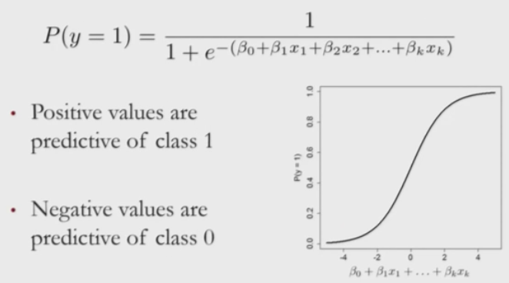

The coefficients are selected so that when care quality is poor then P(y=1) is high, and when good P(y=1) is low.

**Odds = P(y=1) / P(y=0)**. Odds>1 if y =1 is more likely; Odds<1 if y=0 is more likely.

By doing a bit of calculation we find that:

Odds = exp(Bo + B1x1 + ... + Bkxk)

**log(Odds) = Bo + B1x1 + ... + Bkxk // The Logit Function**, which looks like linear regression

Bigger logit -> bigger value for P(y=1)

Before when we wanted to compare predictions to a baseline method we took the **mean** outcome value as our baseline. However for a **classification problem** (where the dependent variable is categorical) it is more typical to use the **mode** **outcome value as our baseline**.

In our particular example in Video 4 using the quality.csv data we get that 98 patients receive good care and 33 receive bad care, so our baseline model would have an accuracy of 98/131 = 75%, which is what we want to beat with our logistic regression model.

In this example we only have one data set rather than a training data set and a testing data set as in previous examples, so we want to split our data set into two to have a training and testing set to test our out-of-sample accuracy. We need a new package for this, namely caTools, so I installed it. Then for the given R session I loaded it using **library(caTools)** and I use it to randomly split our data into a training set and a data set using the function sample.split(dataframe$outcomevariable, SplitRatio = proportionofdataintrainingset) from the caTools package. It could split it differently for different people due to its randomness, but to get the same split as someone else you can choose the same **seed**, which in this example was chosen by the lecturer to be 88, by typing **set.seed(88)**. In our example we have split = sample.split(quality$PoorCare, SplitRatio=0.75)**,** so 75% of the data will be used for the training set and the remaining 25% for the test set. But sample.split also makes sure that the data is well-balanced in each piece. This means that the training set has about 98/131 =75% of its outcomes as good care, and same with the test set. We do this because we want to make sure our test set is representative of our training set. (The 75:25 ratio decided for the sample.split is independent of the 98/131 =75% calculated above; they don't have to be the same, but the lecturer in this example chose them to be by coincidence.) If we enter split then it outputs 131 values that are TRUE or FALSE. TRUE means that the corresponding observation belongs in the training set, and FALSE means that it belongs in the test set. We can then create our training set by qualityTrain = subset(quality, split==TRUE) and our test set by qualityTest = subset(quality, split==FALSE). Now that we have our data separated into a training and testing set we can proceed to build our logistic regression model, which in this example we will call qualityLog. We write qualityLog = glm(PoorCare ~ OfficeVisits + Narcotics, data = qualityTrain, family = binomial). The **glm** is for generalized linear model and **family = binomial** specifies that it is in particular a **logistic regression model** we are dealing with.

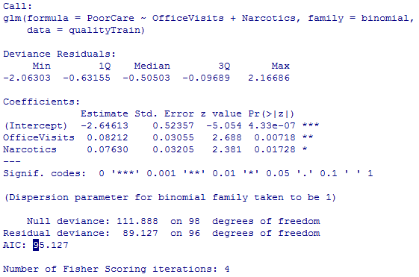

We see that the coefficients for OfficeVisits and Narcotics are positive, which mean higher values for these variables are indicative of poor care by returning to the logistic response function. We also see the **AIC value**, which is a measure of the quality of the model that accounts for the number of independent variables used, like adjusted R2. However, unlike adjusted R2, AIC can only be compared between models on the same data set. So it provides a means for comparing models on a given data set; small AIC is better.

Now let's make predictions on the training set. We write predictTrain = predict(qualityLog, type = "response"); **type="response"** tells us that we want to return probabilities; so we are returning P(PoorCare). **The output of a logistic regression model is a probability.** If we then enter tapply(predictTrain, qualityTrain$PoorCare, mean) it separates our training data into the two cases 1 and 0, whether poor care or good care was received, and for each of the data points in each case it predicts the probability that poor care was given to that data point then averages over the case. Below we see that our model predicted a higher average probability of poor care in the case where poor care was indeed given, which should be the case if the model has a chance of being any good.

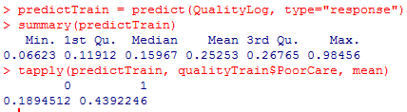

We saw that the outcome of a logistic regression model is a probability. Often we want to make a binary prediction based on the probability - should we or should we not proceed with a given action? We can do this by establishing a **threshold value t** for our probability. Continuing with our example, once we have decided our threshold value t we can say

* If P(y=1)  t then we predict poor care
* If P(y=1) < t then we predict good care
* t is often selected based on which errors are "better"
* If t is large then we predict poor care seldom, good care often. We will make more errors in actual poor care cases by predicting the patients receive good care, and the good care patients will be rightfully marked as having received good care. This approach is good for prioritizing the patients who are likely receiving the worst care; the downfall is that some patients receiving poor care are skipped.
* If t is small then we predict poor care often, good care seldom. We will make more errors in actual good care cases by predicting the patients receive poor care, and the poor care patients will be rightfully marked as having received poor care. This approach is good for identifying all patients receiving poor care; the downfall is that some patients who are actually receiving good care are going to be labeled as having received poor care, therefore causing an overload for the doctors who wish to help all the patients who were labeled as receiving poor care.
* If there is no preference between which type of error then we let t = 0.5, so that we predict poor care or good care solely on which has a higher probability.

We can create a **confusion matrix (or classification matrix)**

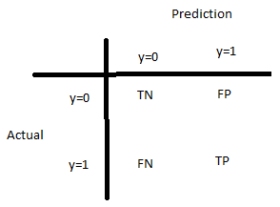

T = True F = False N = Negative P = Positive

* The N/P refers to our prediction; N is when is y=0 and P is when y=1
* The T/F refers to how the actual value of y compares to the prediction; if they are the same then it is T, if not then F.
* The two types of errors are False-Positive and False-Negative.
* In a confusion matrix TN, FP, FN and TP will be numbers corresponding to how many patients there are in each category.

Two outcome measures that help us determine what types of errors we are making: **sensitivity** and **specificity**.

**sensitivity** = TP / (TP + FN)

* This looks at all the times poor care was predicted as a fraction of all times that care was actually poor. This is often called the **true positive rate.** (Think of it as the success rate for predicting poor care among all actual poor care cases.)

**specificity** = TN / (TN + FP)

* This looks at all the times good care was predicted as a fraction of all times that care was actually good. This is often called the **true negative rate**.
* FP/(TN+FP) = 1 - specificity is the **false positive rate**
* FN/(TP+FN) = 1 - sensitivity is the **false negative rate.**

A model with a higher threshold value t will have a lower sensitivity and a higher specificity. The model will predict y=1 less often and so the right column and in particular the TP in TP/(TP+FN) will be smaller; the model will predict y=0 more often and so the left column and in particular the TN in TN/(TN+FP) will be larger.

Think of sensitivity as the model's ability to capture true positives; higher sensitivity means the model is more sensitive to capturing true positives.

A model with a lower threshold value t will have a higher sensitivity and a lower specificity. The model will predict y=1 more often and so the right column and in particular the TP in TP/(TP+FN) will be larger; the model will predict y=0 less often and so the left column and in particular the TN in TN/(TN+FP) will be smaller.

The sum of a given row (the denominators of sensitivity and specificity) is constant as we change t; the columns, not.

In R if we want to create the confusion matrix for actual poor care cases and its predictions for the training set we can use **table(qualityTrain$PoorCare, predictTrain > t)** for different values of t.

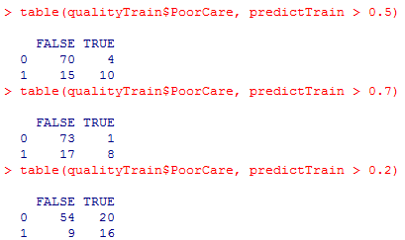

Choosing a good threshold value t can be done using a **Receiver Operator Characteristic (ROC) curve**. We make a graph with False Positive Rate (=1-Specificity) along the x-axis and True Positive Rate (=Sensitivity) along the y-axis. The curve starts at (0,0), which corresponds to t=1, and ends at (1,1), which corresponds to t=0. Because each value of t from 0 to 1 corresponds to a unique False Positive Rate and True Positive Rate we can therefore make a continuous curve from (0,0) to (1,1), where each x and y value is determined by its corresponding value of t. You can label the threshold values in R by colour-coding the curve; the legend on the right specifies the values for t for various colours. We can also add specific threshold labels to the curve.

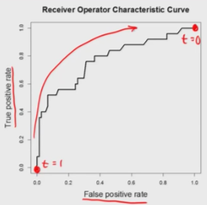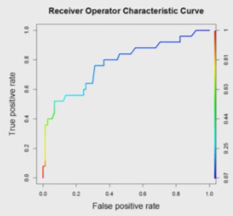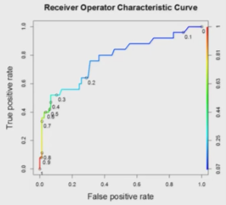

Note that we ideally want both a high TP rate (sensitivity) and a high TN rate (specificity), that is, a low FP rate. However, these are two competing factors, so we need to make a trade-off in deciding the best threshold value. If we decide it is more important to minimize the FP rate then we choose a point on the ROC curve close to the left but which still makes the TP rate high. If we decide it is more important to maximize the TP rate then we choose a point that is high, but still close to the left.

To use ROC curves install.packages("ROCR") and **library(ROCR).**

We use the predictions from our training set predictTrain to create our ROC curve. First we need to call the **predict function of ROCR**, which here we call ROCRpred: ROCRpred = prediction(predictTrain, qualityTrain$PoorCare). (Note that these are the same arguments we used in tapply() above but in reverse.) So the predict function of ROCR is called **prediction** and takes as its first argument the predictions made with our model and as its second argument the actual outcomes of our training points. Now we need to use the **performance function** to define what we would like to plot on the axes of the ROC curve. We will call this ROCRperf = performance(ROCRpred, "tpr", "fpr"), where tpr is for True Positive Rate along the y-axis and fpr is for False Positive Rate along the x-axis (note that "fnr" and "tnr" are also options). Then to see the plot we enter **plot(ROCRperf)**.

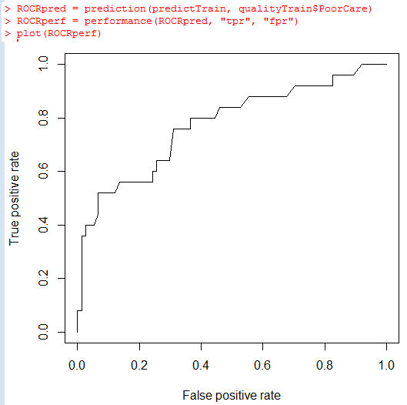

We can then colorize the graph by adding argument **colorize = TRUE** into the plot function and we can add number labels to the t values by adding argument **print.cutoffs.at=seq(0, 1, 0.1**) or some other value in the third slot. We can furthermore add the argument **text.adj = c(a,b)** to shift the text by some amount so it isn't sitting on top of the curve in our plot, where a and b are numbers.

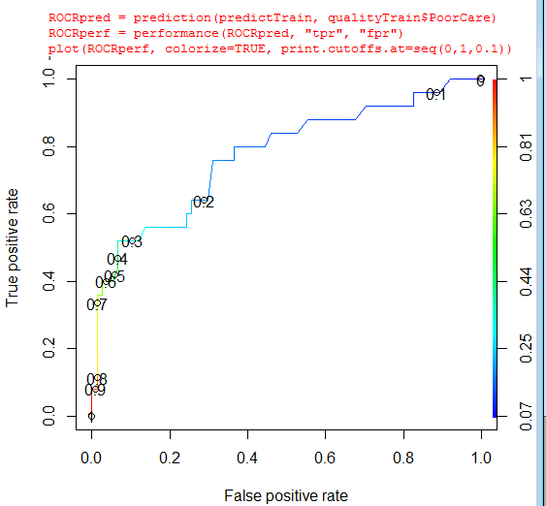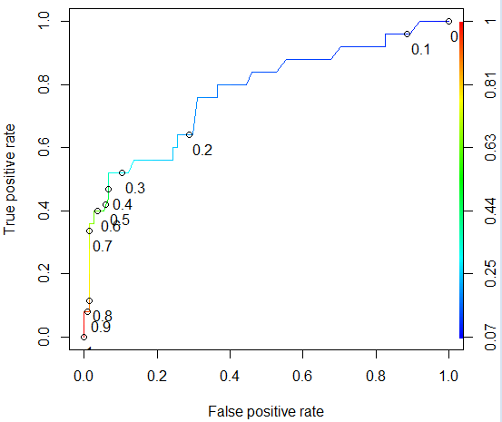



To help decide whether or not we have a good logistic regression model we can take the **area under the ROC curve (AUC)**; higher AUC means a better model. The interpretation is that given two random patients from the data set, one who actually received good care and one who actually received poor care, it is the proportion of the time the model correctly guesses which is which. The best case scenario is that AUC = 1 and the worst case scenario is AUC = 0.5 (when our model is no better than a random guess), which occurs when the ROC curve is a line-segment connecting (0,0) to (1,1). We will revisit these ideas later it appears.

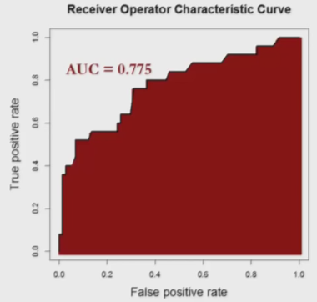

True Positive Rate = TP / (TP+FN) //Sensitivity

True Negative Rate = TN / (TN +FP) //Specificity

False Positive Rate = FP / (FP + TN) //1-Specificity

False Negative Rate = FN / (FN + TP)

Overall Accuracy = (TP + TN) / (TP + TN + FP + FN)

Overall Error Rate = (FN + FP) / (FN + FP + TP + TN)

When we have a logistic regression model and want to make predictions out of sample on a test set, we do it the same way as we would with a linear regression model but this time we furthermore need the argument type = "response" because **logistic regression models output probabilities, which we then convert to a binary outcome using a threshold (e.g. quality is good/bad)**:

predictTest = predict(QualityLog, type = "response", newdata=qualityTest). We need the "newdata" argument here because QualityLog was originally defined using the data set qualityTrain.

____________________________________________________________________________________

**Framingham Heart Study**

For tracking cardiovascular disease. The cardiovascular system is the circulatory system, the organ system that allows blood to transport nutrients, oxygen, hormones, etc. to the various parts of our body.

A **risk factor** for a disease is a variable that increases the chances of the disease. In our example we want to predict the risk of coronary heart disease (CHD) within 10 years from given risk factors, whereby plaque builds up in coronary arteries (which supply oxygen-rich blood to the heart). The risk factors were collected at the time of the first examination of the patients in the study.

**Hypertension** means high blood pressure.

***When splitting our data set into training data and test data using sample.split() the SplitRatio does **not** have to be equal to the ratio of the of times the outcome variable is 1 to the total observations of the outcome variable, as we were unsure of in the PoorCare case (when we saw this ratio was 98/131 = 0.75 and then used SplitRatio=0.75; this was a coincidence.)

When you have more data in your overall data set then we can afford to put less data in our training set and therefore more in our test set, thereby increasing our confidence in the model's ability to extend to new data. This is why we put a smaller split ratio of 0.65 in the Framingham problem, which has 4240 observations. In the training set we typically want to put 50-80% of the overall data.

When we have our confusion matrix we can calculate our **accuracy** = **(TN + TP) / (TN+TP+FN+FP)**, which we can then compare to our **baseline model,** which predicts the mode actual value, found by seeing which row in the confusion matrix has a larger sum, as a fraction of TN+TP+FN+FP. If our logistic regression model with the specified threshold is any good then accuracy should be substantially larger than this mode frequency.

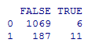

The above confusion matrix has accuracy (1069+11)/(1069+6+187+11) = 0.8483896 and the baseline model predicts no CHD (1069 + 6) / (1069+6+187+11) = 0.8444619, so not much improvement. Our accuracy can be changed by changing the threshold. **Note: due to the way split works, we would expect the proportions to be (almost exactly) the same between the training set, the test set, and the overall data set so the above works for the baseline model; the small difference between these three values is due to rounding errors that occur when splitting according to the SplitRatio (for example if we have 99 observations with a SplitRatio=0.65).

To **calculate the AUC** of a set:

Say we want the AUC of our test set in the Framingham Heart Study, which we called test and from which we constructed predictTest = predict(framinghamLog, newdata = test, type = "response").

* library(ROCR)
* ROCRpred = prediction(predictTest, test$TenYearCHD) //it seems like this predicts t values?
* as.numeric(performance(ROCRpred, "auc")@y.values)
* In this case it outputs an out of sample AUC of 0.7421, which tells us that the model can differentiate between low risk patients and high risk patients pretty well.

So far in R we have used **internal validation**, whereby we have one set of patients, which we split into a training set and a test set. The weakness is that it is not clear if this model generalizes to other populations; the patients in the Framingham Heart Study are white and middle-class adults. To see if our model extends to other populations, we need to test it on them, known as **external validation.**

_____________________________________________________________________________________

**Election Forecasting in USA**

* Many political parties but usually there are only two main candidates, typically a republican or democrat.
* Each of the 50 states is assigned a number of **electoral votes** based on its population size.
* Winner takes all in each state; the winner of that state gets all the electoral votes from that state.
* The president is the one who wins the most electoral votes.
* **Popular vote** is not what is used in the USA, which is when the votes of all individuals are taken and compared.

In our model:

* Dependent variable: Republican, which is 1 if the Republicans won in a given state, 0 if a Democrat won.
* Independent variables are related to polling data in each state and three different years (2004, 2008, 2012):

i)Rasmussen and ii) SurveyUSA: Polled R% - Polled D% in that poll. These are two major polls; the

% of voters who said they were likely to vote R minus the % who said they were likely to vote D in each of the two polls in a given state and year.

iii)There are many such polls though. DiffCount = #Polls with R winner - #Polls with D winner in a given state and year.

iv)PropR = #Polls with R winner / #Polls

In this example we want to talk about **how to deal with missing data**. If we call polling=read.csv("PollingData.csv") then we would expect there to be 150 observations, corresponding to the 3 years of 50 states, but we find only 145. The 5 that are missing (in 2012) are due to the fact that pollsters knew with high confidence who the winner would be in those 5 states, so polls were not taken; this is fine in this example. However if we take summary(polling) we see that Rasmussen and SurveyUSA have many NA's.

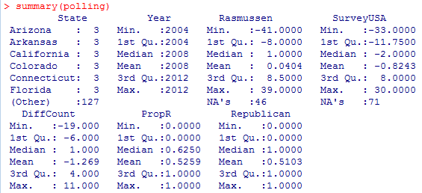

One solution would be to delete all observations which have at least one variable with NA (so delete rows from the data frame). In this example we would be deleting more than half of the data though (between 71 and 46+71=117). Furthermore, we might be left with some states which have no observations, but we want to be able to make predictions for all states.

Another solution would be to remove all variables which have at least one NA (so remove columns from the data frame), in this case Rasmussen and SurveyUSA. However, we expect these two variables to be qualitatively different from aggregate variables like DiffCount and PropR, so we want them.

A third approach would be to fill the missing values with average values. For Rasmussen and SurveyUSA, the average value in each state and year would be approximately 0 across all times reported because there is a rough tie between the Republican and Democrat candidates; we can look at the means in summary(polling). (Recall that our convention in this problem is that Rasmussen and SurveyUSA values represent %'s, so SurveyUSA's mean of -0.8243 corresponds to -0.8243%.)

If other polls in a given state favor one candidate then the missing poll likely will too.

If PropR for a given state and year is close to 1 then we would expect the missing Rasmussen and SurveyUSA stats to be positive; if PropR for a given state and year is close to 0 then the missing Rasmussen and SurveyUSA stats would be expected to be negative.

**Multiple imputation** consists of filling in missing values based on non-missing values. For example, if the Rasmussen variable is reported for a given observation and is very negative then we would expect the missing SurveyUSA variable will also likely be negative. Just like with sample.split() multiple runs of multiple imputation will result in different values being filled in unless you set the seed with set.seed(); in this example we will use **set.seed(144)**. Multiple imputation is mathematically sophisticated but it is easy to use in R. We need the **Multiple Imputation by Chained Equations (MICE) package**: install.packages("mice"), library(mice). For our multiple imputation to be useful we need to fill in the NA's of Rasmussen and SurveyUSA without using the outcome variable Republican. To do so we create the polling data frame limited to the variables Rasmussen, SurveyUSA, DiffCount, PropR: simple = polling[c("Rasmussen", "SurveyUSA", "DiffCount", "PropR")]**.** Now to do the imputation we make a new data frame, which we will call imputed = complete(mice(simple)). This outputs the same data frame as simple but with the NA's filled in. Then we can copy these new values to the original polling data frame by polling$Rasmussen = imputed$Rasmussen and polling$SurveyUSA = imputed$SurveyUSA.

**Important note for imputation**: Even if we set the seed, due to the randomness of it we may still get differing results depending on the operating system. For this reason this course provided the imputed values.

The **sign(x)** function returns -1 if x<0, returns 1 if x>0 and returns 0 if x=0.

In our polling example we use the 2004 and 2008 data for our training set and the 2012 data for our test set, so we create Train = subset(polling, Year==2004 | Year==2008) and Test = subset(polling, Year==2012). As our baseline model we look at table(Train$Republican) to find that it we have Democrat with 47 and Republican with 53 and therefore use the most frequent, Republican, as the prediction by our baseline model, which in this case is a poor baseline model as it has an accuracy of only 53%. Therefore we need an even smarter baseline model against which we can compare our later logistic regression model.

So rather than predicting that R wins for each of the 50 states for the 2 years we can instead look at, say, the Rasmussen variable for each of the 50 states for the 2 years. If positive then Rasmussen predicts R in that state and year; if negative it predicts D; if 0 then inconclusive. So if sign(Rasmussen) = 1 then the new model would predict R for that state and year; if sign(Rasmussen) = -1 then the new model would predict D for that state and year; if sign(Rasmussen) = 0 then there's a tie and the model would be inconclusive for that state. So we look at table(sign(Rasmussen)) and get the following:

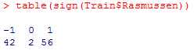

If we were to use this for our model we would predict Republican 56 times and Democrat 42 times, but how accurate is this model? To find out we can create the confusion matrix using table(Train$Republican, sign(Train$Rasmussen)):

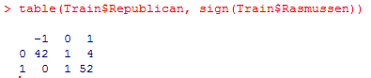

This shows that the model correctly predicts Democrats 42 times and Republicans 52 times, for an accuracy of 94%, which is significantly better than our original baseline model which has an accuracy of only 53%. So it would be better to use this new model as our baseline against which to compare future logistic regression models.

Now in building our logistic regression model, there is good reason to believe that there is high multicollinearity between the independent variables, as they are trying to measure more or less the same thing. So we want to look at the correlation between these variables using cor(Train[c("Rasmussen", "SurveyUSA", "DiffCount", "PropR", "Republican")]). Here I added the outcome variable "Republican" so that we can first start by creating a model of one independent variable by choosing the independent variable that is most highly correlated with Republican.

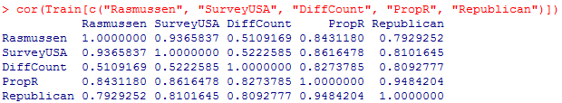

We see that PropR is most highly correlated with Republican so we first start by creating mod1=glm(Republican~PropR, data = Train, family = binomial).

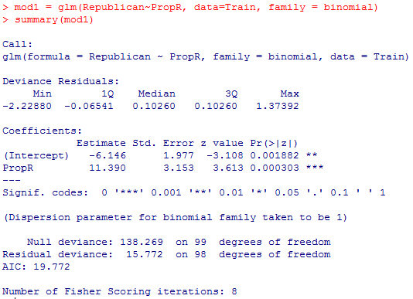

We see that our independent variable has *** significance and the coefficient is highly positive, as we would expect. We want to compare predictions made by the model to actual results so first start by creating pred1 = predict(mod1, type = "response"). Then we can choose a threshold, which in this example makes sense to choose t = 0.5 (so that if the model predicts Republican with at probability at least 0.5 in a given state then it predicts Republican, and if less than 0.5 then Democrat), and create table(Train$Republican, pred1 >= 0.5):

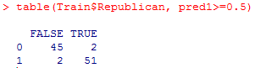

So we see this logistic regression model has an accuracy of 96%, which is slightly better than the improved baseline model.

Now let's see if we can improve our model by using two independent variables. Notice that PropR is highly correlated with each of the other independent variables, so we probably shouldn't keep PropR if we want two independent variables. Instead, we should perhaps choose two independent variables who have the lowest correlations, so either Rasmussen+DiffCount or SurveyUSA+DiffCount; we'll try SurveyUSA+Diffcount.

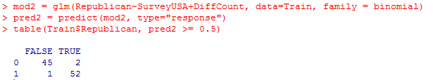

This new model has an accuracy of 97% so it is a bit better. By taking summary(mod2) we can see there are some benefits and disadvantages - it has a lower AIC and the coefficients are positive as expected, but the significance codes involve no stars.

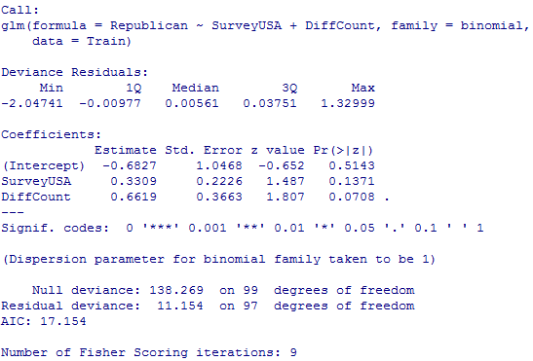

We are now going to compare the mod2 model against the improved baseline model on the test set. To see the out of sample accuracy of the baseline model on the test set we can type table(Test$Republican, sign(Test$Rasmussen)); we see we have 4 mistakes and 2 inconclusive results. This is what we will compare our logistic regression model's results against.

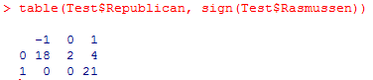

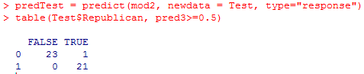

We see that mod2 on the test set has an out of sample accuracy of 44/45 = 98%, so it is significantly better.

Recall for taking only certain variables, say x and y, from a data frame df we write df[c("x","y")] and it prints data frame df but only with the x and y variable columns. (Restudy 1.3 on Michael Jackson).

Suppose we want to **create a logistic regression model** and there are **many independent variables**. We saw before that in glm() we can use a period in place of explicitly writing out each independent variable. However, suppose we want to use all of the independent variables except for a small few. We could first create a vector that consists of each of these independent variables, nonvars = c("year", "songtitle", "artistname", "songID", "artistID"), then to remove them from songsTrain we can write songsTrain = songsTrain**[, !(names(songsTrain) %in% nonvars)]**. Similarly, to remove from songsTest we can write songsTest[, !(names(songsTest) %in% nonvars)]. When we just **want to remove a single numeric independent** variable from the list of all variables we can add **-variablename** in glm(). So we create **Model2 = glm(Top10~. -loudness, data = songsTrain, family = binomial)**; notice there is no comma after the period.

To convert a numerical variable to a factor variable we use **as.factor()**. Note that this does not change the values of the variable, just the way that R understands it. (We could similarly use **as.numeric()** to convert a variable to numerical form.)

The  **accuracy** of a model just means the proportion of times it will predict correctly.

Suppose we want to focus on the **observations of a data frame df corresponding only to a certain variable x's NA values**. We can do this by dfNew = subset(df, is.na(x)**).** If we have multiple variables say x and y and we want observations where at least one is NA then we can write dfNew = subset(df, is.na(x)|is.na(y)), etc. We could have also put is.na(x) ==TRUE | is.na(y) == TRUE but the given notation is faster.

***In later examples we see that the baseline model for our test sets are taken using the mode from the test set and not the train set; we've seen this in multiple examples. Why is this?

Note that **sort(x)** for numerical variable x is itself a variable and so we can look at, for example, the 67th largest observation of x by sort(x)[67]. If we want to instead arrange observations in decreasing order we can write **sort(x, decreasing = TRUE).**

## ***Skipped optional assignment at end of Unit 3 Predicting the Baseball World Series Champion (OPTIONAL)

## _____________________________________________________________________________________

## Unit 4

The American legal system is divided into the state level and the federal level. Federal courts are divided into **district courts** (makes initial decision), **circuit courts** (hears appeals from district courts; i.e. where cases are reviewed; they can change the decision that was made; there are 13 in USA, defined by region) and **the supreme court** (highest level; makes final decision; there is only one supreme court in USA).

The Supreme Court consists of 9 judges called "justices", appointed by the president; they are usually distinguished judges/law professors/attorneys. One of them is the Chief Justice, who is the head of the 9. The Supreme Court of the United States (SCOTUS) decides on the most difficult and controversial cases. Often involve interpretation of the Constitution and have significant social, political, economic consequences.

To predict Supreme Court cases we might suspect that we could use logistic regression because the ultimate decision is binary - affirm the case or reject the case? However, logistic regression models are not easily interpretable; model coefficients indicate importance and relative effect of variables but not a simple explanation of how a decision is made.

In our problem we use data from 1994 to 2001 to make 2002 predictions about Justice Stevens's decisions.

Dependent variable: Did Justice Stevens vote to reverse the lower court's decision? **1 if reverse, 0 if affirm.**

The independent variables are various properties of the case.

The **petitioner** is the party who petitions the Supreme Court to review the case, usually because they lost the case. The **respondent** refers to the party being tried, aka the defendent.

The political scientist Andrew Martin used a method different than logistic regression to calculate the binary outcome reverse/affirm called **Classification and Regression Trees (CART),** which builds a tree by splitting on values of the independent variables. To predict the outcome of a new case (observation) you can follow the path along the tree and predict for this case the most frequent outcome of the observations from the training set that followed the same path (here we are assuming a subset's prediction is determined by the majority outcome, so a threshold of 0.5 for red, but we can actually define the threshold as we like). It is easily interpretable and does not assume a linear model like linear regression or logistic regression.

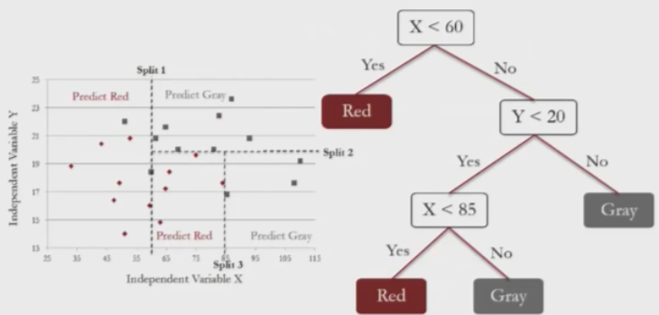

Above we plot two independent variables against each other and their outcome is given by their color, red or gray. CART tries to split the data into subsets in a way that each subset is as homogenous as possible, i.e. each subset has most of its outcomes as the same color. The prediction that CART makes for a new observation is determined by the color of the subset it falls into. The CART model is represented by a tree, which shows all of the splits. In reading a path from root to leaf it's understood that the conjunction of each of the splits that occurred along the path define the subset that observation belongs to. For example for the bottom left RED above the observation had to pass through (X<60) = No & (Y<20) = Yes & (X<85) = Yes, that is, 60<=X<85 and Y<20, so we predict RED. **In R, Yes is always to the left and No is to the right**.

There are different ways to control **how many splits** are made in our CART model. One way is by setting a lower bound for how many observations there can be in each subset; the parameter in R that controls this is **minbucket**. The smaller it is the more splits we get. Making minbucket too small can cause overfitting; this means that the model will fit the training set almost perfectly but will perform poorly on new data. Making minbucket too large will cause the model to be too simple and therefore inaccurate because so few subsets will be made (and so inevitably subsets will be far from homogeneous). Each subset in a CART tree has a **bucket** of observations which may contain both outcomes (reverse and affirm).

Instead of just taking the majority outcome to be the prediction of a given subset we can instead compute the proportion of each outcome in that subset and compare them to a threshold we define (from 0 to 1). In the above example the prediction associated with each subset was determined by a majority, so the threshold would be 0.5. However we could change this threshold to, say t = 0.9, meaning the leftmost subset, which has red 6/7=0.86, would not surpass this threshold and would instead predict gray. By varying the threshold value we can compute an ROC curve and auc value to evaluate our model.

Note that library(caTools) is for sample.split.

To build CART models we need to load **library(rpart)** and **library(rpart.plot)**. Then we can build the model in a way that is similar to building linear regression and logistic regression models: StevensTree = rpart(Reverse~ Circuit+Issue+Petitioner+Respondent+LowerCourt+Unconst, data = Train, method = "class", minbucket = 25). The argument method="class" tells rpart to build a classification tree instead of a regression tree (we will see regression trees later). Then we can **plot** our tree using the **prp()** function (which I assume is the point of rpart.plot): prp(StevensTree).

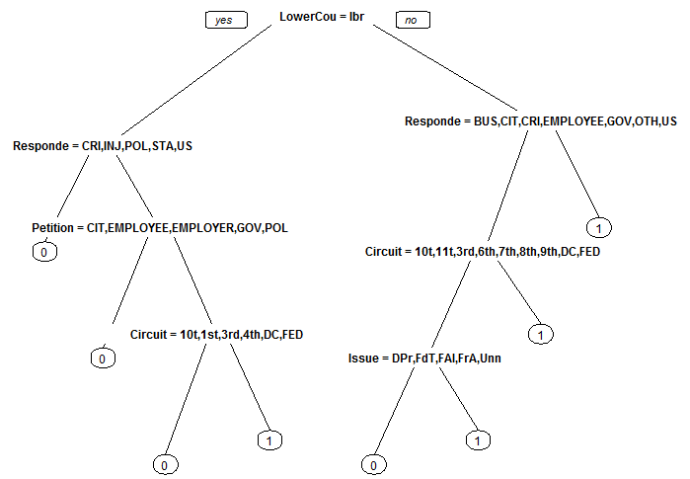

Notice that prp gives the variables abbreviations and does so in a way that they are uniquely identifiable. We see that a CART tree is a series of decision rules which can easily be explained.

Now we wish to compare our predictions from the CART model on our test set to actual outcomes: predictTree = predict(StevensTree, newdata=Test, type="class"). We use **type ="class"** only if we want the majority class predictions; it's the same as using a threshold of 0.5, so we can take it out if this is not the desired threshold. If we enter this command with class it gives a list of 0 or 1 for each of the observations in the test set; if we remove this command it gives a probability for both 0 and 1 for each observation in the test set.

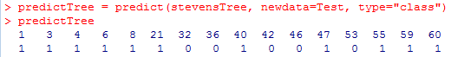...

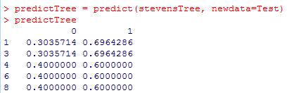

...

To then create the confusion matrix we enter table(Test$reverse, predictCart) if using the first predictTree above or table(stevens$reverse, newdata=Test, predictTree[,2] > 0.5) if using the second.

In this example the accuracy is 0.659 and the baseline model (which predicts the mode outcome all the time) has accuracy 0.547 and if you were to perform the logistic regression, you would find an accuracy of 0.665. So the CART model is significantly better than the baseline model and is competitive with the logistic regression model but is much more interpretable.

Now let's generate our ROC curve. We need to load library(ROCR). Then we need to reproduce our predictions but this time **without method = "class"** because the ROC curve is supposed to generate all possible t values whereas method = "class" is only for t= 0.5. So we write predictCart = predict(StevensTree, newdata=Test).

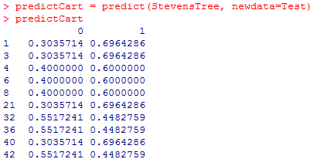

The above continues on downwards to 558. This table shows for each observation in Train (1,3,4,6,...,558) the probability that the StevensTree CART model will predict 0 (affirm) or 1 (reverse). Another way of thinking of this is that because each observation is classified in a bucket/subset, the probabilities of 0 and 1 for a given observation are the proportions of outcomes 0 and 1 of the training data in the respective bucket.

Now in creating ROCRpred we do as before except now we **only want the second column** f**rom predictCart** as this is P(y=1) as before. So we enter ROCRpred = prediction(predictCart[,2], Test$Reverse), then ROCRperf = performance(ROCRpred, "tpr", "fpr") then plot(ROCRperf). Notice the comma in [,2]. By taking [,2] we are just taking the second column from above, which is what we want because we want P(y=1) to compare to what we are doing when looking at Test$Reverse. We don't need the [,2] in logistic regression because they are already as probabilities of just the binary outcome y=1.

Counting how many splits a classification tree has amounts to counting how many "titles" for a split we see. So in the above example LowerCou=IBR is one split, Responde =CRI, INJ, POL, STA, US is one split, etc. and we find a total of 7 splits. We could also count the number of subsets by counting the number of leaves of the tree, and the number of splits is one less.

**Random forests** are designed as an alternative to CART models by building many CART trees and often offer a higher accuracy; the tradeoff is that it is less interpretable and more computationally intensive. To decide on an outcome for each observation each CART tree in the forest "votes" on the best outcome and we choose the outcome that receives the majority of votes. We can't just run CART many times, as this would produce the same tree every time. Instead, for each tree in the random forest a random subset of the independent variables is chosen as well as a random subset of the training set (with repetitions in training data in a given tree allowed) with the size of this random subset the same as the training set. For example if Train = {1,2,3,4,5} then the forest may choose {2,3,4,2,3} or {1,1,5,2,1}.

Like CART trees, random forests have a minimum number of observations in each of its subsets, controlled by the **nodesize** parameter in R, which is the same as minbucket in CART. Smaller nodesize means more splits and therefore bigger trees and will therefore take longer in R. Another parameter for random forests is the **number of trees**, called **ntree**. This ntree parameter should not be too small but the larger it is the longer it will take for R.

A nice thing about random forests is that they are not as sensitive to parameter values as CART trees are.

The syntax for random trees is comparable to that of CART models. We need **install.packages(randomForest)** and **library(randomForest).** If we try to create the model with StevensForest = randomForest(Reverse ~ Circuit+Issue+Petitioner+Respondent+LowerCourt+Unconst, data = Train, nodesize = 25, ntree = 200) then we get a warning message that does not occur when we try creating classification CART trees. This is because when defining our CART trees we added the argument method = "class" to specify that we want classification trees rather than regression trees, but randomForest does not allow this argument. Instead, to be able to create StevensForest as above we would **need to first convert our outcome variable Reverse to a factor variable in our Train set** (and we will do it in the Test set as well so we can apply StevensForest to our Test set). We do this with **Train$Reverse = as.factor(Train$Reverse)** and **Test$Reverse = as.factor(Test$Reverse).** We can then make predictions on our Test set as usual by PredictForest = predict(StevensForest, newdata=Test) and then create the confusion matrix as usual with table(Test$Reverse, PredictForest). However, the **confusion matrix will not always be the same for random forests even if we set the seed, due to different operating systems**. My particular confusion matrix gave an accuracy of 0.676, so a slight improvement over what was offered by the CART model and logistic regression.

Back to CART - Parameter Selection

As mentioned before the minbucket value affects out of sample accuracy, so how should we set this parameter? We could select it so that it maximizes the out of sample accuracy on the test set, but this would be wrong. The purpose of the test set is to measure model performance on data the model has never seen before, and doing this would implicitly use the test set to build our model. Instead we use **K-fold cross-validation**  to determine the best value of a different parameter called the **complexity parameter (cp).** The cp is similar to adjusted R2 for linear regression and AIC for logistic regression in that it measures the tradeoff between model complexity and model accuracy on the training set. A smaller cp means a bigger tree (and therefore possible over-fitting) and a larger cp means a smaller tree (and therefore a model that is too simple to be accurate). We can see this in the graph, and that the best cp typically occurs somewhere in the middle. Given our training set and a particular cp, we separate the set into k equal-sized subsets, called **folds** (in this example k=5). Then we select k-1 folds to build a model and test it on the remaining fold (called **the validation set).** Each fold has a turn being the validation set, so this process is done k times. So we use folds 1,2,3,4 to make predictions on fold 5; we use folds 1,2,3,5 to make predictions on fold 4, etc. This process is repeated for each possible value of cp. So **cross-validation builds many models, one for each fold/cp combination**. In the graph Parameter Value = cp. We choose the **best cp value** as the one that offers the **highest average accuracy** over the 5 folds, so in this case cp = 6. **(Correction: it turns out cp value can only be from 0 to 1, so we can interpret the Parameter Value in this example to be some multiple of cp.)**

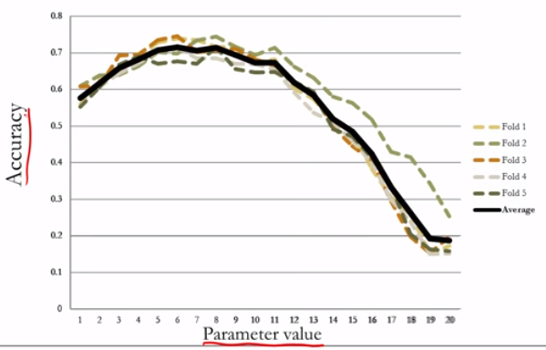

After loading the **library(e1071)** and **library(caret)** we choose our value k for the number of folds using numFolds = trainControl(method="cv", number =10) for k=10; method="cv" tells us that we are doing cross-validation. To define the range of possible values for cp use cpGrid = expand.grid(.cp = seq(0.01,0.5,0.01)), or whatever appropriate sequence of numbers. Note that cp seems to be already defined in R.

Now we're ready to perform cross-validation: we input train(Reverse~+Issue+Petitioner+Respondent+LowerCourt+Unconst, data=Train, method="rpart", trControl=numFolds, tuneGrid=cpGrid). method = "rpart" tells us we are cross-validating a CART model.



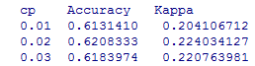

...

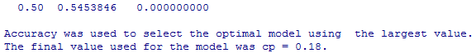

The commands above give this output (I cropped out some values) and tells us the cp value that offers the largest accuracy is 0.18. This should be the same cp value if we rerun the test (I believe it is the Accuracy column that might be different, but the cp that corresponds to the max is not, so cp = 0.18 is best.)

K-fold cross-validation uses random forests to generate a value for cp, which is then used in place of minbucket for a classification tree in CART, which is what we will do now, then use to make predictions on the test set:

StevensTreeCV = rpart(Reverse~Circuit+Issue+Petitioner+Respondent+LowerCourt+Unconst, data = Train, method = "class", cp = 0.18)

predictCV = predict(StevensTreeCV, newdata=Test, type = "class")

table(Test$Reverse, predictCV)

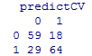

Note that this is the same table as in the video from MIT (so it seems that random forests are not always the same despite setting the seed but classification CART trees are the same). Note further that I forgot to add in library(rpart) but I could still use rpart in StevensTreeCV (not sure why).

The accuracy of this CART model is 0.724, as compared to 0.659 in the previous CART model. Cross validation helps ensure we choose good parameter value for our CART model; before we used minbucket, here we used cp.

**(StevensForest is not actually necessary to compute the cp value of 0.18)**

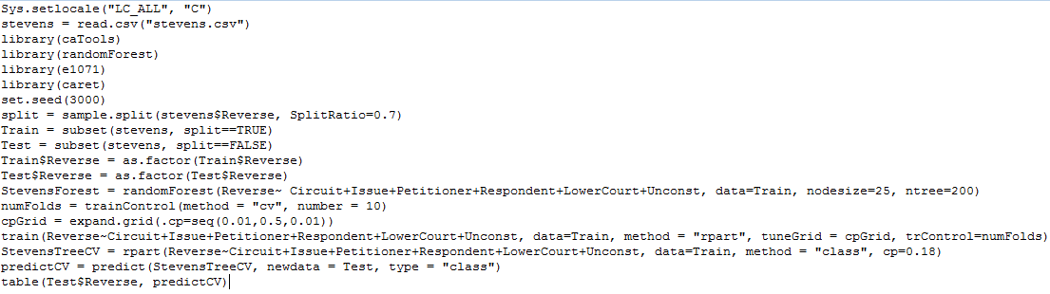

_____________________________________________________________________________________

D2Hawkeye

Goal of D2Hawkeye is to improve the overall quality of medical cost predictions.

In our example we use claims data for 2.4 million people over 3 years. The "observation period" aka training set is 2001-2003 and the "results period" aka out of sample test set is 2003-2004. We only include people with data of at least 10 months in both periods - 400 000 people.

For our cost variable, rather than using the cost directly we instead bucket the costs and consider everyone in a given bucket equal. In our example we define 5 buckets so that 20% of total costs are in each bucket. The % of patients in the <3000$ bucket is 78%, etc.

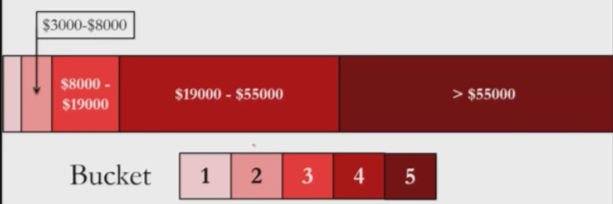

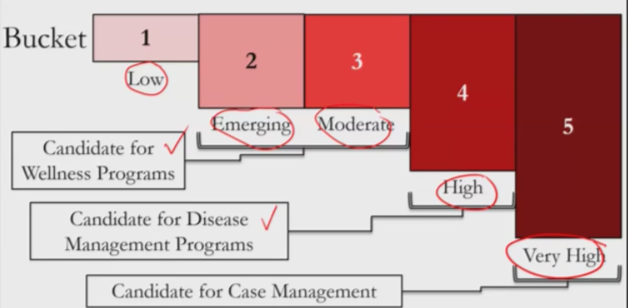

For our error measure we create a penalty to measure to compare a patient's actual risk level (1 to 5) to the predicted risk level (1 to 5). These are Outcome and Forecast. However, predicting low risk for a high risk patient receives a larger penalty than predicting high risk for a low risk patient by a factor of 2.

|  |  |  |  |  |  |  |
| --- | --- | --- | --- | --- | --- | --- |
| Forecast | Outcome | | | | | |
|  | 1 | 2 | 3 | 4 | 5 |
| 1 | 0 | 2 | 4 | 6 | 8 |
| 2 | 1 | 0 | 2 | 4 | 6 |
| 3 | 2 | 1 | 0 | 2 | 4 |
| 4 | 3 | 2 | 1 | 0 | 2 |
| 5 | 4 | 3 | 2 | 1 | 0 |

Notice below the diagonal each entry is the positive difference between Outcome and Forecast. Above the diagonal each entry is twice the positive difference between Outcome and Forecast. However in R we do things as usual; predicted outcomes on top, actual outcomes on the left, so the desired matrix is the transpose of this.

Baseline: The cost bucket in the next period will be the same as the cost bucket in the current period.

_____________________________________________________________________________________

Due to privacy issues we cannot use the data from D2Hawkeye, so instead we do examples from the Medicare program, which provides health insurance to Americans 65+ and some younger people with some specific conditions.

To protect the privacy of patients in this publicly available data set we need to anonymize the data. So we would need to retrain our models developed in this lecture on de-anonymized data if we want to apply our models in the real world.

We are using the data set from ClaimsData.csv and the observations represent a 1% random sample of all patients who received Medicare, limited to those still alive in 2008. Our independent variables are from 2008 and we predict cost in 2009.

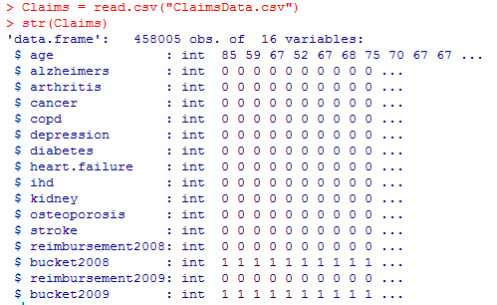

Independent variables

* age: at the end of 2008
* alzheimers, arthritis, cancer, copd, depression, diabetes, heart.failure, ihd, kidney, osteoporosis, stroke: binary variables indicating whether or not the patient had at least one diagnosis code in 2008; it is 1 if yes, 0 if not.

reimbursement2008 and reimbursement2009 are the total amount of reimbursements in $ the patient receives in those years.

bucket2008 and bucket2009 are the cost bucket the patient fell into in those years. We use the same buckets as in the D2Hawkeye example.

Note if we want to **divide the number of frequencies in a table by a number** (for example if we want relative frequencies by dividing by total number of occurrences) we can write /number after table, example table(Claims$bucket2009) / nrow(Claims).

Our goal is to predict the cost bucket a patient falls into in 2009 using a CART model.

Dependent variable: bucket2009

We will start by using the same baseline on the test set as the one used in D2Hawkeye whereby bucket2009 is predicted to be the same as the actual bucket2008, and we see the accuracy is 68.38%.

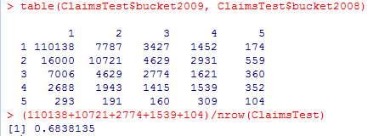

Now we want to consider the **penalty matrix**. In our convention actual outcomes are along the left and predicted outcomes are along the top (the transpose of what was given in the D2Hawkeye example).

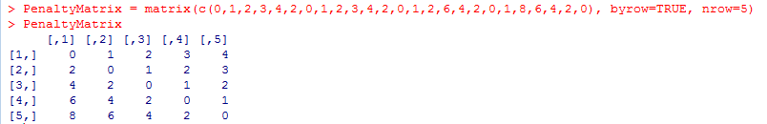

Note that byrow=TRUE copies the values as rows in the order they are entered in the definition of PenaltyMatrix. If we omit this argument then they are instead entered as columns.

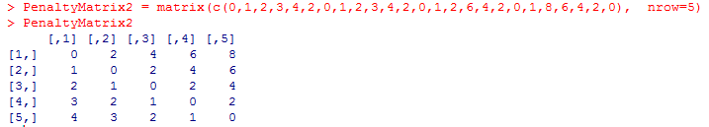

Note that if nrow is not a multiple of the number of entries then we get an error.

We can **multiply two matrices** of the same dimensions pointwise by using *. We can also convert a table to matrix form by using **as.matrix().** So to find the total value of each penalty made in this example:

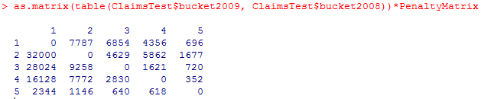

The **penalty error** is the average penalty over the observations. First multiply the classification matrix (after converted from table form to matrix form) by the penalty matrix pointwise, then sum the entries, then divide by the number of observations in the test set.



So our objective is to create a CART model that has an accuracy higher than 68.38% and a penalty error lower than 73.86%.

Let's do that:

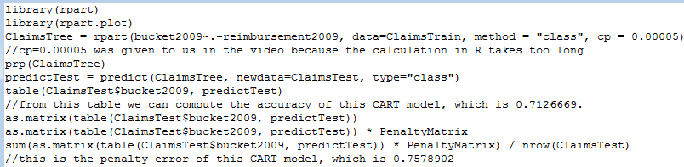

So our accuracy went up, but so did our penalty error. Why? By default rpart tries to maximize overall accuracy and every error is seen as having a penalty of one. How can we change this to decrease penalty error?

We can specify an extra parameter in rpart() called **loss**, which is the penalty matrix: **parms = list(loss=PenaltyMatrix)**. Now the errors are no longer equally weighted; rpart() tries to create a tree that minimizes the worst types of errors, even if the total number of errors goes up (and therefore accuracy goes down) and therefore chooses different splits. As a result we will most likely have a decreased overall accuracy, but the penalty error goes down too. In this case doing so gives an accuracy of 0.6473 and a penalty error of 0.642, so both indeed decreased.

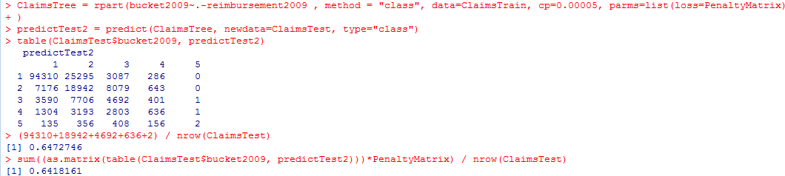

_____________________________________________________________________________________

Boston Housing Data

So far we've talked about classification trees, whereby the output at each leaf is a factor/category (e.g. 0 or 1 in the Stevens case). Like classification trees, **regression trees** can capture non-linearities that linear regression can't. Trees can be used for regression, whereby the output at each leaf is not a factor/category but instead a number corresponding to the proportion of times an outcome occurs. So if the outcome is True 15 times and False 5 times then at that leaf we have 15/(5+15) = 0.75, rather than just assigning the majority of "True" or "1" to that leaf (I think). If we use the default threshold of 0.5 then the value at that leaf would be True (bringing us back to the classification tree case?).

With regression trees we have **continuous variables**, so at each leaf we predict the average of the values of that leaf; so if we have 3,4,5 at a leaf then we predict 4.

Let's try to explain the above. As we can see below linear regression is not a good fit. However, we can see the data fits into three groups and there is very different behaviour in each group. Regression trees can fit this well by applying a different regression model to each of the three groups, using splits of x<10, 10<x<20, x>20 and the prediction at each leaf would be the average y-value of the points in that group.

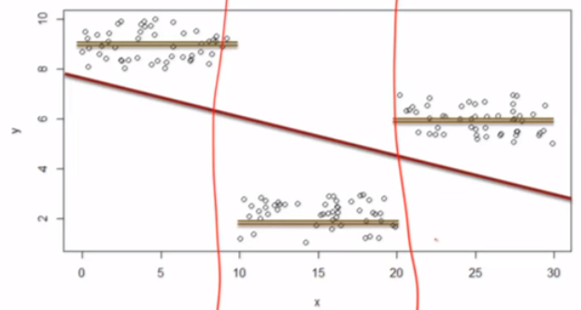

For our boston.csv dataset:

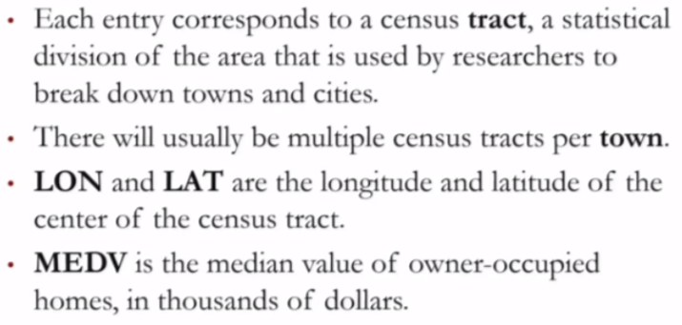

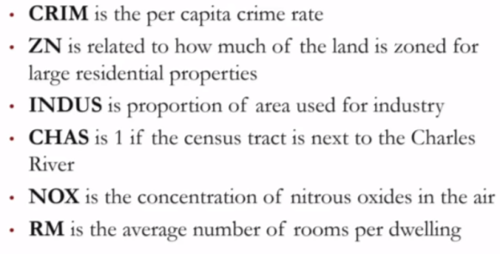

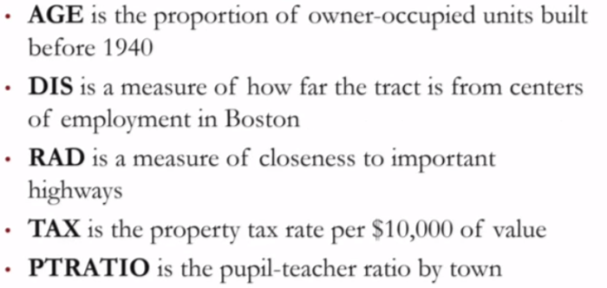

We start by plotting the physical location of the points on a map using LON and LAT:

plot(boston$LON, boston$LAT)

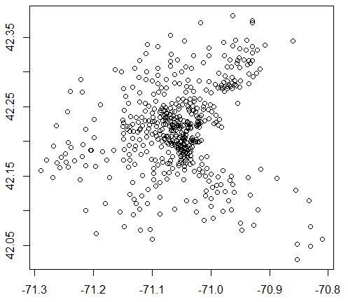

Suppose we have an existing plot(x,y) where x=c(1,2,3) and y=c(2,4,6) and we want to take a subset of the x-values and a subset of the y-values to make some new points. It is therefore necessary that the subsets are of the same size. We can use the **points()** function and choose our subsets using vectors whose inputs are of type TRUE/FALSE, where the TRUE values are the one to be included in the subset.

plot(x,y)

z=c[5,5,13]

points(x[c(FALSE, TRUE, TRUE)], y[z==5])

So both c(FALSE,TRUE,TRUE) and [z==5] return TRUE twice and the new points added to the plot would be (2,2) and (3,4). This is because x[c(FALSE,TRUE,TRUE] returns 2, 3 and z==5 returns TRUE, TRUE, FALSE and so y[c(TRUE,TRUE,FALSE] returns 2, 4.

Now suppose we want to **add colors to a subset of points on an existing plot**. In this case we want to show all the points along the Charles River, using the CHAS variable. We do that in the next line in R using **points():**

points(boston$LON[boston$CHAS==1], boston$LAT[boston$CHAS==1], col="red", pch=19).

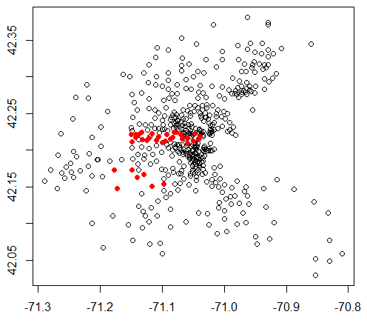

**pch=19**tells the plot to fill the corresponding plot points in. Without this argument the points remain hollow circles, and by changing the 19 to other values we get different types of fills, like + symbols for example; 19 seems the best one.

The teacher tells us the census tract for MIT is 3531, so we can again use points(boston$LON[boston$TRACT==3531], boston$LON[boston$TRACT==3531], col="blue", pch=19)

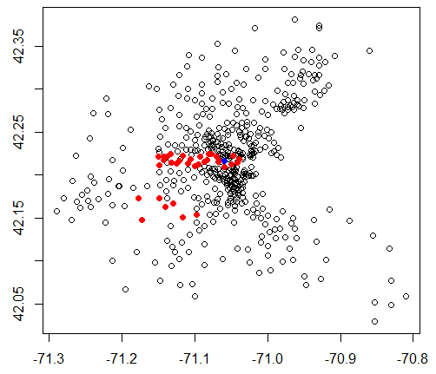

For the next variable of interest NOX, which is a measure of air pollution, we see that it is not binary but rather has decimals. Looking at its summary we find it had a mean of about 0.55 so we add

points(boston$LON[boston$NOX >=0.55], boston$LAT[boston$NOX>=0.55], col = "green", pch=19)

to get an idea of where the pollution is worse than average:

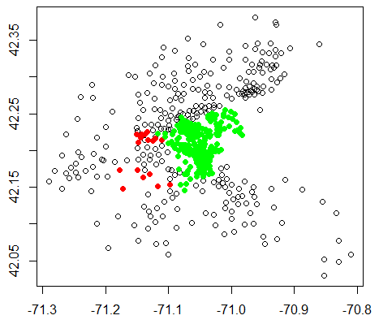

Now using summary we find that the median value of MEDV, which is the median home value in $ in a given tract, is 21.2. So resetting our plot and looking at the points with MEDV>=21.2:

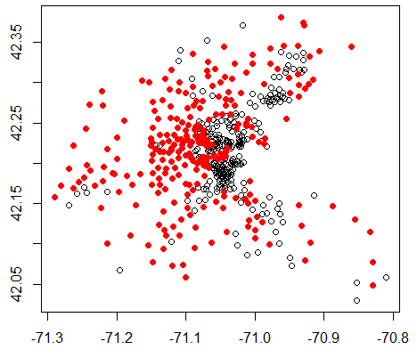

We see that housing prices are distributed in a non-linear way, which makes sense, as we would not expect it to be linearly correlated with longitude and latitude. We can develop this intuition more by plotting the relationship between MEDV and LONG + LAT by defining latlonlm=lm(MEDV~LAT+LON, data=boston).

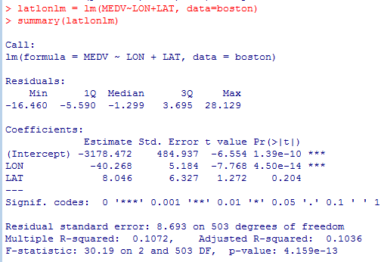

We see the R2 value is weak. Also LON is significant but its coefficient is negative which suggests that as we travel east, towards the ocean, housing prices decrease linearly, which seems unrealistic.

If we want to show the values predicted by a linear regression model on each of the observations we can write **linearregressionomodelname$fitted.values.** It is the same as predict(linearregressionmodelname).

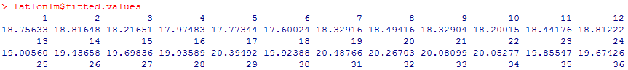

(The table continues until the 506th observation, which is nrow(boston).)

So suppose now we want to compare these predictions to the actual MEDV values. I will use predict(latlonlm) instead of latlonlm$fitted.values:

points=(boston$LON[predict(latlonlm)>=21.2], boston$LAT[predict(latlonlm)>=21.2], col = "blue", pch = "$").

Notice **pch = "$"**. We can type any symbol in place of $, but we choose $ because we are talking about prices. The reason we did this instead of pch=19 is because pch = 19 would merely overwrite the red circles with blue ones, but we want to see how the predictions compare to the actual values.

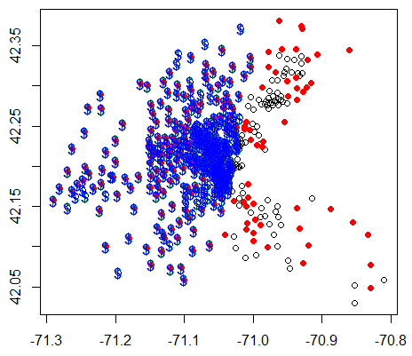

Not surprisingly this is quite inaccurate. For example it predicts a lot of blue in the center even though we saw there wasn't much red there. It also ignores everything to the right of the picture.

Now let's try instead to use a regression tree:

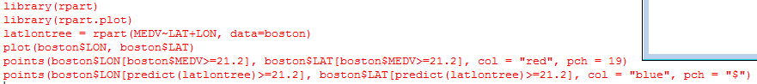

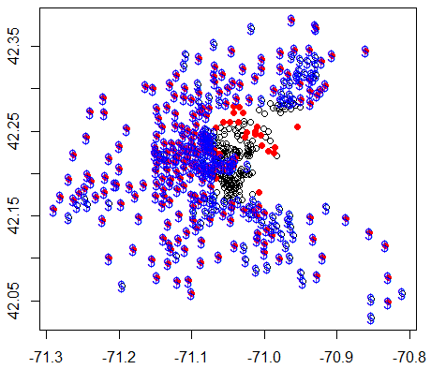 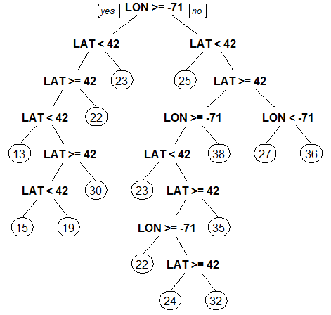



On the right is what we get from prp(latlontree); the leaves represent the mean values of MEDV along those paths. Notice in this example we didn't specify minbucket in the definition of latlontree; if we do we get a different tree, so I'm not sure if there is a default value for minbucket or what.

We see in our graph that our regression tree model latlontree has done a much better job of predicting MEDV based on LON and LAT than our linear regression model latlonlm did. The latlontree model correctly left out the lower part of the black cluster and it correctly predicted many more of the points to the right side of the graph.

This is good, but the tree is complicated, which suggests over-fitting. Can we create a model with most of this effect but with a simpler tree? Yes, by changing the minbucket size to 50.

Now look what happens if we enter our new tree prp(latlontree2):

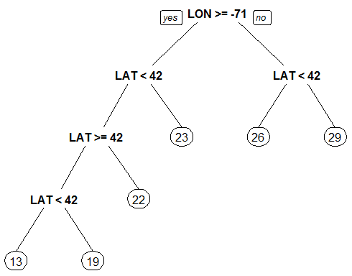

We have a smaller tree. However, the labels at the splits are not ideal; they seem to offer contradictions due to rounding errors. So we can plot our tree in a different way that includes decimals:

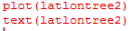 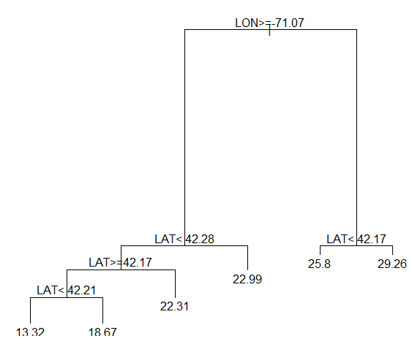

Then we can use these splits and the abline() command to divide up our LON/LAT plot according to our splits. However we will focus on the lowest MEDV of 13.32 in this case, which occurs in the bottom left of the above tree and corresponds to LON>=-71.07, 42.17<=LAT<42.21.

**Add a horizontal line** at y = k to a **plot** that is already open: abline(h=k)

**Add vertical line** at x = k to a **plot** that is already open: abline(h=k)

abline(v = -71.07)

abline(h = 42.17)

abline(h = 42.21)

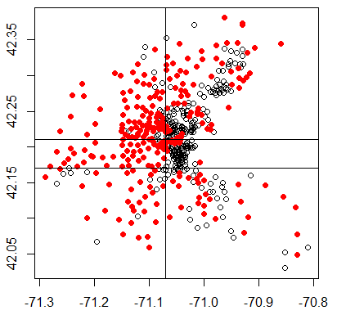

The rectangle in question with the 13.32 average MEDV is in the second row and second column, which is promising, as the red dots are the ones which correspond to more expensive housing and we see fewer red dots here.

Note that when creating a model and we want to use **-variable** to remove an independent variable from the full list rather typing out all the other independent variables manually, we might run into problems when applying to the test set. If the test set has new levels not seen in the training set then this can happen. Notice there is no the first time we run linreg.pred but there is the second.

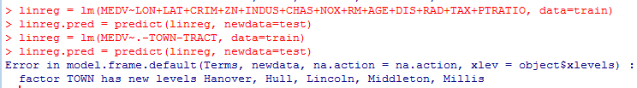

Now using the linreg model as well as a regression tree model we find:

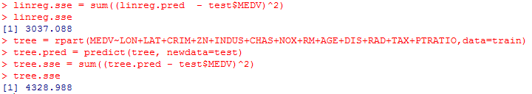

So we see that a linear regression tree actually does better than a regression tree on the test set. (**To give an idea of the accuracy of the model we are here using SSE rather than a confusion matrix because we are dealing with continuous variables in a regression tree whereas in the classification tree case we were dealing with categorical variables. So regression trees and linear regression use SSE; classification trees and logistic regression use a confusion matrix. For regression trees the cp value is determined by train() using the smallest RMSE, as it will say when you output train().)**

When we have too many splits in the tree it is bad for generalization (performance on the test set), so we should penalize the complexity (cp). Just like minbucket, **small values of cp encourage large trees and large values encourage small trees**.

Define: (it seems like this stuff is not as important, but more theoretical).

**RSS = sum ( yi - f(xi) )^2** to be the **residual sum of squares**

**lambda**  is the penalty we pay for each additional split

**S** is the number of splits in our tree

We have two competing goals: minimize RSS (which occurs by maximizing S) and minimize complexity (which occurs by minimizing S)

Goal: minimize **sum(RSS at each leaf) + lambda*S**

Note that the number of leaves is S+1.

If we choose a large value for lambda then each split is penalized more heavily, so the ideal number of splits will be smaller. If we choose a small value for lambda (or 0) then we will make splits until it no longer decreases the error.

cp is closely related to lambda.

_________

Note that library(caret) and library(e1071) are used for cross-validation.

Note the complexity parameter (cp) can only be from 0 to 1.

Another way of **writing sequences**:  **(0:10)*0.001** takes each of the numbers from 0 to 10 and multiplies by 0.001. So this is equal to seq(0,0.01, 0.001).

Note that **(0:10)** outputs 0 1 2 3 4 5 6 7 8 9 10.

Once we've defined numFolds, cpGrid and tr = train() we are given our optimal cp value and the bestTree = tr$finalModel creates that tree automatically. (**Note**: I tried using tr$finalModel on a different example and it gave me an error so maybe it's just best to build the CART model manually. Maybe because that was a classification tree and the example below is a regression tree?**)**

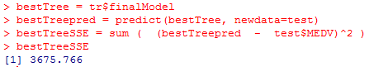

So we originally defined

tree = rpart(MEDV~LON+LAT+CRIM+ZN+INDUS+CHAS+NOX+RM+AGE+DIS+RAD+TAX+PTRATIO,data=train)

and rather than having to retype this with the argument cp = 0.001 after we defined numFolds, cpGrid and tr, we can just define bestTree=tr$finalModel.

**Note about logistic regression when making prediction:** If we write predict(modelname, type="response") without a threshold then we get predictions as probabilities of case y=1 for each of the observations in the relevant data set, but if we just write predict(modelname) then the outputs are the values of the logit for each of the observations.

For CART models method="class" is for classification trees; omit this argument if creating a regression tree.

If we want to add **more decimals to the numbers in our cart tree** we can add the argument **digits = somenumber.**

It seems that the logistic regression function is "linear" because the line y=logit divides the plane into two regions; above this region (when y>logit) we predict y=1 e.g. "poor care", and below this region (when y<1) we predict y=0 e.g. "good care". CART trees on the other-hand divide the plane into multiple regions.

Linear regression is for a continuous dependent variable whereas logistic regression is for a binary dependent variable.

Note when we don't specify minbucket or cp in CART models then R uses default parameters; same if we don't specify ntree or nodesize for random forests.

Random forests are not to help build CART models. Rather, they are an alternative to CART models that often offer a higher accuracy.

Recall that sample.split balances the outcome between the train set and test set.

**Also ask about the problem using MEDV~.-TOWN-TRACT when it wouldn't work on the test set, on p51 of this document. Try redoing this example first.**

Skipped optional assignment at end of UNIT 4.

____________________________________________________________________________________

Unit 5

For this unit we want to look at the commands in the script file rather than in the videos because R was updated since the videos were made and the script file gives these changes.

Until now we have seen data that is structural/numerical/categorical. Now we want to deal with information from tweets on Twitter, where information is loosely structured, textual, poor grammar, different languages, etc. Computers need to understand **text**, and this is done by **Natural Language Processing**. The goal is to understand and derive meaning from human language.

Apple has fans and haters. They want to monitor tweets about Apple, and we want to see if we can correctly classify tweets as positive, negative or neither about Apple using Twitter data (which is publicly available). How do we construct the outcome variable for a tweet given that two people may disagree on whether a particular tweet is +, -, or neutral? One method is using the **Amazon Mechanical Turk**. This means tasks are broken down into small components which are then distributed online; people can sign up to perform the tasks for a fee, e.g. receive $0.02 for each tweet they classify, and AMT takes a small cut.

The task that we put on AMT was to *"Judge the sentiment expressed by the following item toward Apple."* A list of numerous tweets was given to 5 different workers, who were to score each among -2, -1, 0,1,2 where -2 is highly against Apple and 2 is highly in favor of Apple. The score for each tweet is the average of the 5 scores and the following shows the histogram of the scores.

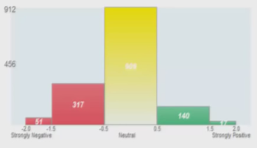

In this lecture we will use a technique called **bag of words** to build **text analytic models**. Fully understanding text is difficult, but bag of words provides a simple approach: it merely treats **each word as an independent variable that counts the number of occurrences of that word in a message**. However, preprocessing the text can dramatically improve performance of the bag of words method.

Some preprocessing steps:

* Cleaning up irregularities 1) Text data often has inconsistencies that will cause algorithms trouble because computers are literal by default. It will for example consider Apple, ApPlE and APPLE all different, so one solution is to either convert all letters to uppercase or all letters to lowercase. We typically choose lowercase, and so Apple, ApPlE and APPLE will all become apple.
* Cleaning up irregularities 2) Punctuation is a problem, and one standard method is to remove all punctuation that isn't a number or letter. However, sometimes punctuation is meaningful, like @apple is a message tweeted to Apple and #apple is a message tweeted about Apple. So we should tailor it to our specific example. In our case we will remove all punctuation, so @Apple, Apple!, --Apple-- could is each considered apple.
* Remove unhelpful terms; many words are often used but are only meaningful in a sentence, called **stop words**. E.g. the, is, which, at, who are examples of words that are unlikely to improve the algorithm and their removal decreases the size of the data at hand. However, we need to be careful because sometimes such words can take on different meanings in pairs, such as "The Who"; if we removed 'the' and 'who' then we can no longer talk about the band The Who. Or "take that" would become just "take", which is not the same.
* **Stemming**: represent words with the same ending as the same word. E.g. argue, argued, arguing, argues could all be represented by the common stem argu. One approach is to build a database of words and their stems. Pro: handles exceptions well; Con: won't handle new words, which is bad for use on the internet. Another approach is to build a rule-based algorithm, such as one that automatically deletes certain suffixes like -ed or -ly or -ing. Pro: handles new words well; Con: misses exceptions like children/child if we remove suffixes of -s for plurality.

Preprocessing data can be difficult, but R's packages provide easy-to-use functions for the most common tasks.

**Important note:** when working on a text analytic problem we always need an extra argument when using the read.csv function so that the text is read properly, namely **stringsAsFactors = FALSE**. So for our tweets.csv file we enter tweets=read.csv("tweets.csv", stringsAsFactors=FALSE). We can see in str() that without this argument the text variables are of type Factor, but with it they are of type chr. Avg is the average sentiment score and is the dependent variable here.

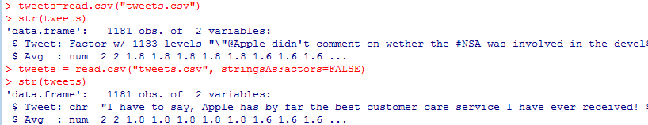

In our example we want to find tweets with negative sentiment of less than or equal to -1, so we define a new variable tweets$Negative = as.factor(tweets$Avg <= -1). Note that **we put as.factor** because we want our variable stored as factors rather than as logicals.

Now to **preprocess our data** so that we can **use the bag of words approach** we need the tm text mining package, so library(tm), as well as SnowballC to help it, so **library(SnowballC)**.

One of the concepts introduced by the tm package is a **corpus**, which is a structured set of documents. (in our case, tweets). We need to convert our tweets to a corpus for preprocessing; tm can do this in many ways, but we'll do it from the Tweet column using the functions **VCorpus()** and **VectorSource:**

corpus = VCorpus(VectorSource(tweets$Tweet))

If we input corpus it tells us how many documents there are. If we want to see what a specific slot in corpus says we can enter corpus[[slot#]]$content, e.g. corpus[[1]]$content.

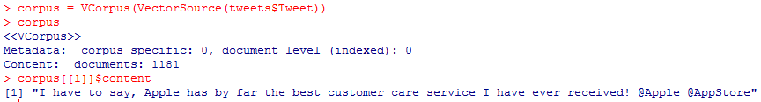

Now we're ready to start preprocessing our data, which we can do using the **tm_map()** function.

* To make all text in lowercase:

corpus = tm_map(corpus, content_transformer(tolower))

* To remove punctuaction:

corpus = tm_map(corpus, removePunctuation)

* To remove stop words:

corpus = tm_map(corpus, removeWords, c("apple", stopwords("english")))

* To stem:

corpus = tm_map(corpus, stemDocument)

Note that R comes with a list of 174 standard English stop words which we can access using stopwords("english")



...

In our remove stop words bullet above we also added in "apple" because in this particular example it probably isn't an important word for predicting the quality of Apple.

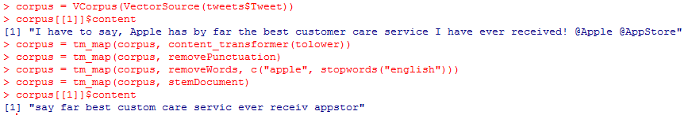

(Note for a matrix M that **M[3:5, 2:4]** would output a matrix that takes the intersection of rows 3-5 and columns 2-4, that is entries 3/2, 3/3, 3/4, 4/2, 4/3, 4/4, 5/2, 5/3, 5/4 from M.)

(Note for a data frame df that **colnames(df)** outputs a list of the column names of df.)

We've now preprocessed our data and are ready to extract the word frequencies to be used in our data. The tm package provides a function called **DocumentTermMatrix()** that generates a matrix from a corpus whose rows correspond to documents (tweets) and each column (term) is a word in those documents. The values in the matrix are the frequencies of each word in each document.

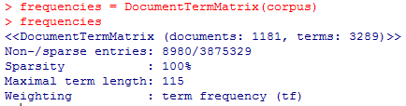

We see above there are 1181 tweets with a total of 3289 different words among them. If we want to access the matrix in matrix form we need to use the **inspect()** function, say inspect(frequencies[1000:1005, 505:515]) which takes rows 1000-1005 and columns 505-515 from the frequencies matrix (because the entire frequencies matrix would be too large).

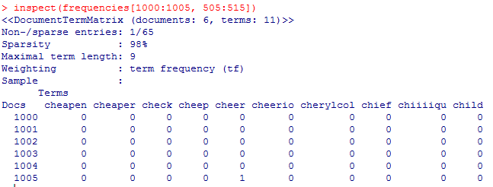

If we just input frequencies[1000:1005, 505:515] the above would output but without the matrix at the bottom. This data is **sparse**, meaning there are many 0's in the matrix.

Now we want to find the frequent terms amongst our entire frequencies matrix, which is found using findFreqTerms(matrixname, lowfreq = number) in our case findFreqTerms(frequencies, lowfreq=20). This outputs a list of all of the terms from frequencies that appear at total of at least 20 times among the tweets.

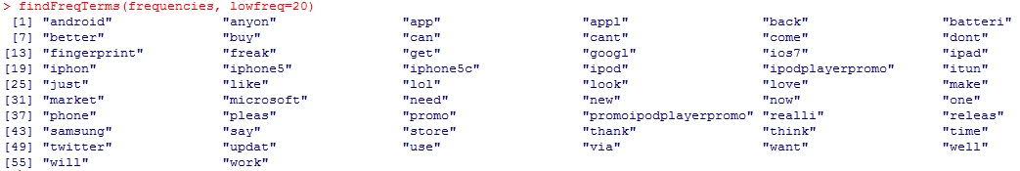

So out of the 3289 words in our 1181 tweets, only 56 appear at least 20 times. So we probably have many terms (independent variables) that will be useless for our prediction model. The number of terms is an issue for two main reasons. More terms means more independent variables, which is more computational complex and therefore it takes longer to build the model. The other, as we have seen, is that if there are too many independent variables relative to observations, then the model doesn't generalize well to new data sets.

So let's remove some terms that don't appear very often. We'll call the output sparse and use the removeSparseTerms() function:

sparse = removeSparseTerms(frequencies, 0.995)

This takes all of the terms from the frequencies matrix and removes all of the ones which don't appear in at least 0.5% of the tweets. In other words, it only keeps the terms which appear in at least (0.5%)*1181 = 5.905 --> 6 tweets. The **sparsity threshold** here is 0.995.

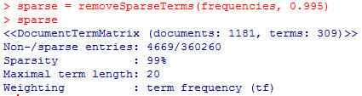

The new matrix sparse has only 309 terms as opposed to 3289 in frequencies.

Now we want to convert our matrix to a data frame so that we can use it to make predictive models:

tweetsSparse = as.data.frame(as.matrix(sparse))

Because R struggles with variable names that start with numbers and we are typically going to have terms that start with numbers, it is **important when we build a data frame using text analytics** to convert the column names to appropriate variable names using **make.names():**

colnames(tweetsSparse) = make.names(colnames(tweetsSparse))

Then we want to add the variable tweetsSparse$Negative = tweets$Negative variable to this data set so we can split our data over this variable using a seed of 123 and a SplitRatio of 0.7.

Now we can use predictive models such as CART and randomForest on tweetsSparse to get predictions of tweetsSparse$Negative from the 309 independent variables. Keep in mind that because text analytics problems typically have so many independent variables (terms) that building a random forest can take a lot more time than building a CART model.

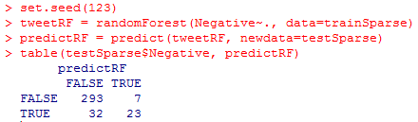

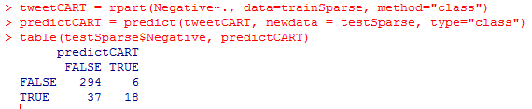

prp(tweetCART)

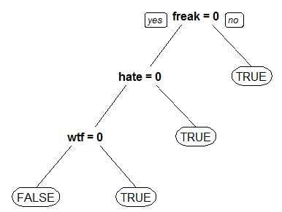

Notice the random forest model is slightly more accurate than the CART model here, but due to the simple interpretability of the CART model it is probably the better model.

So with a bag of words approach and these models we can predict sentiment of tweets even using a relatively small sample of tweets.

____________________________________________________________________________________

IBM's Watson

Watson received the clues in text form and used text analytics and 100+ other analytical techniques to help understand natural language by combining 3000 powerful computers and having a database from a massive number of sources like magazines, Wikipedia, encyclopedias, etc.

One of the tools Watson has is a **lexicon**, which describes the relationships between different words. E.g. "water" is a "clear liquid" but not all "clear liquids" are "water".

Another tool Watson has is a part of speech called **tagger** and **parser**, which identifies functions of words in text, e.g. "race" can be a noun or a verb.

**Parse** means to analyze a sentence into its parts; text semantics.

Using the data sources and tools, Watson would answer a question by going through the following 4 steps:

i) **Question Analysis:** figure out what the question is looking for. This is defined as trying to find the **Lexical Answer Type (LAT)** of the question, the word in the question that specifies the type of answer. E.g. Mozart's last and most powerful symphony shares its name with this planet. E.g. Smaller than only Greenland, it's the world's second largest island. You should be able to replace the answer with the LAT and the sentence would still make sense. The first answer is Jupiter, and the following sentence makes sense: Mozart's last and most powerful symphony shares its name with Jupiter. We can see that sometimes the LAT is very specific like "this planet", and sometimes vague like "it's". If we know the LAT then we know what to look for. However, there are many different possible LATS, and many of the questions have LATS that are not explicit, like "it's". So to enhance the Question Analysis step Watson also performs **relation detection** to find relationships among words, and **decomposition** to split the question into different clues.

ii) **Hypothesis Generation:** use the Question Analysis to produce candidate answers by searching the database. Typically several hundred candidate answers are produced. E.g. "this planet" could generate Jupiter, Earth, Mars... Then each candidate answer is plugged into the question in place of the LAT and is considered a hypothesis. E.g. Hypothesis 1: Mozart's last and most powerful symphony shares its name with Mercury, Hypothesis 2: Mozart's last and most powerful symphony shares its name with Jupiter, etc. If the correct answer is not generated at this stage then Watson has no hope of getting the answer right, so Watson errs on the side of generating a high number of hypotheses, and leaves it up to the next step to find the right answer (among a variety of incorrect answers as well).

iii) **Scoring Hypothesis**: compute a **confidence level** for each hypothesis; Watson needs to accurately estimate the probability of each answer being correct. Watson only buzzes in an answer if its confidence level is above a certain threshold. To compute these confidence levels Watson combines a large number of methods. First, Watson starts with **lightweight scoring algorithms** (there are many) to prune down a large set of hypotheses by removing the unlikely ones; about 100 hypotheses make it past this step and are then passed to the next stage. Then Watson moves on to **more advanced** **scoring analytics**, whereby it first needs to **gather supporting evidence** for each candidate answer which it can then analyze. One way of gathering evidence is through **passage search**, where Watson retrieves passages that contain text from the hypothesis. E.g. if we enter "Mozart symphony mercury" into Google we get 900k results, and some are decent, but 'Mercury' is next to 'symphony' only once and there is no mention of it being his 'last' symphony. If we enter "Mozart symphony Jupiter" we get 1.5m results, we see 'last symphony'. (So the hypothesis with Jupiter seems to be more supported.) Then all of the evidence is scored using scoring analytics with **more than 50 different scoring components/algorithms**. One is **temporal relationships**, e.g. "In 1594 he took a job as a tax collector in Andalusia". If there are two candidate answers Thoreau and Cervantes, then given that Thoreau was not born until 1817, we can be more confident about Cervantes.

iv) **Final Merging and Ranking:** Once all of the scoring algorithms are run we need to select the single best supported hypothesis. Before this can be done, equivalent candidate answers need to be merged, e.g. "Abraham Lincoln" and "Honest Abe", so their scores need to be combined; Watson should not view similar answers as competing choices. Now Watson is ready to rank the hypotheses and estimate a final confidence for each using predictive analytics. Logistic regression is used; training data is historical Jeopardy! questions; each of the scoring algorithms is an independent variable; predict probability of being correct for each of the hypotheses; if the confidence for the best hypothesis is above a certain threshold then buzz in with that answer.

_____________________________________________________________________________________

Enron

We will look at how to use the text of emails of Enron executives to predict if those emails are relevant to an investigation into the company.

In the recitation we will talk about **predictive coding**, an emerging use of text analytics in the area of criminal justice.

Enron was a US energy company whose market capitalization exceeded $60billion until its widespread accounting fraud was exposed in 2001, which led to its bankruptcy. Enron is a symbol of corporate greed and corruption.

The **eDiscovery problem**: In law, this refers to how we find files relevant to a particular lawsuit when there are many to choose from. Relevant files are called **responsive documents**. Traditionally this problem was solved using keyword search, followed by an expensive/time-consuming manual review of all the documents to determine which are responsive. **Predictive coding** is a new technique in which attorneys manually label some documents and then use text analytic models trained on these documents to predict which of the remaining documents are responsive.

The Federal Energy Regulatory Crisis (FERC) investigated Enron's involvement in California's frequent blackouts in 2000-2001, despite California having many power plants. The FERC will be our focus for this recitation, as it has released >600k emails from Enron, which we will use as our dataset. Our dataset has just two fields:

i) email: text of the message in question

ii) responsive: does the email relate to energy schedules or bids?

The labels of these emails were made by attorneys. So the words in all the emails, after preprocessed, make up the independent variables to predict the outcome variable responsive.

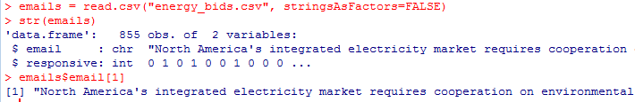...

Note that emails$email[1] continues on to the right, which is an inconvenient way to read a long message. To fix this we can use the **strwrap()** function:



...

This email seems not to be related to energy schedules or bids so it is not responsive to our query, so its responsive variable is 0.

If we repeat strwrap(emails$email[2]) we find an email that is mostly the names of people that the email is forwarded to, followed by a pdf attachment at the end. While our data set contains only the text of the emails, not the attachments, as it turns out this pdf had to do with Enron's electricity bids in California and so the lawyer valued its responsive variable as 1.

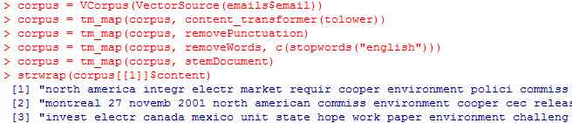

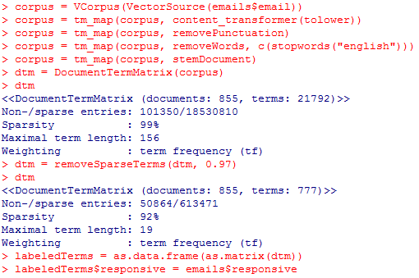

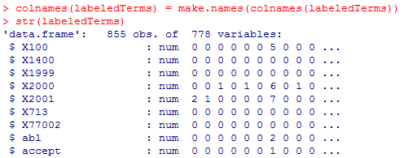

...

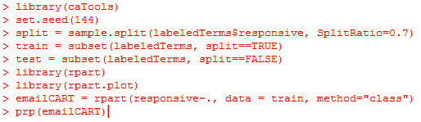

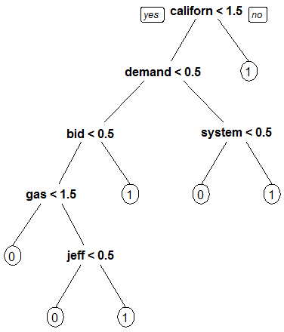

Note that for an object of type predict for a CART model for probabilities, say predCART = predict(emailCART, newdata=test), that predCART outputs two columns, headed by 0 and 1, with a probability for both for each observation in test. If we want to access rows 5 to 12 from predCART then we use predCART[5:12,] and the comma means that we use all (both) columns; if we want to access just one column, say the second one, but use all rows (observations) then we use predCART[,2]. When computing our confusion matrix using table() we want to use the second column, predCART[,2] because this gives us the probability that we predict outcome 1. (If we instead used predCART[,1] then FALSE in the confusion matrix would correspond to a prediction of 1, and TRUE would correspond to a prediction of 0, which is the reverse of our usual convention.)

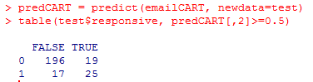

This model has an accuracy of 0.8599 on the test set and the baseline model has an accuracy of 0.8366. After this has been done the lawyers are still going to manually look through each of the documents/emails that were predicted as responsive, so the FP's will cause a bit of extra work but will ultimately be correctly identified. However, the FN's will go undetected, and therefore they will assign a higher penalty to a FN than to a FP.

Now the ROC curve to understand the performance of our model at different cutoffs:

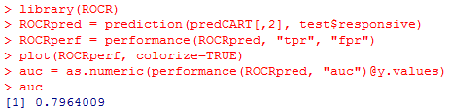

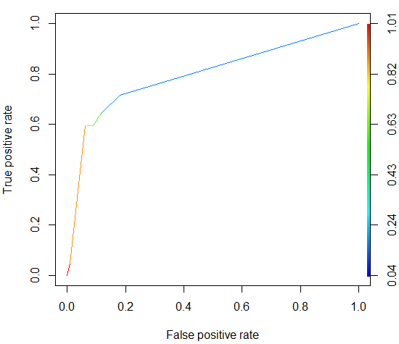

In this example we want a high true positive rate as this means correctly identifying a high proportion of the responsive documents. We don't want to make the false positive rate too high because there are so many documents and this means a lot of extra work. So a good threshold looks like it might be around t=0.15, much smaller than our original t=0.5 above, which makes sense; this means we will predict responsive more often and so have less FN's but more FP's. That auc=0.7964 means that our model can correctly differentiate between a randomly selected responsive and non-responsive document 79.64% of the time.

Suppose we want to add a specific letter, say A, to the beginning of each variable name in a data frame, say wordsAdded. Then we can write colnames(wordsAdded) = paste("A", colnames(wordsAdded)).

However, this leaves a space between the A and the names; if we don't want a space we can use **paste0** instead.

Recall before that the **rbind()** function is to combine two data frames that have the **same variables** but **different sets of observations** (the **'r'** is for **rows**; we are stacking one set of rows below another set of rows in the data frame). Now we introduce the **cbind()** function which combines two data frames that have **different variables** but the **same # of observations** (the **'c'** is for **columns**; we are placing columns beside another set of columns in the data frame). We learned about paste() because in a specific example we had two data frames created from DocumentTermMatrix() which had the same number of observations and we wanted to put them together, but because some independent variable names (i.e. terms) may have existed in both data frames and we wanted to distinguish them, we added "A" in front of each of the terms in one data frame and "R" in front of the other.

The **grepl()** function is for deciding whether or not a string exists as a substring of another string. So grepl("why", "why not?", fixed=TRUE) returns TRUE and grepl("why", "whi not?", fixed=TRUE) returns FALSE.

The ifelse(expression, a, b) takes a logical vector 'expression' and outputs number 'a' each time expression is TRUE and number 'b' each time expression if FALSE, e.g. ifelse(c(TRUE, FALSE, TRUE), 0.2, 0.5) returns 0.2 0.5 0.2. If we instead want it to output strings we could put quotations around a and b, e.g. ifelse(TRUE, "a", "b") outputs "a".

For a matrix M **rowSums(M)** outputs the sums of each row; **colSums(M)** outputs the column sums.

**nchar()** counts the number of characters in a piece of text; e.g. nchar("dnms") outputs 4; nchar(c("sjh", "skjl", "k7d")) outputs 3 4 3.

Note:

* **RANDOM FOREST predictions** are by default class predictions without adding extra arguments so if we want to make probability predictions for each class we add the argument **type = "prob"** into the predict() function; we can put pred = predict(modelname, type="prob")[,2] if we want the probabilities for the second column only (which is typically the case in binary situations, where we want the outcome variable to be equal to 1 rather than 0). We can also write pred=predict(modelname, type="prob") and then take pred[,2].
* **CART predictions** are the opposite; they are by default probability predictions without adding extra arguments so if we want to make class predictions we add the argument **type = "class"** into the predict() function; we can put pred = predict(modelname)[,2] if we want the probabilities for the second column only (which is typically the case in binary cases, where we want the outcome variable to be equal to 1 rather than 0). We can also write pred=predict(modelname)and then take pred[,2].
* **LOGISTIC REGRESSION predictions** by default output the value of the logit without adding extra arguments so if we want to make probability predictions we add the argument **type = "response"** into the predict() function.

A good **indication of overfitting** is when the accuracy and AUC are near-perfect on the training set but far from it on a test set. If a model has similar accuracies and AUCs between both its training set and test set then this is an indication of a good model.

I skipped the optional assignment at the end of Unit 5. This assignment uses commands from the assignment before it, which I have saved in a script file called Unit5_Assignment3.R in the usual R-3.4.1 folder.

_____________________________________________________________________________________

Unit 6

Netflix provided 100m data points for the training data and 3m for the test set. They were offering a 1m$ prize to anyone who could come up with an algorithm for Netflix recommendations that beat their own by at least 10%, as measured by RMSE.

Two main types of data:

i) Each movie in has a rating based on all users who have rated it.

ii) Facts about the movie itself, actors, director, years released, etc.

**Collaborative filtering** is a technique that the Netflix recommendation system uses, and it works by using other users' ratings to make predictions. E.g. if Carl and Amy have rated certain movies similarly and Amy rates a movie that Carl hasn't seen as a 5, then the system might recommend that movie to Carl, because they seem to have similar tastes. Here we didn't use any movie facts. This method can accurately suggest complex items without understanding the nature of the items (e.g. that they are movies). However, it requires a lot of data and computing power.

Or we could use movie information. For example if Amy ranks a movie with a certain director, genre, actor, etc. highly, then the system could recommend another movie that has similar criteria. Here we are not using the ratings of other users. This technique is called **content filtering**. It requires little data but is limited in scope; you're only recommending similar things to the user has already liked.

Netflix uses a **hybrid recommendation system**, which combines both collaborative and content filtering. For example if we already determined that Amy and Carl have similar preferences from collaborative filtering and they have both liked 'Terminator', then we can apply content filtering to recommend 'Starship Troopers' for them both even though neither has seen it before. If we were only doing collaborative filtering, then one of them would have had to have seen it before; if we were only doing content filtering, then we would only be recommending to one user at a time.

_____________________________________________________________________________________

MovieLens

We use data from MovieLens.org, a movie recommendation website. They collect user preferences about movies and do collaborative filtering to make recommendations based on the similarities between users. We will use their movie database to do content filtering using a technique called **clustering**. Movies in the MovieLens data set are categorized as belonging to different genres (action, drama, etc.) and each movie may belong to many genres.

Question: Can we systematically find groups of movies with similar sets of genres? To answer this we use **clustering**, which is different from the other analytics methods we've used so far. It is an **unsupervised learning** method, which means that the goal is to segment each of the data points into a group with similar values in the data; it doesn't make predictions. However, clustering can be used to improve predictions by building a predictive model on each of the cluster groups; be careful not to over-fit your model to the training set; works better for larger data sets.

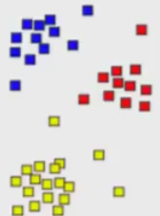

There are many different algorithms for clustering which differ what makes a cluster and how clusters are found. In this class we will cover **hierarchical clustering** and **K-means clustering,** two of the most popular methods. To cluster points we need to compute how similar they are, which is done by computing the distance between them.

The most popular way to computer **distance between points i and j** and the method we will use is by using the euclidean distance:

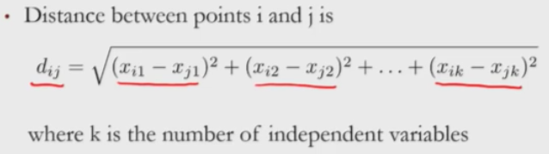

The xi1 etc. are the independent variables.

We also want to define the **distance between two clusters.** This can be done using the **minimum distance**, which is the euclidean distance between their two closest data points.

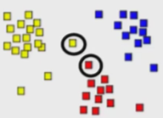

We could also use the **maximum distance**.

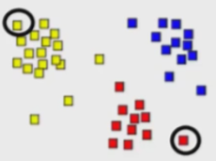

The most common metric for **distance between two clusters** and the one we will be using is called **centroid distance.** This first computes the **centroid** of each cluster, which means the data point that is the average of all data points in that cluster (average component-wise); the centroid can be thought of as the middle point. Then it computes distance between centroids.

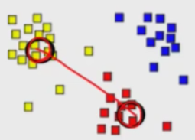

When computing distances it is highly influenced by the scale of the variables. For example if computing the distance between two points where one variable is in the thousands and the other is in the tens, then the thousands variable will dominate in the distance calculation. Therefore it is typical to **normalize** the data first, by subtracting the mean of that variable and dividing by its standard deviation.

**Hierarchical clustering:** Each data point starts in its own cluster. Then the two nearest clusters are combined into one cluster using euclidean distance between centroids. We repeat this process until all the points are in one cluster.

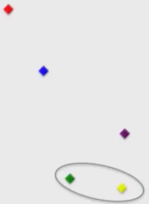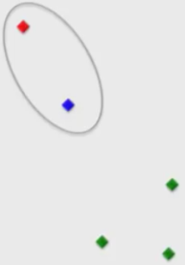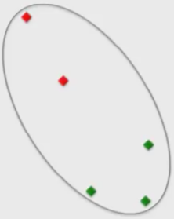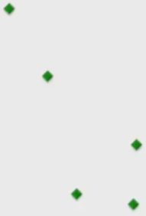

The hierarchical clustering process can be displayed through a **cluster** **dendrogram:**

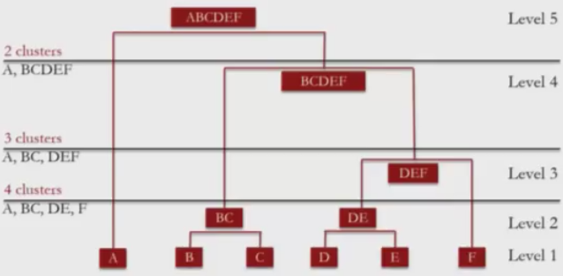

The lowest row represents the data points (initial clusters) and the remaining represent the clusters that are built along the way. The length of the vertical lines depict the distance between a child cluster and its parent cluster. The longer a vertical line the more dissimilar a child is to its parent; this is because they have a larger distance (i.e. their observations differ more in their variable values). Above we see that DEF is closer to its parent BCDEF than BC is. This is because the centroid of DEF is an average of three data points whereas the centroid of BC is of only two, and so when computing the centroid of BCDEF the points D,E,F contribute more to the new average than B,C. Cutting the dendrogram at a given level yields a certain partitioning of the data. E.g. if we cut through Level 4 and Level 3 we get A, BC, DEF. If we cut through Level 3 and Level 2 we get A, BC, DE, F. If we cut through Level 5 and Level 4 we get A, BCDEF. The smaller the number of clusters the coarser the clustering is; but having a larger number of clusters may spread the data too thinly. We should have this trade-off in mind when deciding how many clusters we want. A good partition belongs to a cut that has enough room to move up and down without crossing over any horizontal lines. In this example it looks like 3 clusters might be a good pick. (Keep in mind though that we should also take into consideration the particular application at hand when deciding number of clusters.)

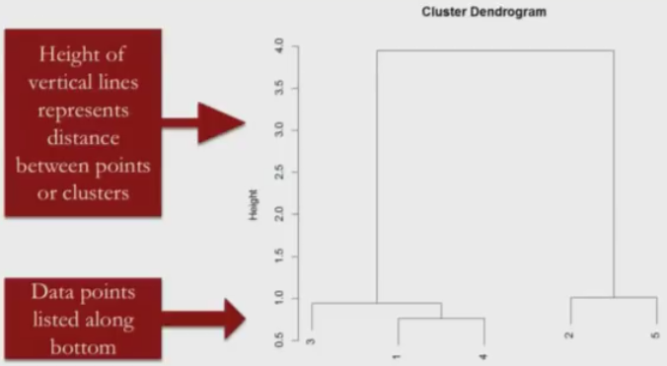

The length of a vertical line (the difference in y-coordinates between its top point and bottom point) represents how far apart a child cluster is to its parent cluster.

The lines show how the clusters were combined.

We can use a dendrogram to decide how many clusters we want for our model. The easiest way is to draw a horizontal line across the dendrogram; the number of vertical lines it passes through is the number of clusters there will be. In the 2 clusters example below the clusters consist of 5,2,7 in one and 1,3,4,6,8,9,10 in the other. This is because these are the clusters at the bottom of the two vertical lines. The farther the horizontal line can move up and down in the dendrogram without crossing another horizontal line the better. This is because this represents a larger distance between clusters, resulting in clusters that are more significantly different from each other. In this example we can see the 2 cluster choice is better than 3. However, when deciding how many clusters we also want to keep the specific application in mind.

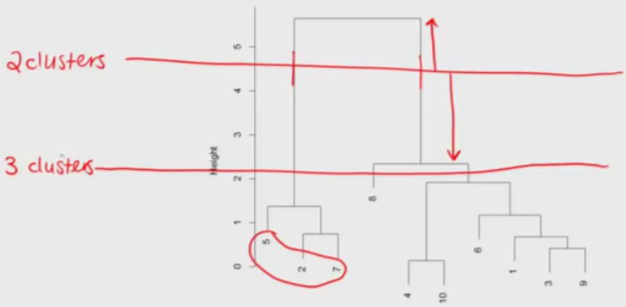

In video 6 we were sent to a link from movielens that has 1682 observations of data, and we copied and pasted this into Notepad and saved it as movieLens.txt, which we then load into R.



...

However, our file is not a .csv file but a .txt file, where entries are separated by a vertical bar, so we load it differently:

**movies = read.table("movieLens.txt", header = FALSE, sep = "|", quote = "\"")**

* header=FALSE because our data doesn't have a header/variable name row.
* sep = "|" note this is the vertical bar, not a lowercase L.
* quote = "\"" makes sure our text is read in properly.

Because our variables don't have names (header=FALSE) R just labels them V1, V2, etc.

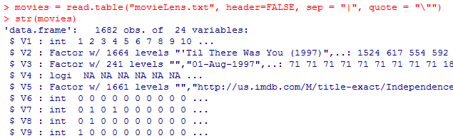

...down to V24

But because we know the variable names from the .txt file we can add in the names manually:

colnames(movies) = c("ID", "Title", "ReleaseDate", "VideoReleaseDate", "IMDB", "Unknown", "Action", "Adventure", "Animation", "Childrens", "Comedy", "Crime", "Documentary", "Drama", "Fantasy", "FilmNoir", "Horror", "Musical", "Mystery", "Romance", "SciFi", "Thriller", "War", "Western")

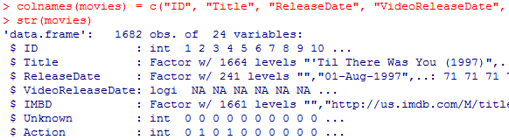

...

If we want to **remove a variable from a dataset** we can write dataset$variable = NULL. In this example we won't be using ID, ReleaseDate, VideoReleaseDate or IMDB variables so we remove them.

There are now a few **duplicate entries** in our data set (because variables were removed? Maybe some of the observations in the original data set were different only in a subset of the removed variables so that when removed they were no longer different), so we want to remove them using movies=unique(movies). So now we have a data frame with 1664 observations, 20 variables and their appropriate variable names.

(Recall for data frame df that df[3] would output variable 3 with its values over all observations; df[3:6] would do these for each of variables 3 to 6.)

Now we use hierarchical clustering on the movies dataset to cluster by genre, so all remaining variables except for Title, that is, the 2nd through 20th variables

There are two steps to hierarchical clustering:

i) Compute the distance between each of the data points: distances=dist(movies[2:20],method="euclidean"). Note that distances is a matrix with some modifications.

ii)Cluster the movies using hierarchical clustering: clusterMovies = hclust(distances, method = "ward.D")

The ward.D method cares about the distance between clusters using centroid distance, as well as the variance in each of the clusters.

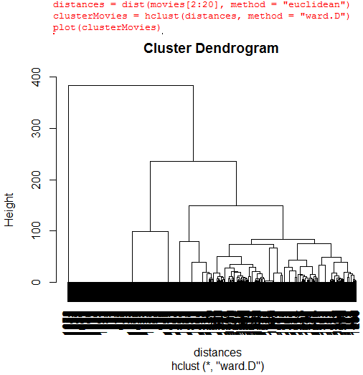

We have all that black at the bottom because there are so many data points. How many clusters would we pick? It looks like 2, 3 or 4 might be good if considering only the method of moving the horizontal line up and down. However, because we are clustering movies by genre, this is probably not enough; we need to keep our specific application in mind. We will instead choose 10.

Now we can label each of our data points according to which cluster it belongs to using

clusterGroups = cutree(clusterMovies, k= 10); the clusterGroups variable just outputs a number from 1 to 10 for each of the observations.

Now we can take a look at what the clusters are like using tapply() on the various variables (genres):



This tells us for each of the 10 cluster groups which proportion of its data points (movies) have the Action label. We can repeat this for each of our 19 genre variables, and then create a table in Excel:

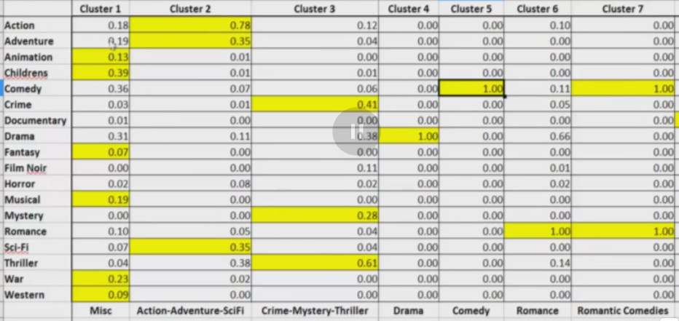

How can these clusters be used in recommending movies? We saw that Amy likes Men In Black so we can figure out what cluster MIB falls into and then recommend other movies in that cluster:

To find which cluster MIB is in: subset(movies, Title == "Men in Black (1997)"), which tells us it's the 257th observation in movies.

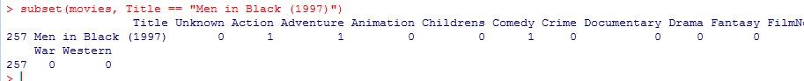

Then find its cluster group by clusterGroups[257], which outputs 2. (The clusterGroups variable just outputs a number from 1 to 10 for each of the observations.)

Then cluster2 = subset(movies, clusterGroups = 2) would be movies we could recommend to Amy given that she likes MIB, also in the second cluster group.

Then cluster2$Title[1:10] to take a look at the first 10 titles in that subset.

_____________________________________________________________________________________

Predictive Analytics in Medicine (Using Clustering Methods for Predicting Heart Attacks

Analytics helps understand patterns of heart attacks and provides good predictions that lead to improved monitoring and taking action early and effectively. Here we use claims data which talks about many factors, such as various other diseases and hospital visits and medical costs to predict heart attacks ; examine 9 months of diagnostic history leading up to a heart attack/no heart attack event, splitting the 9 months into 3 months before, 6 months before and 9 months before.

The **Random Forest** algorithm is known for its attractive property of detecting variable interactions and excellent performance as a learning algorithm.

We use medical costs as a measure of a person's health (lower cost means more healthy). Patients are divided into 3 cost buckets: <$2k, $2k-$10k, >$10k; we are trying to predict whether or not a person will have a heart attack. Initially each bucket is split 50:50 between training and testing data and then its own random forest is built and tested on its test set, giving an accuracy for each of its cost buckets (so 3 random forests total). Below is repeated for each of the 3 cost buckets:

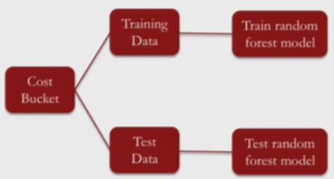

However, patients in each cost bucket may have different characteristics, so we can furthermore divide the buckets into clusters to **cluster-then-predict:**

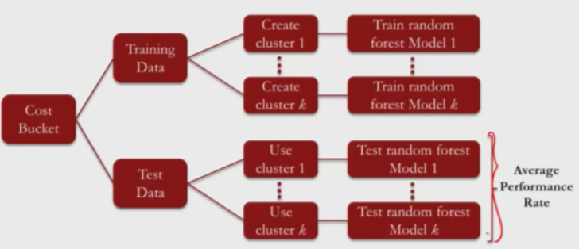

Performance is measured as the weighted (by #observations) average performance over the k random forest models on their corresponding clusters.

**Clustering is** **mostly used** in the absence of a target variable to search for relationships among independent variables/to organize data into meaningful groups. Here, although our target variable is specified (whether or not a heart attack will occur), there are many different trajectories that lead to a heart attack; there are many different dynamic health patterns that lead to one.

As an alternative to hierarchical clustering here we use

**k-means clustering**:

* Step 1: decide on the number of clusters, called k
* Step 2: randomly assign each data point to a cluster
* Step 3: compute the centroid of each cluster
* Step 4: reassign each data point to the cluster with the closest centroid
* Step 5: repeat Step 3 and Step 4 until no more changes occur

E.g. here k = 2

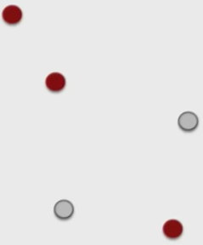 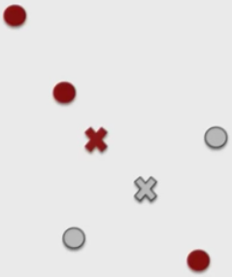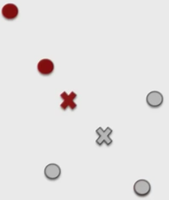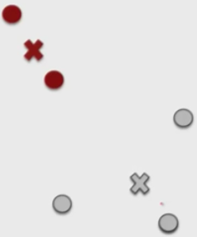

* k can be selected from previous knowledge or experimenting.
* We can strategically select an initial partition of points into clusters if you have some knowledge of the data.
* We can also run the algorithm several times with different random starting points.

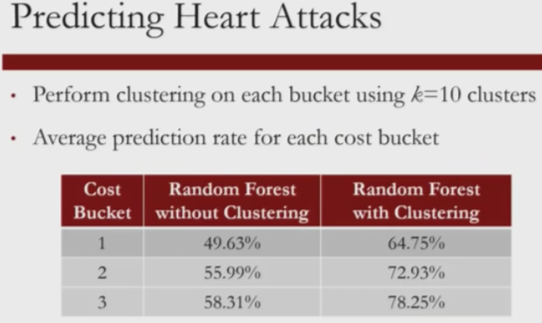

Above we see a large improvement in prediction using clustering than without.

Clusters are interpretable and can reveal unique patterns of diagnostic history among the population.

_____________________________________________________________________________________

Recitation

We will see how to apply clustering techniques to segment images, with the main application geared towards medical image segmentation.

**Image segmentation** means dividing up a digital image into regions/clusters that share the same visual characteristics (color, texture, intensity, etc.). The segments should also be meaningful, in that they correspond to particular surfaces, objects or parts of objects. Think of a river, a mountain in the background and the sky; image segmentation should detect 3 different objects and assign their corresponding pixels to 3 different regions.

The goal of image segmentation is to modify the representation of an image from pixel data into something meaningful to us that is easier to analyze.

E.g. for image segmentation is **medical imaging**, where image segments often correspond to different tissues, organs, pathologies, tumors, etc. Image segmentation helps locate these geometrically complex objects and measure their volume.

E.g. for image segmentation is **object detection** such as buildings, pedestrians, humans, facial recognition, etc. Facial recognition is used for the auto-focus in cameras and in surveillance cameras.

E.g. for image segmentation is **recognition** **tasks** such as fingerprint and iris recognition.

**Clustering methods** partition an image into clusters based on differences in pixel colors, intensity, texture etc.

**Edge detection** is based on detecting discontinuities or boundaries such as an abrupt change in color.

**Region-growing methods** divides the image into regions then sequentially merges sufficiently similar regions.

In this recitation our focus is on *clustering methods*, particularly hierarchical and k-means clustering on grey-scale images using pixel intensity information.

Greyscale Images (continued from above)

Only one variable: **pixel intensity information**

Observations: each pixel offers one observation, so 49 observations in this example

For greyscale an image is represented as a matrix of pixel intensity values ranging from 0 (black) to 1 (white). We are dealing with 8 bits/pixel (8 bpp), which means 256 possible color levels for each pixel. A greyscale image can be converted to a matrix with each entry corresponding to a pixel and its color. This matrix is what is given in our datasets. The number of columns is the width of the image; the number of rows is the height. Below is a greyscale image whose resolution is 7 pixels x 7 pixels.

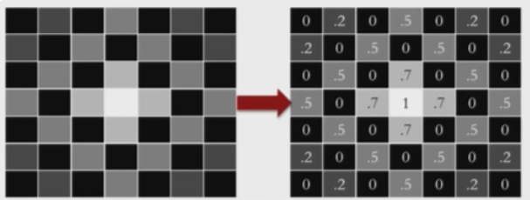

Greyscale image segmentation clusters pixels according to their intensity values

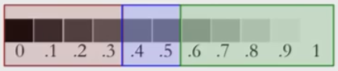

Up until now in data sets our rows would correspond to observations and our columns to variables, which is not the case here (each of the 49 entries corresponds to an observation), so we need to be careful when reading the data into R. So the input to the clustering algorithm should be a vector containing the 49 intensity values, and therefore we need to first morph the matrix into such a vector using as.vector(). Once we do this we can feed the vector into a clustering algorithm and assign each of the 49 elements to a cluster.

We will first use hierarchical clustering. Because there are 49 elements there should be 49C2 distances to be computed. In general, if the size of the **intensity vector** is n, then we have n choose 2 distances to compute and store in the **distance matrix**.

Note that by default R assumes the first row in a data set is the header. So when loading flower.csv we need to **add the argument header=FALSE** because the data is only a matrix; if we didn't add this argument then the first row of information from the intensity matrix would be lost.

The idea of this example is to take a greyscale image of a flower and use clustering to improve its appearance by clustering pixels of similar intensities as the same (like in the red/blue/green strip above). The first image is the original image of the flower, a greyscale image, which can be produced before any clustering using image(flowerMatrix, axes=FALSE, col = grey(seq(0,1,length=256))). The second image is the greyscale image that occurs after clustering in 3 groups (as we can see there are only 3 different pixel colors), given by image(clusterGroups, axes=FALSE, col=grey(seq(0,1,length=256))).

The two colored pixels below are what we get if we omit the argument col=grey(seq(0,1,length=256)). It seems every time we omit this argument we get a mixture of red/yellow/orange/white, regardless of what matrix we input into image(); I've tried many random different input matrices and only ever got these colors. (The second image looks like it has some green but that's just due to Microsoft Word; the image in R indeed had just 3 colors, no green.)





We chose 3 colors (that is, 3 cluster groups) because our analysis below suggests this is probably the best number of cluster groups. We can see below what will result if we choose 2, 6 and 10 respectively without col = grey(seq(0,1,length=256)):



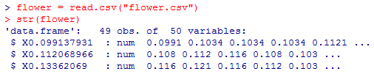

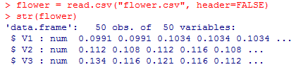

See above without header=FALSE that the first row of observations 0.0991, 0.112, 0.134... became the variable names.

Continuing with the header=FALSE version:

Recall that R treats the rows of the flower data frame as observations and the columns as variables. We want to change this to matrix form so that each value is its own observation and there is only 1 variable. Then we want to convert our matrix to a vector:

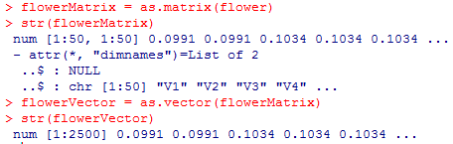

If we don't first convert flower to a matrix and try to jump ahead to just converting to a vector it won't work; the result will just look the same as flower.

Recall in the movieLens example when computing distances = dist(movies[2:20], method = "euclidean") that movies[2:20] is a table that has all 1664 observations as rows and variables 2 to 20 as columns (in other words, the movies data frame but with the V1 = Title variable column missing). distances computes the distance between each pair of observations using their corresponding values over the 19 variables.

In our flower example we now have 2500 observations but with just one variable (pixel intensity) instead of 19, and these observations are given by flowerVector. So we use distance=dist(flowerVector,method="euclidean").

So both examples are the same: using the vector(s) for all of the relevant variable(s) over all observations to compute pairwise distance among all the observations and output as a matrix.

The **ward.D** method is a minimum variance method which tries to find compact and spherical clusters.

We see below that hclust() is of type tree

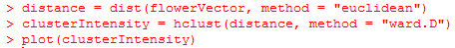

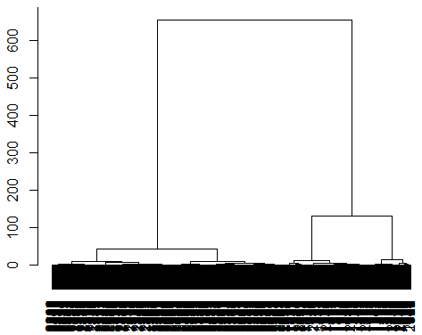

We can see here that 2 or 3 clusters would probably be good. Let's try 3. We can actually **visualize the cuts** (i.e. which data points go in which cut) using rect.hclust(clusterIntensity, k = 3, border = "red"):

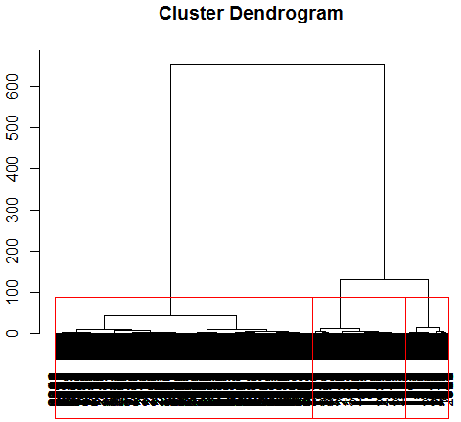

So we can actually create the 3 cluster groups using clusterGroups = cutree(clusterIntensity, k=3) and then see the average pixel intensity in each of the 3 cluster groups using tapply(flowerVector, clusterGroups, mean)

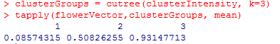

So cluster 1 corresponds to the darkest color in our image and cluster 3 to the lightest.

Recall that clusterGroups is nothing more than a vector that outputs the cluster (1 to 3) for each of the 2500 observations (so it has no memory of clusterIntensity; if we had the time we could manually create a 50x50 matrix with the same inputs and get the same image), so we want to convert it to a 50x50 matrix (because the image is 50 pixels x 50 pixels) so that we can display the image. So we first use dim(clusterGroups) = c(50,50) where the first slot is #rows, second is #columns, then image(clusterGroups, axes=FALSE). If we want to look at the greyscale image we can use image(clusterGroups, axes=FALSE, grey=(seq(0,1,length=256)))**.** This last argument corresponds to the convention for greyscale.

The input for the **image() function** is a matrix.

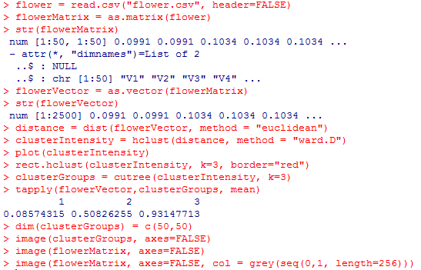

Note image(flowerMatrix, axes=FALSE) and image(flowerMatrix, axes=FALSE, col = grey(seq(0,1,length=256))) could have been used right after flowerMatrix was defined.

Note that we are converting to a vector at the beginning just because there is only one variable, but the data is given to us in a matrix. If we are instead given a data frame where as usual, the rows are observations and columns are variables, then we can just jump straight ahead to dist().

Recall that the goal of image segmentation is to modify the representation of an image from pixel data into something meaningful to us and easier to analyze.

MRI Image (video 4)

Before any clustering is done we see this is the greyscale image we are working with:



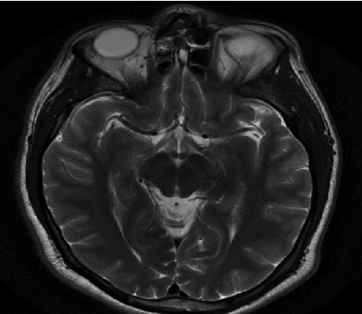

We start by loading healthy = read.csv("healthy.csv", header=FALSE), healthyMatrix = as.matrix(healthy) and healthyVector = as.vector(healthyMatrix), just as in the above example. However, in this case our healthyVector is 365636 components long and so if we try to compute the distance matrix to use for hierarchical clustering then R returns an error, as this tries to store 365636 C 2 or about 67 billion entries. Hierarchical clustering doesn't work because the resolution of the original image is too large.

What other solutions could we pursue? We could try k-means clustering.

The first step is specifying the number of clusters. The number of clusters would ideally correspond to the number of tissue classes/particular substances, which are well known to the medical community. Setting the number of clusters depends on what information you are trying to extract. Here we will use k=5.

We should also set a seed because data is being randomly assigned to clusters. Here we will use set.seed(1).

Recall that in the hierarchical clustering case, after we defined our vector from our matrix, we then would compute the distance matrix using dist(), which would then be used to create our intensity plot using hclust(), which would then be used to create our cluster groups vector using cutree().

In the k-means clustering case once we have the vector defined from our matrix we can jump ahead to using the KMC = kmeans() function which automatically creates the cluster groups vector for us, **KMC$cluster**, which we can then convert to a matrix as before with dimensions the same as the resolution of the original image, which we can then image.

KMC = kmeans(healthyVector, centers=k, iter.max=1000); note that because kmeans is an iterative process it can take a long time to converge, hence the last argument.

Note that str(KMC) also gives us other information, such as the mean of each cluster, given by **KMC$centers**, as well as the size of each cluster, given by KMC$size. Below we see the third cluster is the largest and has average pixel intensity of 0.0196, which corresponds to near-black in the greyscale image.

We can add color in our image using the argument **col=rainbow(k)**, where k is the number of colors we want, that is, the number of clusters (here k=5).

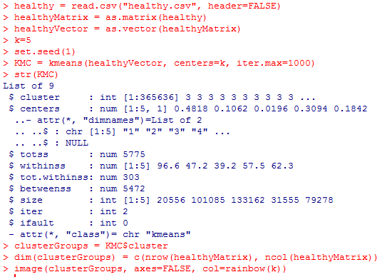

On the right is what we get from image(clusterGroups, axes=FALSE, col=grey(seq(0,1,length=256))) (Compare this to the original greyscale image.)

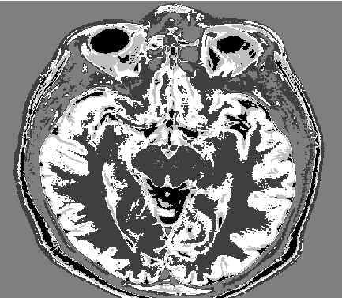

We have identified clusters/tissue substances in a healthy brain image. It would be useful if we could use these clusters to detect a brain tumor in an MRI of a sick patient.

image(tumorMatrix, axes=FALSE, col=grey(seq(0,1,length=256)))

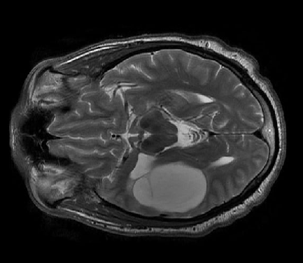

We won't run the k-means algorithm again on the tumorVector. Instead we apply the k-means algorithm results from the healthy brain image on the tumor image. In other words, healthyVector is our training set and tumorVector is our test set. To do this we need to **install.packages("flexclust"), library(flexclust).**

The flexclust package contains the object class **KCCA (K-Centroids Cluster Analysis)**. We need to convert the information from our clustering algorithm, given by KMC, to an object of type KCCA before we can use predict():

KMC.kcca = as.kcca(KMC, healthyVector) //this step takes a couple minutes to run

The first input is the data from the clustering algorithm, KMC, and the second is the data that we clustered, healthyVector. We can think of **KMC.kcca as type model** which can then be used to predict for example on our training set healthyVector using healthyClusters = predict(KMC.kcca) or on our test set as below:

Now we can cluster the pixels in tumorVector using predict():

tumorClusters = predict(KMC.kcca, newdata=tumorVector)

This is a vector that assigns a value of 1 to 5 for each of the intensity values in tumorVector as predicted by the k-means algorithm. Then we can convert to a matrix then image, as before.

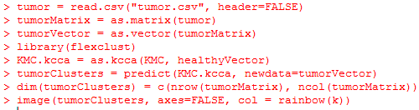

On the right is what we get from image(tumorClusters, axes=FALSE, col = grey(seq(0,1,length=256))).



We see the tumor as the big red structure. Below is the image of the healthy patient (taken from the beginning of this section and rotated). Looking at the eyes regions we can see that the images were not taken at exactly the same sections of the patients' brains, hence some differences in the shapes in the pictures.



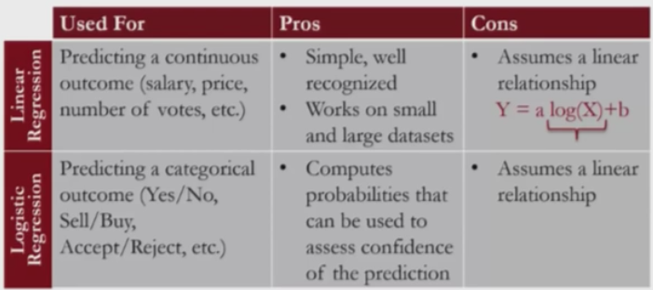

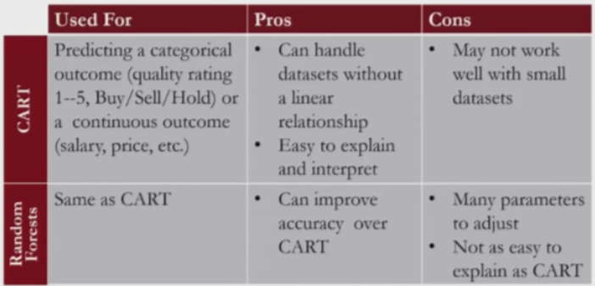

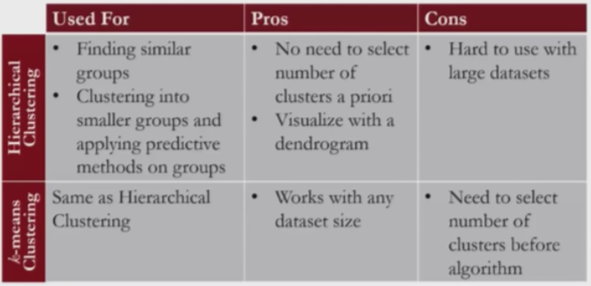

For hierarchical clustering, large data sets don't work because of the problem we run into when trying to compute the distance matrix, which is too large.

_____________________________________________________________________________________

Note that if we have a list of values and want **to look at the last 6** in the list we can use **tail();** if we want to look at the first 6 we can use **head().**

e.g. tail(sort(colMeans(dataframe))) first takes the means of each column (variable) in the data frame, then sorts them in increasing order, then outputs the 6 last (i.e. largest) ones along with their variable names.

Recall that when clustering we **need to standarize our data** or else the larger-valued variables will dominate in our distance calculations. However, **once those clusters have been determined**, we refer back to our original data (not the standardized form; the standardization is just for determining clusters). We can do this on our airlines data set by:

loading library(caret) because we want the preProcess() function, then:

preproc = preProcess(airlines)//pre-processes the data

airlinesNorm = predict(preproc, airlines) //standardizes the data

More compactly: airlinesNorm = predict(preProcess(airlines), airlines)

We need to preprocess the data because the predict() function cannot take a data frame such as airlines as its argument, and so preProcess() converts airlines to the correct form.

The above is the same as taking (X-mean(X))/sd(X) for each variable X.

If we have both a training set and a test set then we want **to standardize by the mean and standard deviation from the training set on both the training set and test set**:

library(caret)

preproc = preProcess(train)

trainNorm = predict(preproc, train)

testNorm = predict(preproc, test)

Again, the standardization is for determining clusters. Once we have done this we want to return to our original training and testing sets.

Note that if we have two variables x and y then c(x,y) is a new variable that has all the slot values of x followed by all of the slot values of y:

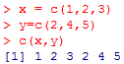

Cluster-then-predict assignment at end of Unit 6 (logistic regression):

* Break the data into train and test sets
* Predict the dependent variable PositiveDec using logistic regression as usual and calculate the accuracy of the model on the train and test sets.
* Move on to cluster-then-predict (and compute the test set accuracy to compare to the above accuracy; ideally it will be higher):
* Before creating clusters we have to remove the dependent variable from our test and train sets as this would affect our clusters; the point is to use clusters to predict the dependent variable so it would be circular to use the dependent variable itself in creating these clusters. However, make sure to define new sets from the test and train sets when removing the dependent variable because we will eventually need the original train and test sets to create our clusters after the cluster group locations of the data have been decided.
* Normalize the train and test sets by first loading library(caret); the normalization that occurs on the test set is by subtracting the mean and standard deviation from the training set instead of its own (not sure why). We needed to normalize so that we could create respectable clusters which take into account all variables, not just dominant ones.
* Use the appropriate clustering algorithm (here we use K-means with k=3 and seed 144) to create the clusters.
* Load library(flexclust) to create KMC.kcaa, which is then used to predict on both the normalized train and test sets.
* Now that our data have been partitioned into cluster groups for both our train and test sets we can return to our original train and test sets to divide each into subsets according to its own cluster groups. In our case we have k=3.
* Now we can create a logistic regression model for each of the 3 train subsets which can then be used to make predictions on their corresponding test subsets.
* We can compute the overall accuracy of this cluster-then-predict method on the test set (or train set accordingly) by combining the dependent variable for each of the 3 test subsets, then doing the same for the 3 test subset predictions and using the table() function as usual to create the confusion matrix:

allResults = c(test1$depvar, test2$depvar, test3$depvar)

allPreds = c(predTest1, predTest2, predTest3)

table(allResults, allPreds >=0.5)

Note for allResults that it is important to write it like this instead of simply test$depvar because the order of the observations is not the same in both cases, so the confusion matrix would be different in both cases.

* Note that the overall accuracy as given by the previous bullet is the same as if we were to compute the correct guesses (TP and TN) in each of the 3 confusion matrices and divide by the total number of observations between the 3 confusion matrices (so a weighted average between the 3 tables, weighted by the number of observations in each).

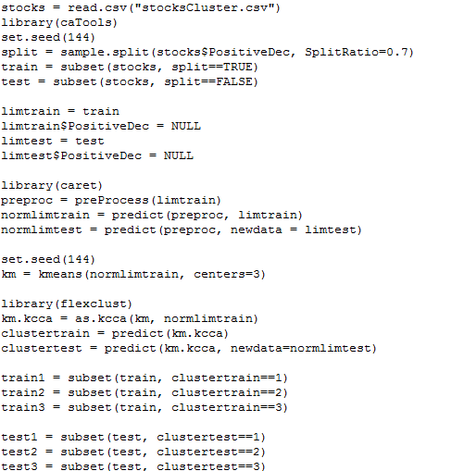

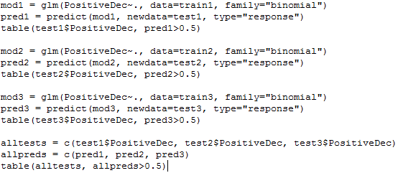

What does it mean to predict(KMC.kcca) or predict(KMC.kcca, newdata=tumorVector)?

_____________________________________________________________________________________

Unit 7: Data Visualization

**Data visualization** is a mapping of digital properties to visual properties. Digital properties are usually numerical or categorical, such as mean, max, # of observations with a certain property, etc. Visual properties can be coordinates, colors, shapes, sizes, etc. Both types of data are used to understand the data in different ways.

Consider Anscombe's Quartet: The means, variances, correlations and regression equations are the same in each of the 4 data sets, so we might conclude they are similar distributions solely from digital properties. However, when we graph them we see they are quite different, which we might miss if we didn't try to visualize the data:

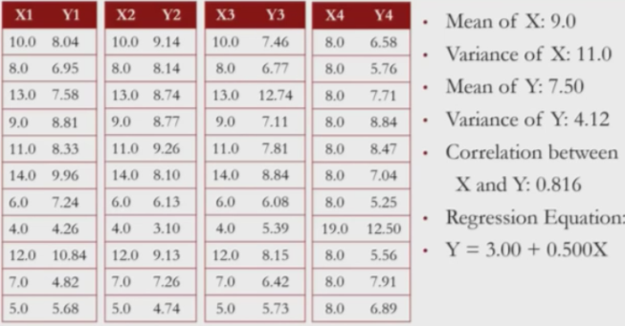 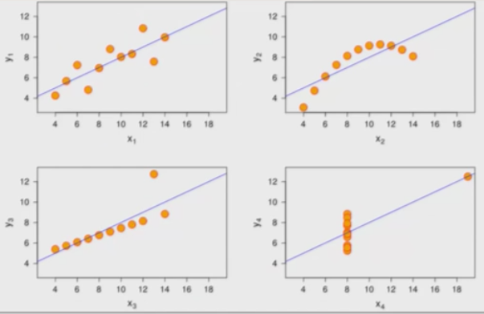

We use the **ggplot2** package in R for creating data visualizations. What do we gain by using ggplot2 over base R (the basic R functions)? Base R graphics are composed of simple elements like points/lines (it's difficult to get a sophisticated visualization) and it is difficult to add elements to existing plots. In ggplot2 the mapping of digital properties to visual properties is done by adding layers to the plot, making it easier to create sophisticated plots and add to existing plots.

ggplot graphics consist of at least 3 elements:

i) **data frame**

ii) **aesthetic mapping** describes how variables in the data frame are mapped to graphical attributes (x-y axes, scale, shape, color, subsets...)

iii) **geometric objects** determine how values are rendered graphically (points, lines, boxplots, bars, polygons...)

Below we see 3 visualizations, with geometric objects as points, bars and polygons respectively.

They all have the aesthetic mapping property of color.

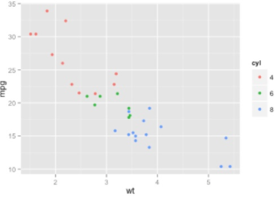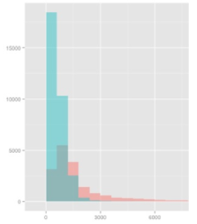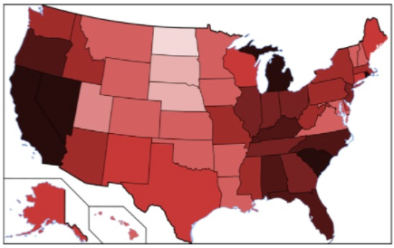

We are back to using the WHO data frame from week 1. Compare using base R plots to ggplot2 plots:

 

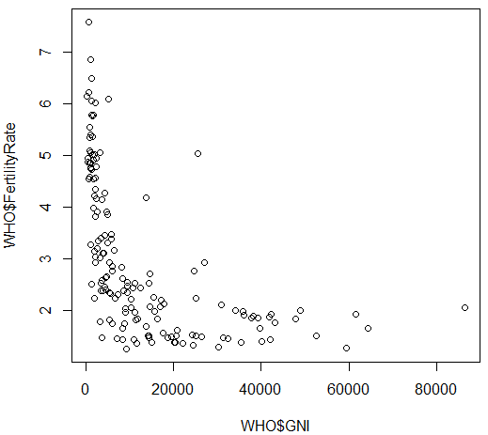 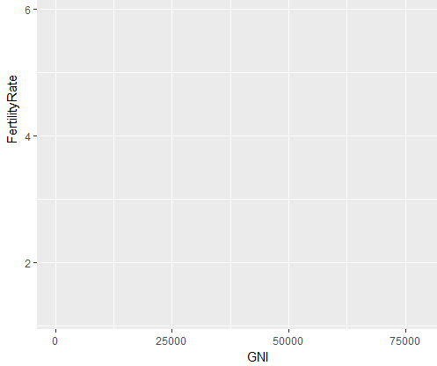

A big advantage of using ggplot() over base R is that you can build different graphs using the same ggplot object, so that you don't have to continually redefine your plot; there's no need to learn one function for bar graphs, another one for line graphs, etc. Above on the right we still haven't defined our geometric objects, only the data frame and aesthetic mapping. But the nice thing is we can then use scatterplot to create multiple scatterplots corresponding to different geoemtric objects without having to redefine the data frame and aesthetic mapping each time. Moreover, ggplot gives better axes names by getting rid of WHO$, it gives a nice grid in the background and it colors its points differently than the background color. We can then add the geometry objects by taking the ggplot object scatterplot and using + geom_

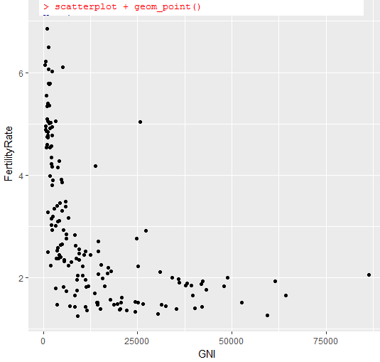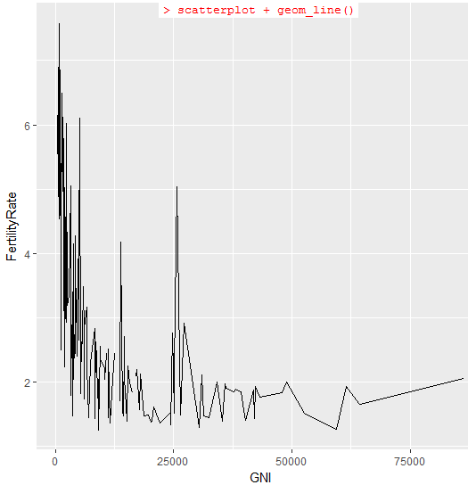

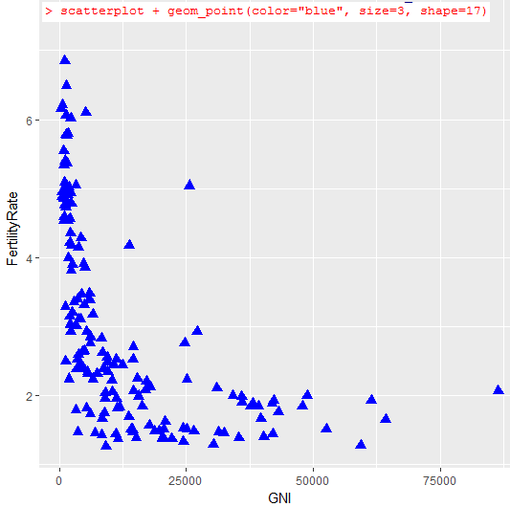



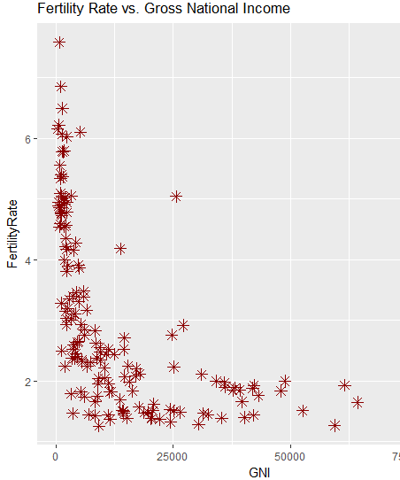

Now suppose we want to save a plot to a pdf file. **Important note: to save to a file the directory in which the file will be saved (in this case WHO) cannot be restricted by administrator privileges on the computer I'm guessing. So if I leave the WHO folder in the usual R-3.4.1 folder then the following pdf("MyPlot.pdf") command givens an error. We can work around this by moving the WHO folder to the desktop.

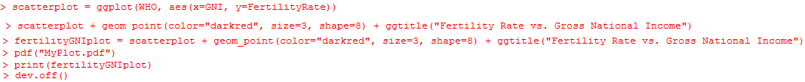

The above saves MyPlot.pdf in the current directory, which is WHO in this case.

Note that each thing after + is a **layer**, e.g. geom_point(color="darkred", size=3, shape=8) is a layer.

Now suppose we want to instead color the data points according to their value in a specific independent variable, for example the "Region" variable in the WHO data frame or the "Under15" variable. Because Region is a factor variable with 6 levels we see 6 colors; Under15 is a numerical value so we see instead a gradient. This helps us see something we didn't see before; the points from the different regions are in different parts of the graph.

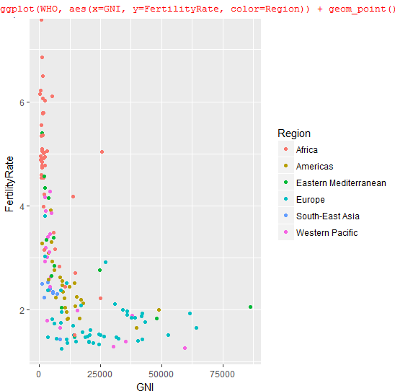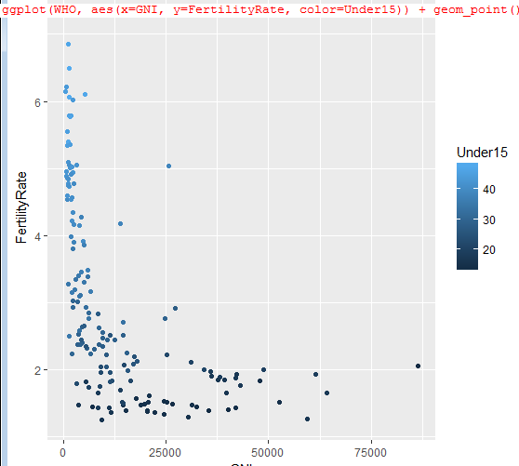

Now consider the following scatterplot:

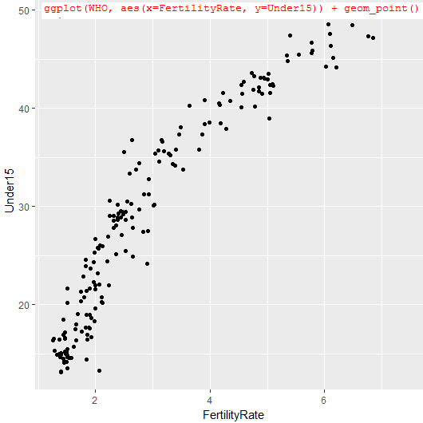

Notice that it looks more like a logarithmic relationship rather than a linear one, so we instead plot log(FertilityRate) vs. Under15:

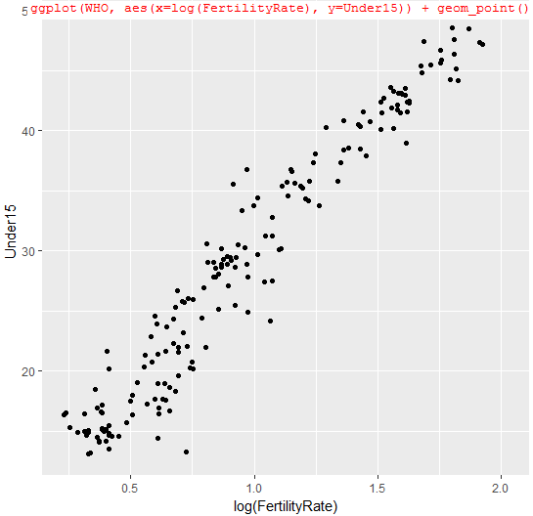

Creating a linear regression model for this plot using model = lm(Under15~log(FertilityRate), data=WHO) we find that the R2 value is high (0.9391) and the log(FertilityRate) variable is 3-star significant. Visualization was a great way to show this relationship between the two variables that we might have otherwise missed. Now let's add the linear regression line to our plot by adding another layer:



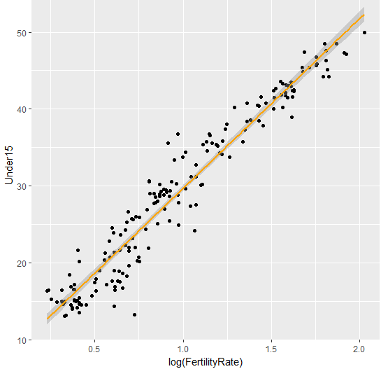

By default a 95% confidence interval is drawn around the line of best fit, but this can be changed.

There are other ways other than scatterplots to represent data visually, such as box plots, histograms, geographic maps, etc. ggplot makes it easy to go from one type of visualization to another by simply adding the appropriate layer to the plot.

____________________________________________________________________________________

Predictive Policing

Before, human judgment was the only tool available for indentifying patterns in criminal behaviors. Police forces around the world are augmenting human judgment with analytics, a.k.a. predictive policing. However, for analytics to be useful we need visualization; police forces are not going to be convinced by showing equations and tables. The idea of predictive policing is not to catch more criminals but to identify crime hotspots and then to send extra police officers to these hot spots to prevent the crimes before they have a chance to occur.

In almost every application, before we even consider making a predictive model, we should try to understand the historical data. In this lecture we'll use motor vehicle thefts data from Chicago.

Suppose we want to communicate crime patterns over the course of a week. Merely displaying the daily averages is not very useful because it does not tell us the times. We could make a chart with Days for columns and Times (by hour) for rows, which is a valid way but difficult to read when the table is large. We could also use a **heat map**, where the x-axis could be the days of the week, the y-axis the hours of the day and the colors represent how much crime is happening (e.g. 1=very low, 2=low, 3=medium, 4=high, 5=very high). So heat maps of 3 pieces of information.

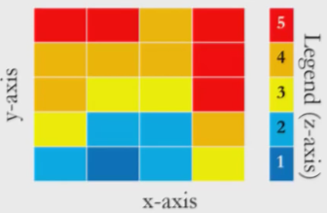

We can also pick different coloring schemes:



We might use the greyscale one for example if we only want large values (which we can label as black) to stand out.

The axes do not need to be continuous; for example we can have day of the week for the x-axis, which is categorical.

When a variable with text in its name in a data frame is loaded into R it is by default a factor variable; so we add stringsAsFactors = FALSE when we don't watch this to be the case and for R to instead treat the strings as they are.

Motor Vehicle Thefts

We want to extract the day of the week and hour of the day from the Date variable from the mvt data frame where the Date variable in the mvt data frame is of the form "month/day/year hour:month". Recall that R can read dates when they are in the form yyyy/mm/dd HH:MM:SS, so to convert dates to this format we can use the **strptime()** function. To get the day of the week as a name rather than a number (so "Monday", etc.) we can use the **weekdays()** function.

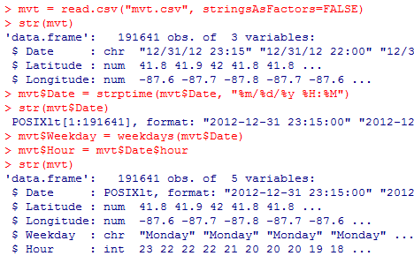

Now suppose we want to create the line plot comparing the number of thefts on each day of the week. Recall that ggplot() accepts a data frame as its first input, so we can first create a table then convert it to a data frame. Recall that for a factor variable the factors are usually in alphabetical order so we will want to change that using the **factor()** function.

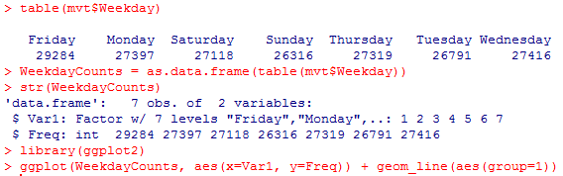

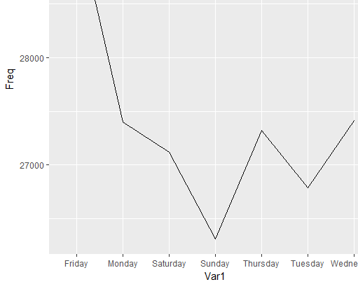

Note that we add the argument aes(group=1) because we only have 7 data points and want to group them together (i.e. create a plot with just 1 line). Note that the days of the week are out of order and the labels of the axes are not ideal, so we fix this with:



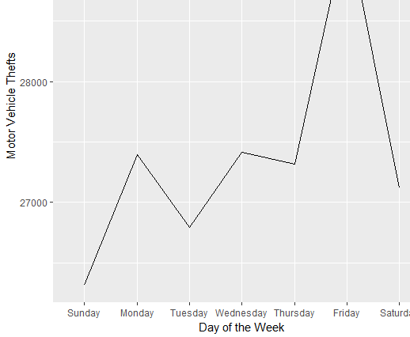

Now we'll change the x-axis to Hour and have a line for each of the 7 days of the week.

Note: To **convert a variable X that is of type factor but consists of numbers** **to a numerical variable** we use X = as.numeric(as.character(X))

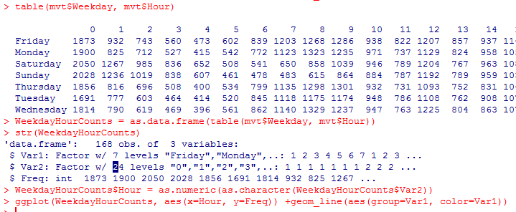

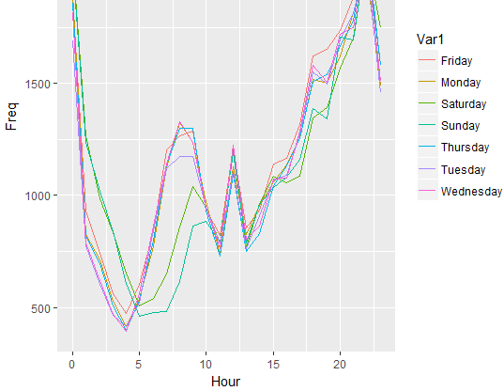

In the above if we didn't have color=Var1 then all 7 lines would be the same color.

Now let's visualize the information with a heat map, but first ordering the days of the week, starting with Monday. The layer for heat maps is **geom_tile()**.

WeekdayHourCounts$Var1 = factor(WeekdayHourCounts$Var1, ordered=TRUE, levels=c("Monday", "Tuesday", "Wednesday", "Thursday", "Friday", "Saturday", "Sunday")

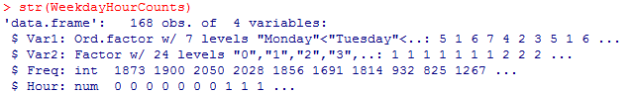

ggplot(WeekdayHourCounts, aes(x=Hour, y=Var1)) + geom_tile(aes(fill=Freq)) + scale_fill_gradient(name="# MVTs") + theme(axis.title.y = element_blank())

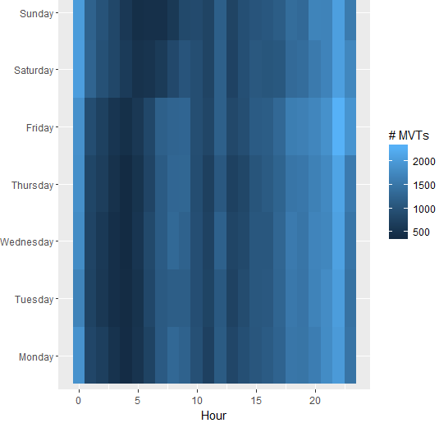

* theme(axis.title.y = element_blank()) gets rid of the title of the y-axis; we could also use ylab(NULL).
* scale_fill_gradient() refers to our fill gradient
* geom_tile(aes(fill=Freq)) means we are making a heat map and the colors will be assigned according to the size of the WeekdayHourCounts$Freq variable.

We can change the colors of our gradient as well:

ggplot(WeekdayHourCounts, aes(x=Hour, y=Var1)) + geom_tile(aes(fill=Freq)) + scale_fill_gradient(name="#MVTs", low="white", high="red") + theme(axis.title.y = element_blank())

Using white as low frequencies and red as high is a common color coding for policing. It's common to change the colors according to the particular application, and what values you want to pop out

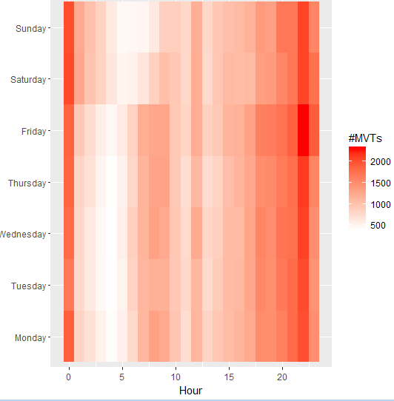

Now we'll plot crime on a map of Chicago. We can look at maps from Google using **library(maps)**  and **library(ggmap)**, which has a pre-defined locations such as cities in lower case, and zoom levels. My guess is library(maps) is to obtain the maps and library(ggmap) is to display and manipulate them.

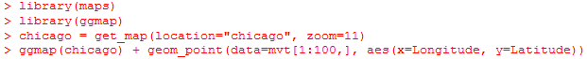

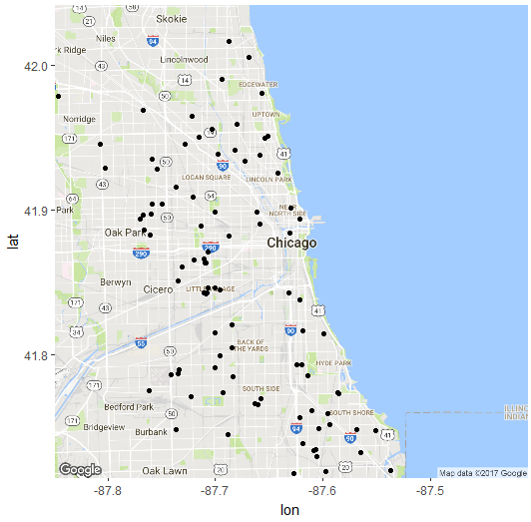

ggmap(chicago) shows the map without any points; it is like ggplot. However, now instead of our arguments about which data frame and aesthetics being added here they are instead added in the geometric object argument (which could also include the usual arguments, such as color, shape, size, etc.). By data=mvt[1:100,] we are taking only the first 100 observations from the mvt data frame (with all variables), and we are taking the Longitude and Latitude variables from the mvt data frame to give our x and y coordinates on the map.

If we plotted all 191k+ observations in our mvt data set this wouldn't be helpful; we are instead interested in locating crime hotspots.

Note that **round(x, 3)** rounds x to 3 decimal places (we can change 3 accordingly).

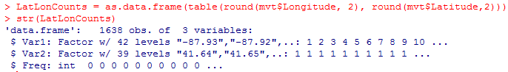

Here the observations refer to the 1638 = 42x39 squares in which we divided our map, and Freq tells us how many crimes were committed in its given square. This is because LatLonCounts counts how many times each Longitude/Latitude pair (after rounded to 2 decimals) occurred in the original data frame mvt, and each pair corresponds to a crime by the way mvt was defined.

Now suppose we want to plot the number of crimes (Freq) in each of these 1638 squares. First we need to convert Var1 and Var2 to numeric values, then we can plot the observations with differing color and size according to the size of the Freq variable:



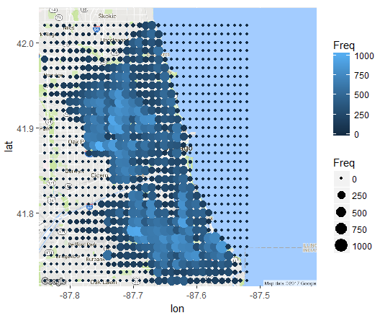

So we see a point for every longitude/latitude pair (2 decimals) whose color and size depend on the frequency of crimes in that area. If we want to change the color scheme we could add a layer:

ggmap(chicago) + geom_point(data=LatLonCounts, aes(x=Long, y=Lat, color=Freq, size=Freq)) + scale_color_gradient(low="yellow", high="red")

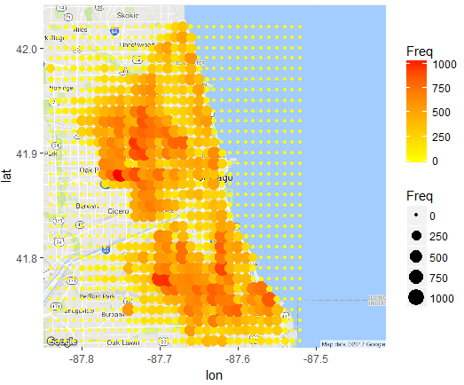

Note that instead of the color=Freq argument, which uses different colors, we could also use the **alpha=Freq** argument for tiles, which uses different darknesses of the same color.



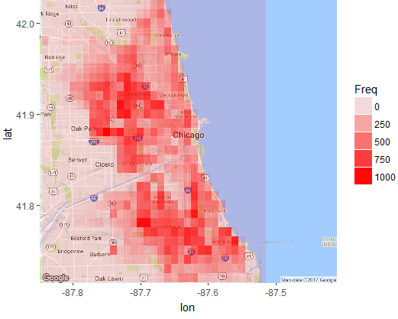

The **merge()** function: (related to cartesian product)

We can merge two data frames A and B if they have a variable name y in common by writing merge(A,B,by="y"). This creates a new data frame as follows:

* The first variable of the new data frame is y, then all of the variable names of A, then all of the variable names of B.
* Under y we have in increasing order duplicates of the values that occur in A$y and B$y. The number of duplicates is given by the product of the number of times that value appears in each.
* The values of the remaining variables are determined as cartesian products. For a given y value, we run through all possible (x,y) combinations for the values of x that occur in the same slot locations as the given y value in A$y and the values of z that occur in the same slot values as the given y value in B$y.
* We fix the x-values first (starting left-most), run through all the z-values (left to right), then move to the next x-value.
* We do this for each value of y.

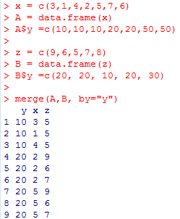

Note when we convert a table to a data frame, a Freq variable is created and the entries in this variable are read by the first column of the table, then the second, etc. Also a variable is created for both the row and column names of the table, called Var1 and Var2.

It seems that scale_fill_gradient is for geom_tile and geom_polygon but scale_color_gradient is for geom_point.

A data frame that can be used to draw a map of USA using ggmap() is included in R and can be loaded using **statesMap = map_data ("state").** (map_data has a number of built in data sets for building maps, for example for France, Italy, a world map, etc.)

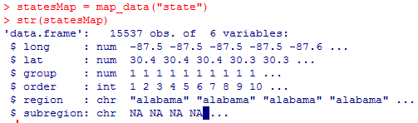



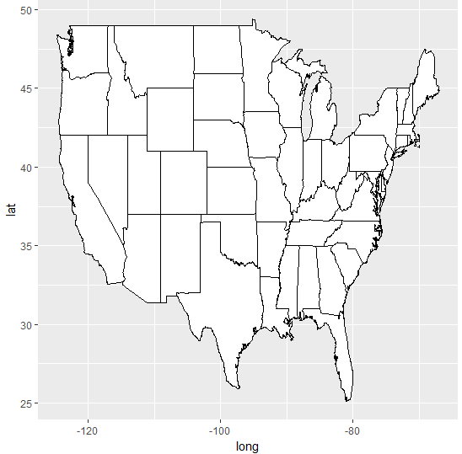

group = group tells R to draw the map into groups (by State).

Now we want to map murders by State which can be done by merging statesMap with murders. We first need to convert murders$State to lower case because that is how it is in the murders data frame, and we need to give this new variable name the same as it is in the murders data frame (region) so that the merging can take place.

The "group" variable below is a way of grouping the states, so each group corresponds to a group. The "order" variable below tells ggplot which order to draw the lines within a given group; if this order is off then we can get an incorrect map with lines connecting points across the map that shouldn't be connected.

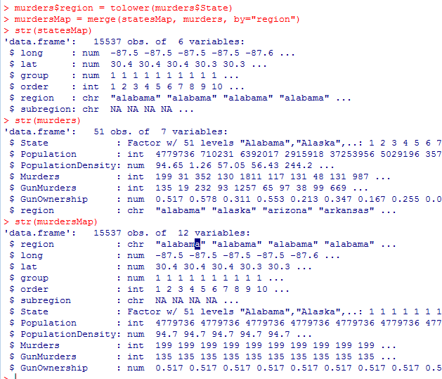

It seems that by default when using the fill/color arguments in aes() for ggplot (so as to fill/color according to a certain variable) it uses a bluescale by default. To change which colors are actually used is done in different levels such as scale_fill_gradient or scale_color_gradient.



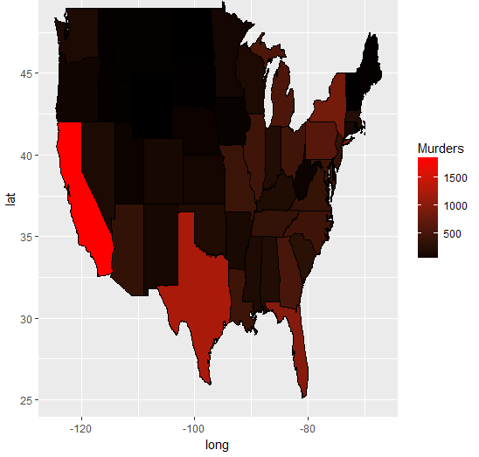

Without scale_fill_gradient(low="black", high = "red") this would be in blue scale.



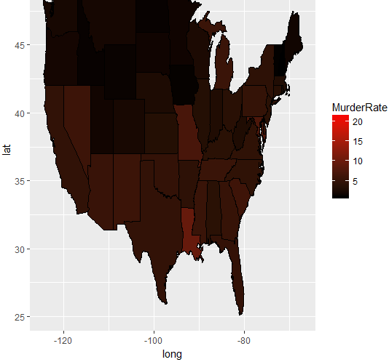

Notice that all of the visible colors are 10 or below, yet the scale goes up to 20. This is because Washington DC, which is too small to see, is an outlier with an unusually high murder rate. So we can remove this outlier from our data by adding limits to our scale_fill_gradient and draw the plot again:



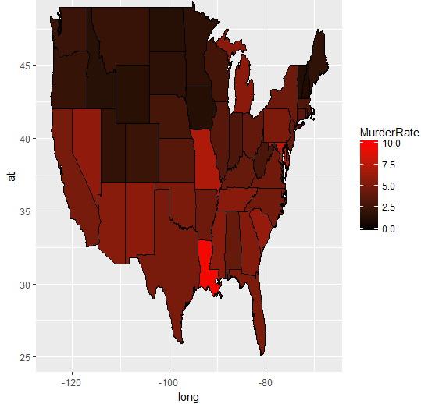

With the outlier removed we can see a wider range of colors in our map. Note that anything that falls outside these limits is just colored grey.

Visualization is subjective; it requires your own personal judgment.

Some bad examples of visualizations:

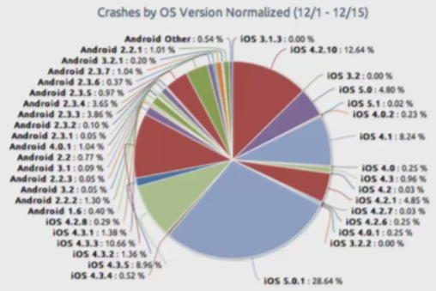

Bad because:

* Way too many labels.
* The labels are ordered neither by operating system version or %.
* It computes percentage of total crashes by each version of Android/iOS, which is not what we want because it doesn't take into account how many Androids there are to iOS phones. For example if there are two times as many iOS phones as Androids then we are comparing # of crashes from two iOS phones to number of crashes in one Android. We want to compare one Android to one iOS phone, as we are interested in seeing which operating system crashes more than the other.
* Many of the regions are too small to even see.
* Regions with 0.00% are still being displayed.

We could group versions together according to their first digit; iOS could be grouped into 3 segments, 3,4,5, while retaining most of the information.

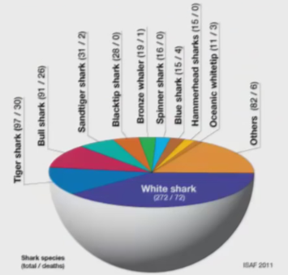

Bad because:

* The labels are vertical
* The chart is drawn as a hemisphere which adds no value but instead distorts the image; it makes it more difficult to directly compare the sizes of regions.

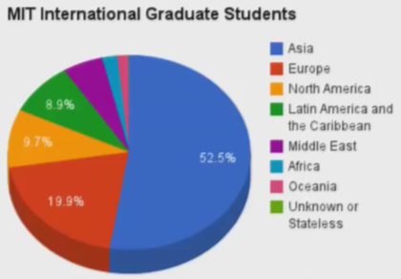

Bad because:

* Again, the image is vertically compressed, which adds no value but instead misleads regarding the relative sizes of the regions.
* Not all %'s are labeled.
* Some of the colors are so similar it is difficult to distinguish them.
* The Unknown or Stateless region isn't even present in the chart.

Now we want to make a bar plot from the following, which is approximately the same data as the pie graph above:

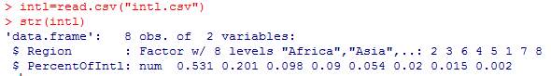



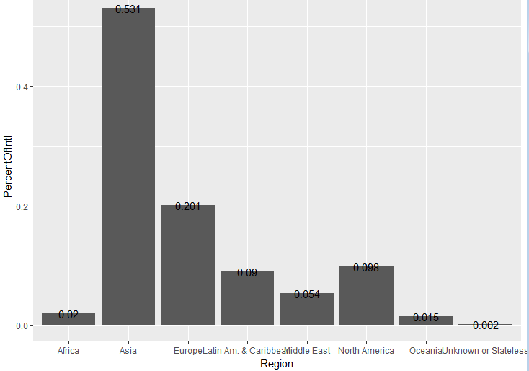

So geom_bar creates rectangles and stat="identity" tells R that the height of the rectangles are given by the y value as it is, PercentOfIntl. Our geom_text argument above tells us to label the rectangles by their values, which makes it easier and more precise than trying to read it off the y-axis.

Some bad qualities about the above:

* The labels are on the rectangles.
* The regions are not in any useful order; they are alphabetical. We will change them to decreasing order.
* The "Region" label for the x-axis is redundant; it is obvious that Africa, Asia etc. are regions.
* The x-axis values overlap. We can fix this by tilting them on an angle, which we will do by 45 degrees.
* We will furthermore color the rectangles blue.

Suppose we have a data frame df with variables x and y and we want to **reorder** x according to increasing values of y. We can write **x=reorder(x,y)**. If we wanted according to decreasing values of y we could use **x=reorder(x,-y).** Note this doesn't actually change x in df; we would have to write **df$x=reorder(x,y)** for that.

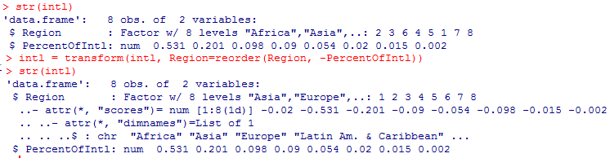

By default factor variables are ordered alphabetically (so "Africa"=1, "Asia"=2...) and we see that PercentOfIntl is ordered in decreasing order. By using **transform()\*\*** above we transform intl according to the relabeling of the factors given by decreasing order of PercentOfIntl (so "Asia"=1, "Europe"=2...). So none of the observations change, just the numerical values associated with each factor and therefore the order in which those factors will appear for example in a chart.

**Another way instead of using transform():

intl$Region = factor(intl$Region, ordered=TRUE, levels=reorder(intl$Region, -intl$PercentOfIntl))

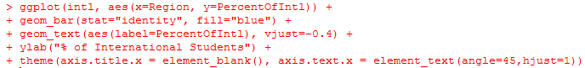

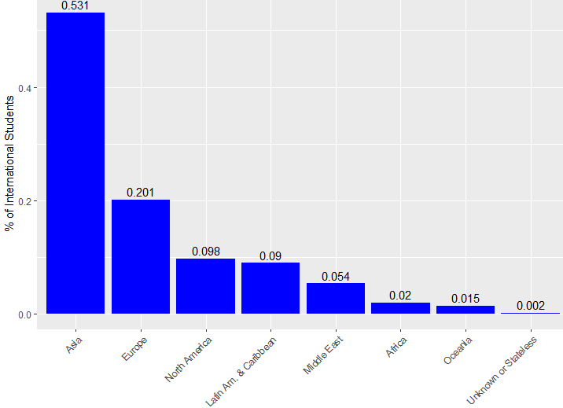

**vjust** adjusts the height of the text; negative means up, positive means down.

**hjust**  moves the text left if positive, right if negative.

**axis.text.x = element_text(angle=45, hjust=1)** moves the text for the regions left and then rotates them 45 degrees.

Comparing this graph to the pie graph, now all the data is visible and easily comparable and we don't lose the regions with small values. Something to consider however is that some people will find the bar graph less visually exciting.

For video on visualizations about the **World Map** check out video 5: World Maps in R at the end of Unit 7.

Bad scales:

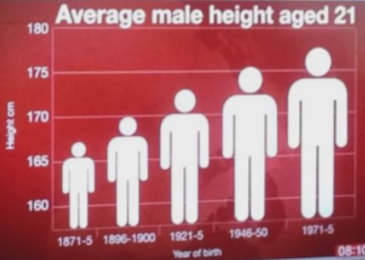

* This makes it look like men have doubled in height and width; should only plot heads.

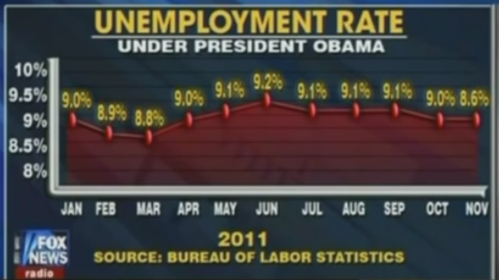

* The last point is incorrectly plotted
* The points only range from 8.6% to 9.2% yet the y axis from 8% to 10%; if the y axis was from 0 to 10% seeing changes in the curve would be even more difficult and we would conclude nothing is changing at all.
* Jan-Feb and Feb-Mar are not equally spaced
* The size of the markers blocks some precision in the exact location of each point.

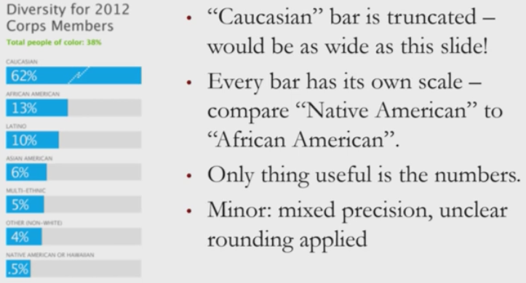

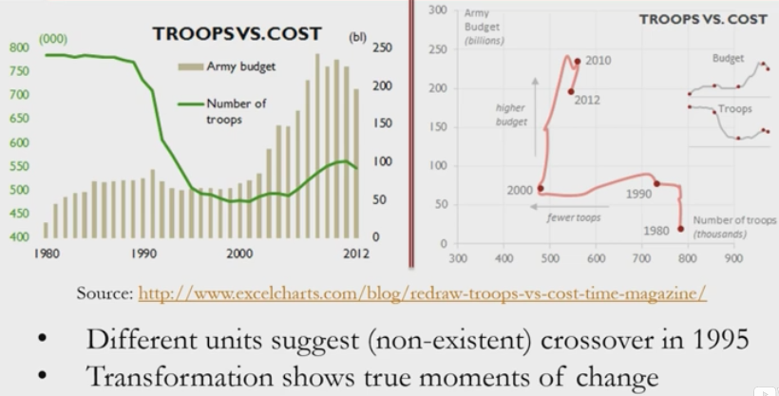

* This is a before and after of the same data.
* On the left we have two graphs which are fine on their own, but when superimposed offer a mixed message because using two different units ($ and people), suggesting a non-existent crossover around 1995.

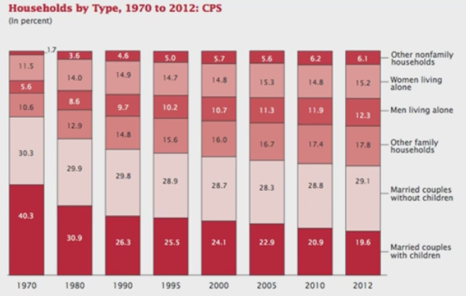

* If interested at looking at proportions in a given year this is good. But if we want to compare one year to another it's not so easy. For example, compare Married couples without children in 1970 and 2010; without looking at the numbers, is it easier to tell which is larger?
* This doesn't show rates of change in the various groups over time. In particular, the jumps in the x-axis are not constant.
* Numbers are relative, not absolute. It may be that one group is remaining constant in size over time but its relative size is decreasing to due population growth.

The **Melt()** function: We need **library(reshape2)** for melt().

* Input a data frame df with one of its variables we want to melt over. The output is a new data frame that consists of three variables/columns:

i) The variable we melted over

ii)"variable"

iii)"value"

* Under the first column we write a list of each of the values of the melted over variable and duplicate the list for each of the other variables in the original data frame.
* Under the second column we write the name of the variable from the original data frame which corresponds to the current list duplicate.
* Under the last column we write a list of the values of the given variable from the original data frame.
* If the original data frame has nrow() observations and c variables then the melt has nrow()*(c-1) observations.
* So the melt() function likes to look at pairs of values from the original data frame rather than keeping them as n-tuples; the first variable in the pair is the one being melted over.
* So df has 3 observations: (1,10,100), (2,20,200), (3,30,300) and melt has (1,y,10), (2,y,20), (3,y,30), (1,z,100), (2,z,200), (3,z,300)

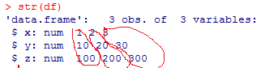

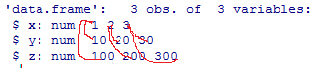

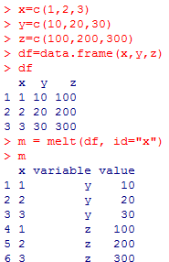

The melt function is good when we have a data set where observations consist of many variables but we only want to compare all but one of the variables to just a single variable in the data set (the melted one); the melt function separates the other variables from each other, so that for example (3,8,2,9) breaks into (3,8), (3,2), (3,9) if melted over the first variable.

Once we have melted it can allow us to use ggplot(), as we now have a specific x-variable for aes() (the melted one), the y-variable is "value" and group=variable to group our information by the different variables.

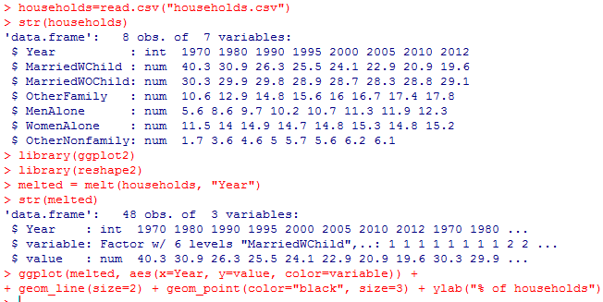

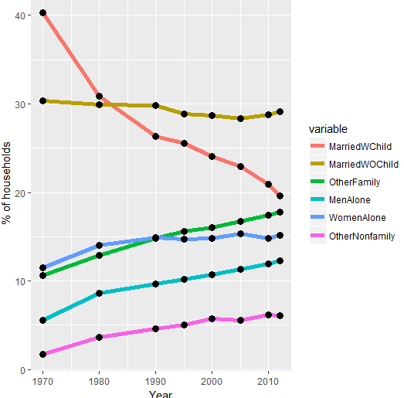

Unlike in the previous example, we can now see rates over time within a given variable. So this representation would be better for comparing over years. Furthermore, we can clearly see that the last 2 data points in each variable have near x-values (2010 and 2012), which was not so obvious in the original.

Note that **order(x)** for a numerical value x lists the increasing order of the sizes of x, e.g. order(c(7,2,9)) outputs 2 1 3.

Note if we have a data frame df with 5 observations, then df[c(4,1,5,3,2),] would be a new data frame which uses as its first observation the fourth observation from df, as its second observation the first observation from df, etc.

Note if we want to use a legend rather than a gradient for our guide we use **guide = "legend"** as an argument for our scale_fill_gradient.



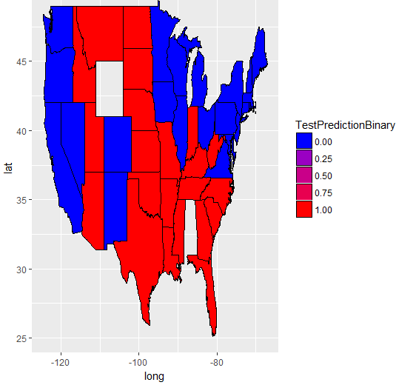

If we want to change how many values are printed on the guide and the name of those values we can then use **breaks=c(0,1)** and **labels=c("Democrat", "Republican")**; these two vectors must have the same length.

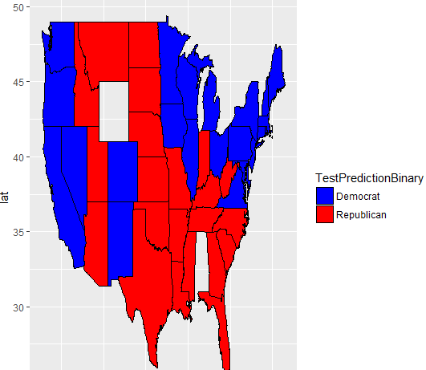

The important commands from Unit 7 Assignment 1 are below. Also, this file is saved as Unit7Homework1.

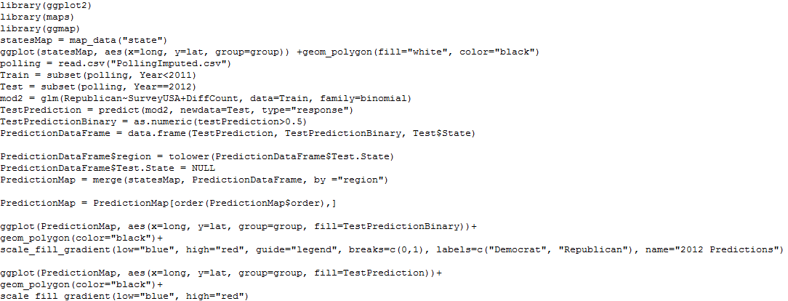

We use **library(igraph)** to visualize networks (for graph theory type problems). We can create graph objects using **graph.data.frame().** The edge set is given by the first argument, whether or not it is a directed graph is given by the second (FALSE if undirected, TRUE if directed) and the vertex set is given by the third argument. The output of g is a list of information that looks a bit like a data frame; we can plot(g) if we like.

In our case if we try to plot(g) then the vertices are large and are labeled, which cause clutter. So instead weplot(g, vertex.size=5, vertex.label=NA).

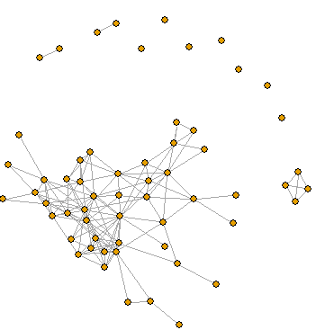

**degree(g)** is a vector that shows the degrees of all the vertices.

**V(g)** outputs all the vertex names

**E(g)** outputs all the edge names

**V(g)$size** accesses the size of the vertices displayed by plot()

**V(g)$color** accesses the colors of the vertices displayed by plot()

Because our data frame from the vertex set users had variables id, gender, school and locale they are now stored in g as **V(g)$id, V(g)$gender, V(g)$school, V(g)$locale**.

In our case we use V(g)$size = degree(g)/2 +2 to make vertices of higher degrees larger. Then

plot(g, vertex.label=NA)

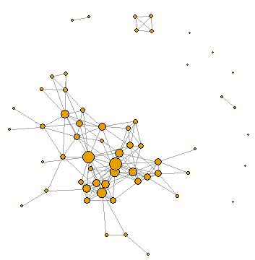

Recall that if x=c(4,2,9) then x[c(TRUE, FALSE, TRUE)] outputs 4 9 and if y = c(3,2,9,6) then y[c(4,1)] outputs 6 3.

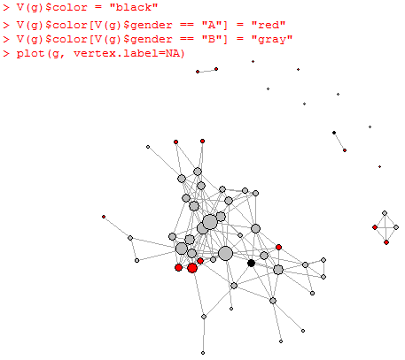

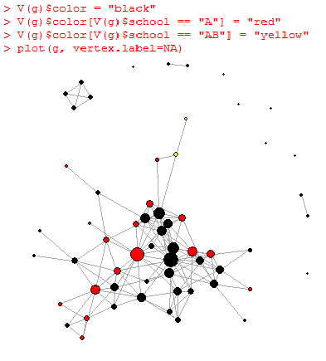

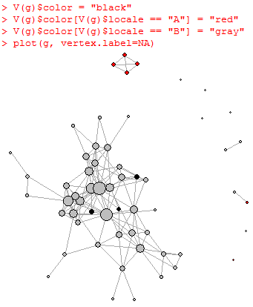

Using **?igraph.plotting** we can read about other changes we can make to the graph, such as changing edge with by adding edge.width = to plot(). You can also make 3D graphs which can be rotated (see note at end of problem 4 in Unit 7 assignment 2). Here are most of the commands from Unit 7 assignment 2, which are also saved in Unit7assignment2:

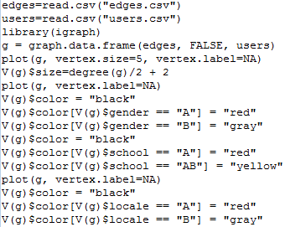

_____________________________________________________________________________________



A word cloud is a nice way to visually display the most common words in a text, with the more common ones being larger. To build word clouds we need **library(wordcloud)**  and then we can use the **wordcloud()** function, which is easy to understand by looking at ?wordcloud. The first two arguments are words, then freq but there are many others possible. For example the scale=c(a,b) argument refers to the size of the words according to their frequencies, with a being the size of the more frequent words and b the size of the less frequent words. By default the scale is c(4, 0.5). We can also remove less frequent terms either by using min.freq (the minimum number of times a word must occur to be displayed) or max.words (the maximum number of words the cloud can have, lower frequency words dropped) which seems to be infinity by default. The random.order = TRUE argument plots the words in random order so that big and small words will both occur all over the word cloud; if random.order=FALSE then the words are plotted according to decreasing frequency, so that more frequent/larger words are in the center and smaller words are around the perimeter. The argument rot.per controls which proportion of words are vertical and by default is 0.1.

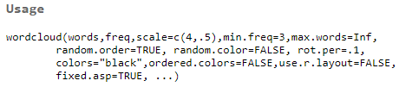

The above is found from ?wordcloud in R and it looks like these are all the default values for the available parameters.

In the following homework assignment we didn't stem words while preprocessing because it would be difficult to read them in the word cloud.

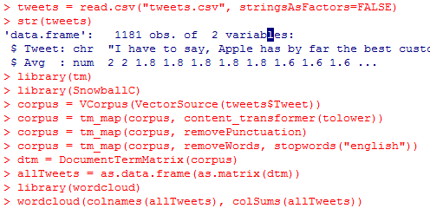

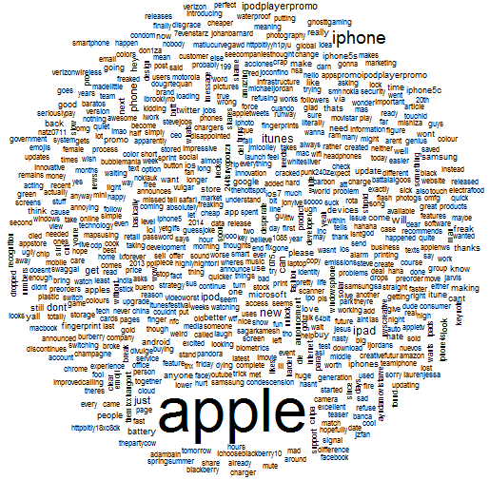

Above is what we get using the default scale=c(4, 0.5) as shown in ?wordcloud. Below is what we get when we make the change scale=c(2,0.25):

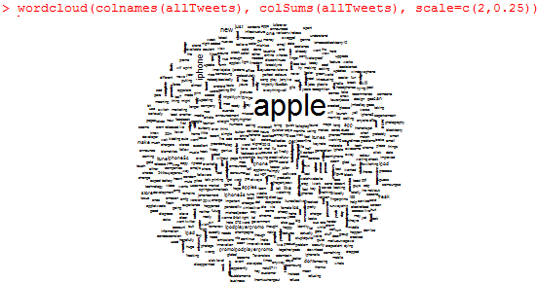

Now we repeat the process but removing 'apple':

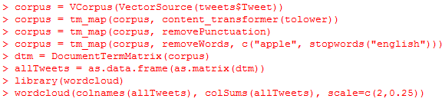

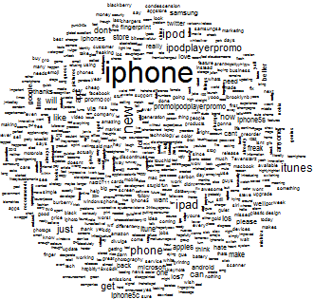

Looking at negative tweets (ones with an Avg value of <= -1):

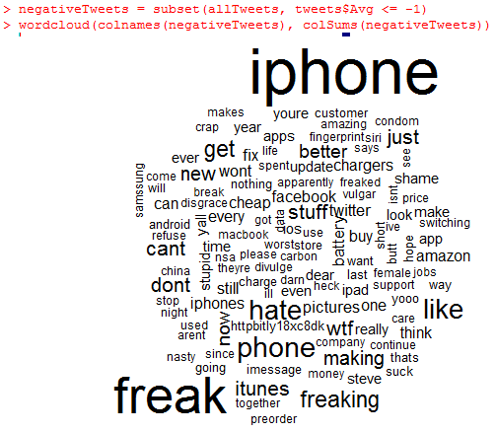

**library(wordcloud)** also loads the **RColorBrewer** package, which offers a palette of colors that can be used to improve visualization for word clouds, maps, etc. To see the palette of available colors we type display.brewer.all(). We can select our own colors when plotting by typing for example colors=c("red", "blue", "yellow"), or we can use colors = brewer.pal() with the appropriate arguments. The first argument is the number of colors in the palette (so it seems to be a constant for a given palette) and the second is the name of the palette, for example colors = brewer.pal(9, "Blues"). However, sometimes we don't want all of the colors from the palette because for example perhaps the lighter colors are difficult/impossible to see. So for the Blues palette if we only want the 5 darkest colors we could use brewer.pal(9,"Blues")[5:9]; if we want colors 3, 5, 6 from Blues we could use brewer.pal(9,"Blues")[c(3,5,6)], etc.

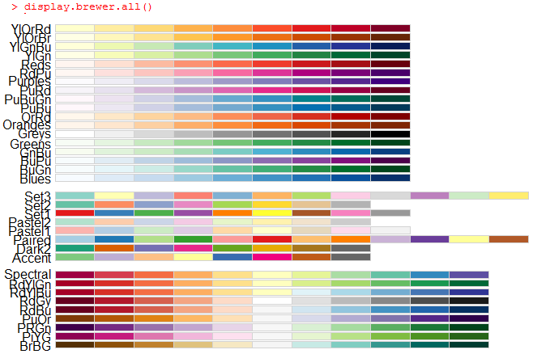

Some of these palettes are **qualitative,** such as Set3, meaning the difference in colors does not clearly represent differences in frequencies, unlike **sequential** palettes, for example YlOrRd or Greys.

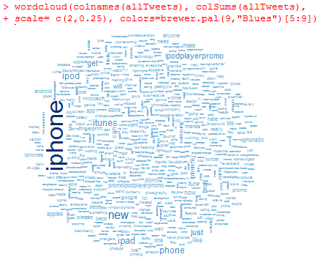

Unit 7 Assignment 3 has been saved in Unit7Assignment3.

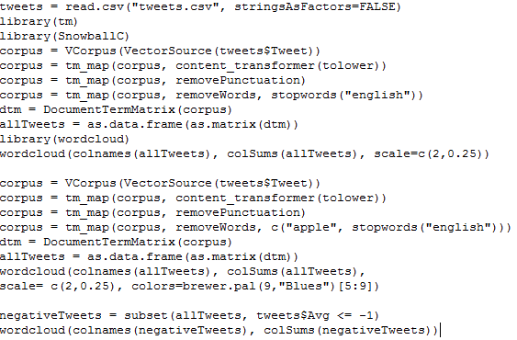

_____________________________________________________________________________________

Unit 8: Linear Optimization

We see how American Airlines used revenue management to offer discounted fares that beat the competition. We learn how to solve optimization problems through a spreadsheet software. In the second lecture we discuss how optimization is used to design radiation therapy treatments.

To solve optimization problems we can use R but it is preferable to use Excel. This is because solving optimization problems in spreadsheet software is more intuitive and more widely used in the business world.

Some notes for Excel:

* Each cell in a worksheet is indentified by its **cell reference,**  given by its column name first and its row number second, e.g. A5.
* A cell by default can only display 8 characters. If there are more than 8 characters then its display will spill over into the next cell, unless that cell has an entry.
* Data for a specific type of value such as $ or % will display #### if the column is not wide enough.
* In both cases above we can just widen the columns.
* A volatile function will be recalculated whenever calculation occurs on any cell in the worksheet (it doesn't have to be a cell where the function is applied).
* The =TODAY() function is a volatile function and outputs today's date as mm/dd/yyyy, like at the bottom of desktop.
* A **named range** is created when one or more cells is given a name to make them easier to identify. This can be done by clicking the **name box** to the left of the space where function formulas are written, at the left-most part of Excel. We can then use the name associated with a given cell instead of its cell reference (but the cell reference would still work); so it's basically a nickname.
* Formulas always begin with = typed into the cell where we want to add the formula.
* It is usually a good idea when using formulas to enter an input cell's reference/name rather than the explicitly-typed value of the data point because if the value of that input cell changes then the formula will automatically update the corresponding cells.
* When creating a formula in a given cell, after = it is a good idea to copy the value of another cell using **pointing**, i.e. clicking on it rather than typing it so as to minimize the chance of making an error. In the formula cell this will write the name of that cell if there is one, but its reference if not.
* The **fill handle** appears at the bottom right corner of a highlighted cell and can be used to copy formulas across or down. If we have a row of cells each with a formula, we can highlight them all and drag down; if we have a column of cells each with a formula, we can highlight them all and drag across. Excel knows to use the same formula on the new cells by changing the cell references in the formula accordingly.
* For various number formats go to Number (near the middle of the top of Excel under Home; by default it says "General").
* We can merge cells using **Merge and Center**; just highlight the cells to be merged and they become one. If the cells being merged have values then the value of the left-most cell is kept.
* Add borders to cells by clicking the button to the right of **B** *I* U, to the left of the paint can.

American Airlines

In an attempt to sell more seats and be more competitive, AA started to offer discounted seats. Their key strategy was to sell enough seats to cover operating costs while selling the remaining seats at higher prices so as to maximize revenue/profit. This lead to the science of **revenue management,** which we study in this lecture.

Different customers have different requirements. For example businesspeople like to be more flexible with last minute bookings/cancellations as well as first class, so they are willing to pay more. People going on vacation on the other hand like to book long in advance and won't be willing to pay as much, so AA can offer discounts for bookings in advance.

Key question: How should AA decide how many seats of each type to offer so as to maximize revenue? If they offer too many discount seats then they will miss out on the customers who are willing to pay a lot; if they offer too few then their flights will have a lot of empty seats.

Demand for different types of seats (prices) can be forecasted using analytics tools by looking at historical data and incorporating models like linear regression and time series methods. Of course the forecasts have errors so we would need to assess sensitivity to forecast errors.

Below we assume demand has already been forecasted:

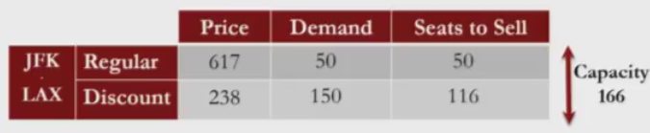

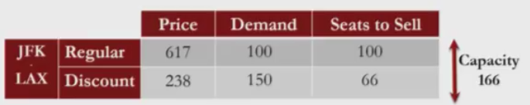

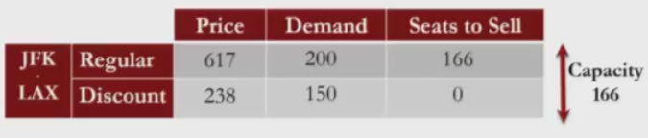

But what if there are many price options and many different flights? We can solve this using **linear optimization.** Here we demonstrate how to formulate a linear optimization problem using the middle case above, where Demand is 100 and 150:

Formulation of linear optimization problem:

Let R be the number of regular seats offered and D the number of discounted seats.

Maximize 617*R + 238*D

Subject to R + D  166, R 100, D   150, R   0, D   0

Maximize 617*R + 238*D is the **objective**, R and D are **decision variables** and we see there are 5 **constraints** (two **demand** constraints, **two non-negativity constraints** and one **capacity constraint**).

For **solving linear optimization** problems in Excel we needed to install **Solver** (see notes under Video 4: Solving The Problem in Unit 8), which is now under the Data tab. When we open Solver we see we can add constraints to our decision variables. In the particular case of making our decision variables all non-negative, rather than typing out these constraints manually we can use Options->Assume Non-Negative in the Solver window.

If we enter **=SUMPRODUCT(C5:C8,G7:G10)** for a cell it inputs the sum after multiplying the first cell before the comma by the first cell after, the second before by the second after, etc. So in this case C5*G7 + C6*G8 + C7*G9 + C8*G10. Note that there must be the same number of cells before and after the comma for this to be defined. We could similarly define for example **=SUMPRODUCT(B3:B6,D9:D12).** We can also generalize this to multiplying more than two rows or columns.

The following is the AirlineRM.ods file provided by the course which we use to solve the above linear optimization problem; this will fill in the yellow and blue cells for us.

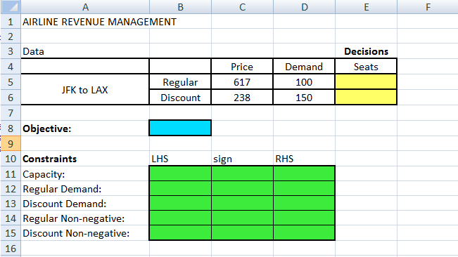

* Enter the formula for the objective in the blue cell: =C5*E5+C6*E6. It is better to use formulas rather than manually typing in data so that if we want to change values later it will also change all the values that use them in their formulas.
* This should output 0 for now.
* An easier way to do this than by manually typing would be to use =SUMPRODUCT(C5:C6,E5:E6) by highlighting/dragging over the appropriate boxes.

|  |  |  |  |
| --- | --- | --- | --- |
|  | LHS | Sign | RHS |
| Capacity | =E5+E6 | <= | 166 |
| Regular Demand | =E5 | <= | 100 |
| Discount Demand | =E6 | <= | 150 |

Note that we do not need to enter values in Rows 14 or 15 in Excel because Solver in Excel has the option to Assume Non-Negative (the above example wasn't done in Excel). Also we do not need the Sign column; it's for the reader. Also, we should probably click "Assume Linear Model" under options.

* Once we have entered the table from above into Excel we are ready to use Solver:

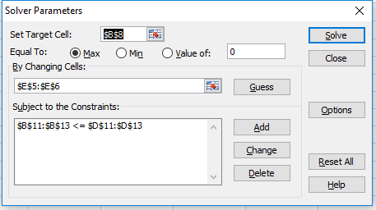

* Set Target Cell tells us $B$8 is the Objective that is being maximized is B8, given by C5*E5+C6*E6.
* By Changing Cells tells us the decision variables
* Subject to the Constraints $B$11:$B$13 <= $D$11;$D$13 tells us that we have the constrains B11<=D11, B12<=D12, B13<=D13, which we did by pressing "Add" then dragging as usual.
* When we hit Solve:

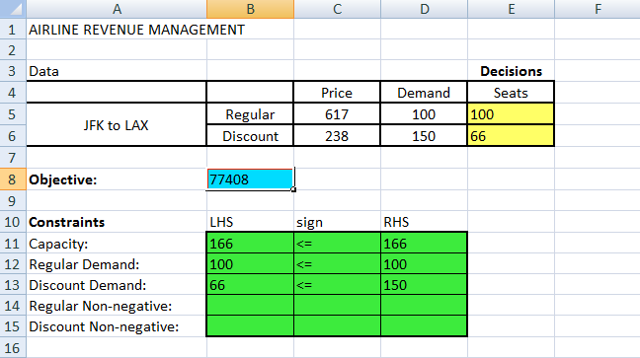

We can visualize the problem by plotting R and D along the axes along with their constraints to get the **Feasible Space** in pink:

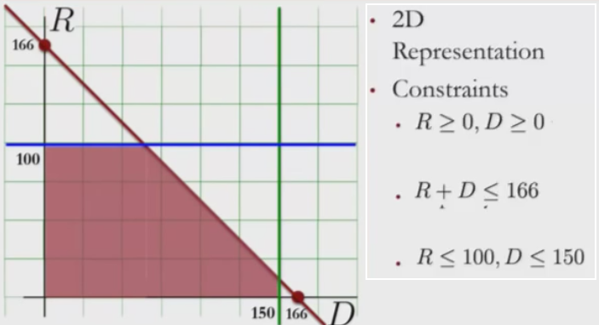

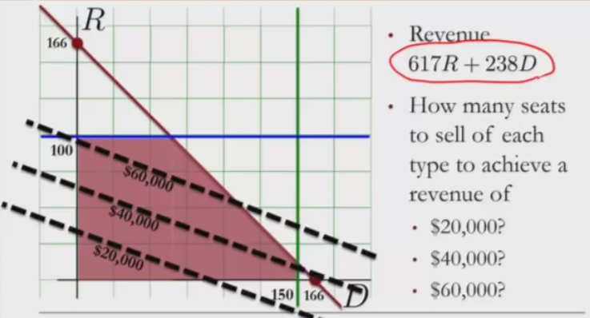

Notice along each of the dotted lines the Revenue is fixed to a value k, and the higher the line, the higher k is. This is because we can write 617R+238D = k --> R = -(238/617)D + k/617 which is of course a line of negative slope. Because we want to maximize 617R +238D we therefore choose the highest line with this slope (corresponding to the highest value of k) that still intersects with the feasible space, which is the intersection of the blue and red lines, giving R=100, D=66 and 617R+238D=77408.

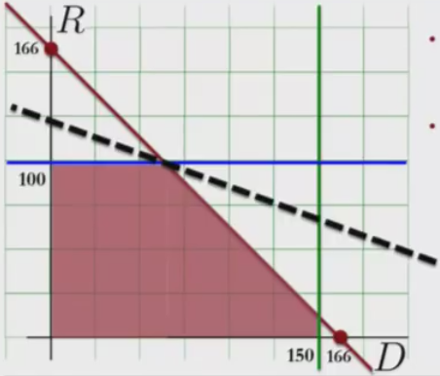

Often in linear optimization problems the data is subject to change, and therefore so is the optimal solution. **Sensitivity analysis** studies how the optimal solution changes when the data changes.

**Marginal revenue** is the revenue of selling one unit. The **Shadow Price** of a varaiable is the surplus revenue of increasing demand by 1 unit. (So the upper part of the range of possible values for the given variable has increased by 1, which may have allowed room for more revenue.)

Question: Suppose AA wants to determine whether or not it would be worthwhile to market each of their two fares and that they estimate that every 200$ spent marketing one particular fare will increase the demand for that fare by one seat. How should they market accordingly?

­Answer:

* Notice that marketing D will move the green line right, not adding a superior solution for revenue while incurring a larger cost due to marketing, so profit actually decreases. We could instead move the green line left, all the way to D=66, without changing revenue. The shadow price for the discounted fare is 0 for D greater than or equal to 66.
* Notice that marketing R will move the blue line up, adding superior solutions for revenue, and we can continue this until the blue line reaches R=166. The revenue at this point is 102422 compared to 77408, so a jump of 25014 over 66 units, that is a revenue of 379$/unit, while the cost per unit is 200$/unit, so a profit of 179$/unit. So because there is an increase in profit, this adds a superior solution. The shadow price of the regular fare is 379$ from R=0 to R=166.
* So the marketing department should work on increasing demand for regular fares by 66 units while spending less on marketing discounted fares.

Another sensitivity analysis question: Suppose we have more than one aircraft available, each with a different cost and capacity. Which aircraft should we choose (assuming demand remains fixed)? We want to maximize profit.

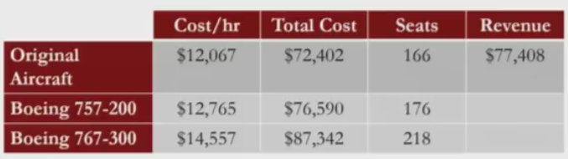

Solution:

* For Original Aircraft: Profit is 77408-72402 = 5006
* For Boeing 757-200: Increasing seats to 176 moves the red line north-east, and the optimal revenue is at R=100, D=76 for a revenue of 79788 and a profit of 3198.
* For Boeing 767-300: Increasing seats to 218 moves the red line north-east, and the optimal revenue is at R=100, D=118 for a revenue of 89784 and a profit of 2442.

So we see the Original Aircraft offers the greatest profit and therefore should be chosen.

Next example:

Here we have flights from JFK->DFW and DFW->LAX, which divides us into 3 cases: people who are doing both legs, people who are doing just the first, and people who are doing just the second. We have prices for R and D for each, so 6 prices total. (The price for those who take both is less than those who take just one - don't let this confuse you in this problem.)

Objective: Max 428*RJFK-LAX +190*D JFK-LAX +642*RJFK-DFW + 224*D JFK-DFW +512*RDFW-LAX +190*D DFW-LAX

Constraints:

* Capacity: RJFK-LAX + D JFK-LAX + RJFK-DFW + D JFK-DFW <= 166

RJFK-LAX + D JFK-LAX + RDFW-LAX + D DFW-LAX <= 166

* Demand: RJFK-LAX <= 80, D JFK-LAX <= 120, RJFK-DFW <= 75,

DJFK-DFW <= 100, RDFW-LAX <= 60, DDFW-LAX <=110

* Non-negativity: RJFK-LAX >=0, D JFK-LAX >=0, RJFK-DFW >=0,

D JFK-DFW>=0, RDFW-LAX >=0, D DFW-LAX >=0

Notice in the capacity constraints that those doing both legs are in both constraints because they are occupying seats in both cases. (So we can imagine it is just one plane throughout this whole example.)

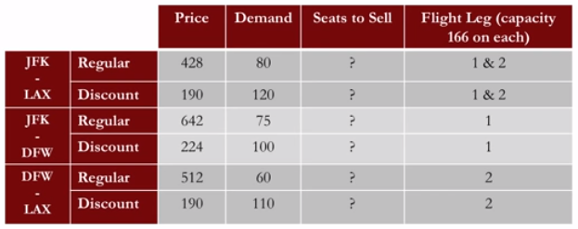

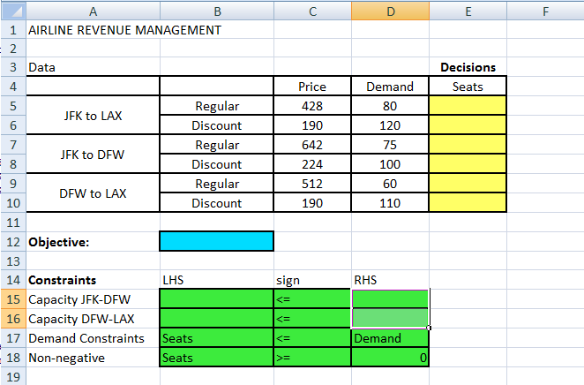

Objective: In B12 enter = SUMPRODUCT(C5:10,E5:E10) by dragging

Capacity JFK-DFW: In B15 enter =E5+E6+E7+E8 (this takes into account all people going from JFK-DFW, not just the ones doing this leg only).

Capacity DFW-LAX: In B15 enter =E5+E6+E9+E10 (this takes into account all people going from DFW-LAX, not just the ones doing this leg only).

Demand Constraints and Non-Negative are written as reminders that we need to add them in too in solver:

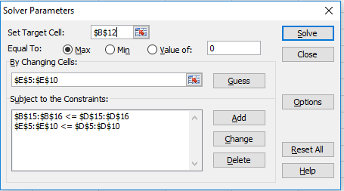

(And remember to put non-negativity by going to Options)

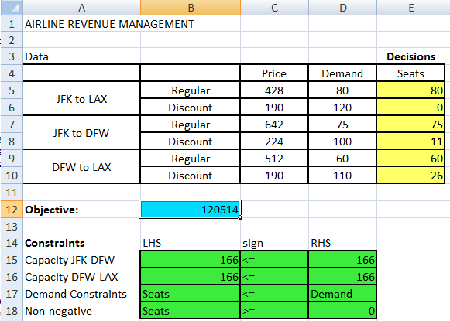

The point of marketing is to increase demand, but profitably. If the demand exceeds the number of items to sell then marketing is a waste of money as it costs money to increase demand yet you are already selling at full capacity. We may want to increase demand (by marketing) when Seats>Demand, depending on increase in revenue and costs in doing so, but when Seats<Demand increasing demand doesn't help because Seats are already filled to capacity. So above for example it is not worth it to market Discount seats from JFK to DFW because the demand already exceeds the number of seats available. Now, if we increase the Demand from JFK to LAX for Regular seats to 90 and rerun Solver we find now a revenue of 120654$, so +140$, but it cost 10x200$ to market these extra 10, so the end result is a smaller profit. Therefore we wouldn't want to market this either.

**Revenue management** is the science of selling the right seats to the right customers at the right price, and can be generalized to other fields.

_____________________________________________________________________________________

Designing Cancer Treatments Using Linear Optimization

Cancer is the second leading cause of death in USA, second to heart disease. These trends are also seen throughout the world. Cancer can be treated using **radiation therapy (RT**), where beams of high-intensity photons are sent to the cancer cells to try to destroy them; however, healthy cells also get killed in the process. First X-rays were used to kill cancer cells, then Radium (after discovered by Marie-Curie and her husband) was used, and the progress has gone from there. In the 1980s **intensity modulated radiation therapy (IMRT**) was developed, which significantly improved RT's ability to target cancerous cells. The IMRT aims to send beams of radiation that "fit" the tumor as closely as possible to reduce the dose to healthy cells. In IMRT the intensity profile of each beam is non-uniform; each **beam** is divided into **beamlets**, each beamlet having its own intensity, which allows the beams to better fit the shape of the tumor, therefore maximizing the damage to the tumor while minimizing damage to the healthy tissues.

* *

On the left is traditional RT, on the right is IMRT; Target is the tumor and Critical Structures are parts of the body we want to avoid.

The question in IMRT: How should the beamlet intensities be decided so as to maximize damage to the tumor while minimizing damage to healthy tissue? We address this using linear optimization.

The Data: Treatment starts with a CT scan, and a radiation oncologist draws outlines around the tumor and critical structures. Each tumor/structure is broken down into small cubic units called **voxels**, typically 4mmx4mmx4mm. From the CT scan we can compute how much dosage each beamlet sends to each voxel.

 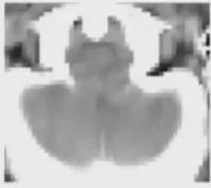

The CT scan and the image broken down into voxels. Here they appear in 2D but in reality they are in 3D.

2D example, 9 voxels, 6 beamlets:

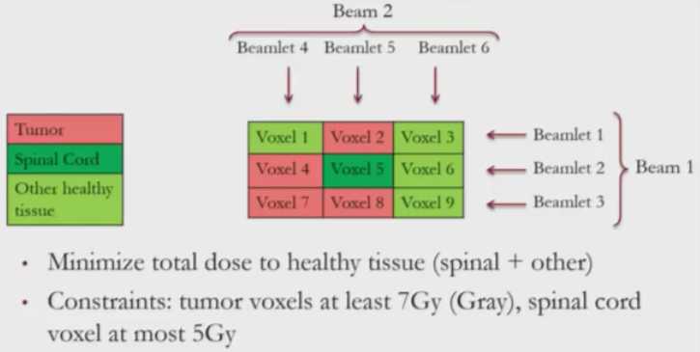

Gy is a unit for radiation dosage. **Dosage** and beamlet **intensity** are not the same but directly proportional. Once beamlet intensity has been decided, the dose to a voxel is also dependent on the distance the beamlet has to travel as well as the type of tissue it has to pass through.

Although we want to kill tumor cells, we prioritize minimizing damage to healthy cells over maximizing damage to tumor cells.

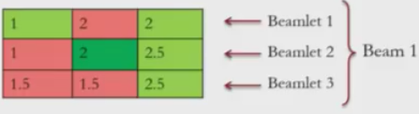 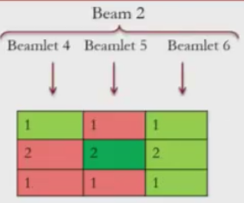

Above are doses at unit intensity for each beamlet.

Decision variables: x1, ... , x6 //beamlet intensities

Objective: minimize (1+2)x1 + (2+2.5)x2 + 2.5x3 + x4 + 2x5 + (1+2+1)x6 //damage to healthy tissue

Constraints: 2x1 + x5 >= 7

x2 + 2x4 >=7

1.5x3 + x4 >=7

1.5x3 + x5 >=7 //each tumor voxel needs at least 7Gy

2x­2 + 2x5 <=5 //spinal cord voxel can handle at most 5Gy

x1 ,x2 ,x3,x4,x5 ,x6 >= 0 //intensities are non-negative

After linear optimization:

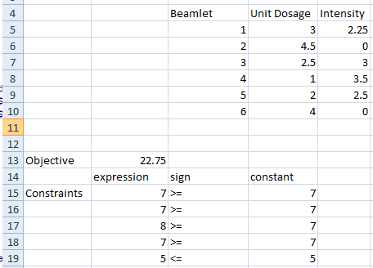

(The video gives a different solution, but the objective is the same.)

Notice that beamlets 2 and 6 have intensity of 0. This makes sense given that beamlet 2 crosses the spinal cord and beamlet 6 passes only through healthy tissue. Also, each of our tumor voxels receive a dosage of at least 7Gy and the spinal cord does not receive more than 5, as desired.

Head and neck example

* Total of 132878 voxels, 9777 of which are target voxels (tumor)
* Five critical structures (spinal cord, brain, brain stem, mandible, parotid glands)
* 328 beamlets

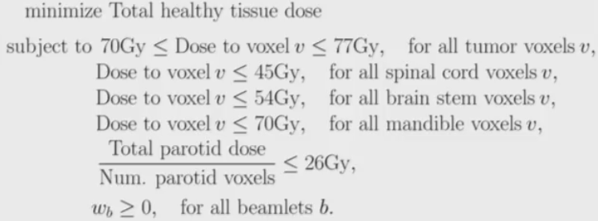

* The solution:

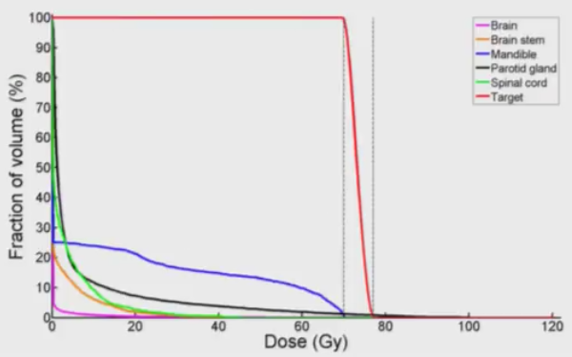

* The y-axis is the % of volume of voxels that receive *at least* the dosage given by the x-axis.
* We can see that of the critical structures the mandible receives the highest dose.
* What if we want to reduce the dose that the mandible receives? We can do this by **modifying the objective**. Our current objective is to minimize TB + TBS + TM + TPG + TSC., where T represents the total dose to each critical structure. We can change this to minimize TB + TBS + 10*TM + TPG + TSC. This sets the weight of the mandible from 1 to 10, so that the new solution will make the TM dosages smaller and the others larger. This is because this is a minimization problem. If this were a maximization problem then more value would be associated to TM and less to the others.
* Below the solid lines are the solution with the new objective. We can see the blue line has gone down but the lines for the other critical structures have gone up.

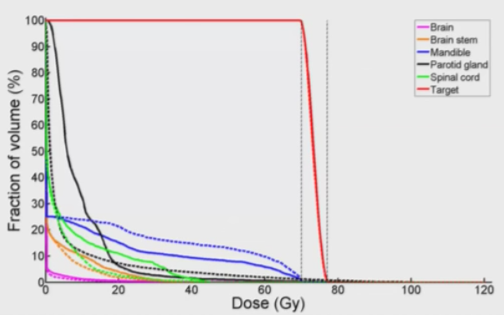

* This shows how you can modify the objective to show different trade-offs.
* Another way to explore trade-offs is to **modify constraints**. In this example we could consider relaxing our constraints on decision variables by increasing their upper limits and then looking at their shadow prices.

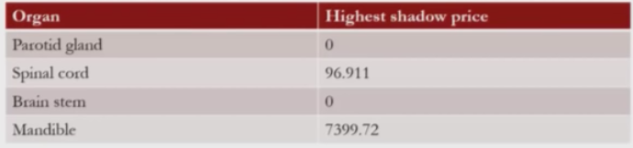

* Above are the highest shadow prices for any voxel in its critical structure.
* We see that the parotid glands and brain stem have shadow prices of 0, which means that even if we increase the maximum possibility intensity by 1 unit this would not change the total dosage to critical structures.
* The spinal cord has a shadow price of 96.911, meaning if we increase the radiation available to any voxel of the spinal cord by 1 unit then we can decrease the total radiation to critical structures by 96.911 units.
* The mandible shadow price is high, meaning if even a small increase in mandible intensity is tolerable then the total radiation to critical structures can be significantly decreased.
* **Important note**: The revenue example was a maximization problem whereas this one is a minimization. **Shadow price** in maximization refers to how much a unit increase in a decision variable's upper bound of possibilities will increase the objective, whereas in minimization it to refer to how much a unit increase in a decision variable's upper bound of possibilities will decrease the objective. (If the variable is bounded below instead then the definition of shadow price seems to change; look at Assignment 2 Unit 8 problem 2.3. Perhaps for a minimization problem if the variable is bound below then the shadow price is the amount the objective increases if that bound is increased by 1 and for a maximization problem if the variable is bound below then the shadow price is the amount the objective function decreases if that bound is increased by 1.)

Recitation

* Go over the basic steps in building, solving and analyzing a linear optimization model.
* To do so we use Google AdWords, which is Google's advertising system, where 97% of Google's revenue comes from.
* The Google search engine does not generate revenue directly (it's free) but instead Google makes money by selling space on its webpages, in particular results from search queries, to outside companies that advertise. Below we see only two search results but many ads.

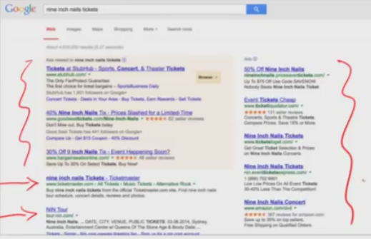

* How does advertising on Google work? Advertisers place bids to place their ads on different queries (searches). Based on bids and **quality score** (fit of ad to query) Google decides a price-per-click for each ad, dependent on which query it is displayed in. Google then decides how often to display each ad in each query, which is where linear optimization comes in.
* The **price-per-click (PPC)** is the amount of money an advertiser pays to Google for a single click of a given ad on a given query. The advertiser will also specify their **budget**, so the budget is depleted by the PPC each time a click on the ad is made, dependent on the query that displayed it.

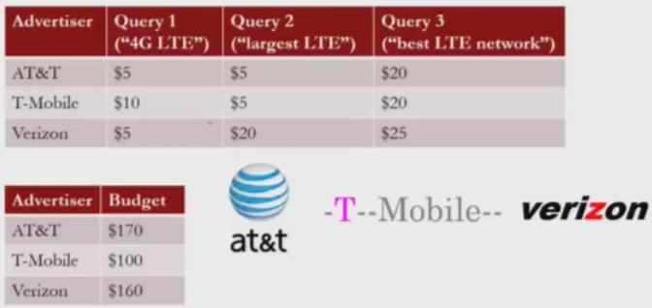

* To capture how often a user clicks on a specific ad from a specific query Google uses the **click-through rate (CTR)**, so the proportion of users that click on it when the ad is shown to them through a specific query.

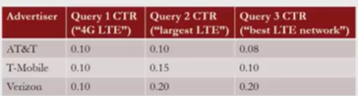

* For example if there are 50 users who are shown a specific ad from a specific query and the CTR is 0.08 then 4 clicked on the ad after being shown it from that query.
* The **average price per display (APPD)** of an ad in a given query is **PPC*CTR**. We can also think of this as the average revenue Google earns per display of a given ad in a given query.

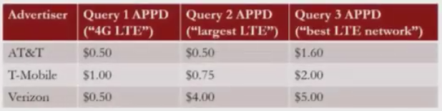

* The last piece of data we need to define our problem is how many times a query is requested, which Google has daily estimates for.

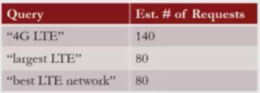

Question: How many times should Google display each ad on each query so as to maximize its revenue? (Keep in mind that for a given user in a given query they will not be shown two of the ads at the same time. Also, we are actually maximizing *expected* revenue.)

Solution:

Let the following table be our variables, representing the number of displays for each ad and query:

|  |  |  |  |
| --- | --- | --- | --- |
|  | Query 1 | Query 2 | Query 3 |
| AT&T | X11 | X12 | X13 |
| T-Mobile | X21 | X22 | X23 |
| Verizon | X31 | X32 | X33 |

Objective: Maximize 0.5*X11 + 0.5*X12 + 1.6X13

+ X21 + 0.75*X22 + 2X23

+ 0.5*X31  + 4*X32 + 5*X33

Constraints:

* Non-negativity of the 9 variables
* Budget: 0.5*X11 + 0.5*X12 + 1.6X13 <= 170

X21 + 0.75*X22 + 2X23 <= 100

0.5X31  + 4*X32 + 5*X33 <= 160

* Query: X11+ X21+ X31  <= 140

X12+ X22+ X32 <= 80

X13+ X23+ X33 <= 80

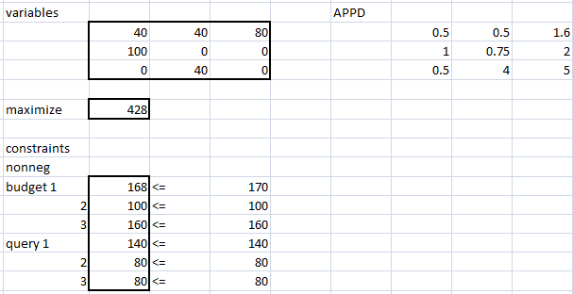

Note for using SUMPRODUCT() we don't just have to enter rows or columns, but can also enter two tables of the same size (for example two 3x3 tables, such as the variables and APPD tables above).

Note if we have a formula in one cell and drag this down to the cell below it, then all of the numbers in the cell references in the formula increase by 1. If we drag to the right then all of the letters in the cell references in the formula increase by 1. If we drag over rows and columns so as to create a table then both numbers and letters in the cell references increase accordingly.

When we say B35:D37 this means all cells with references in {B,C,D} x {35,36,37}.

\*\*\***Note**: To make sensitivity analysis more easily accessible it would be better to also include the PPC and CTR tables above, not just APPD. This way we can just change one value in PPC or CTR and the APPD updates accordingly.

What happens if we try a greedy approach to decide our displays?

This approach sequentially allocates ads by prioritizing the highest APPD of all remaining ad/query combinations. We identify the highest remaining value in the APPD table and allocate as many as possible of that ad/query, respecting both that advertiser's remaining budget and the remaining query limit (so we take the minimum numbers of ads allowed between the two cases). Then we move on to the next biggest APPD and repeat. We do this until there are no changes left to be made. If at any point the maximum remaining APPD value occurs more than once we can choose either way. (In Video 6 of the recitation of unit 8 they highlight a row red whenever an advertiser's budget has been dropped to 0, or a column red whenever a query's limit has been dropped to 0, to make it obvious that the remaining values in the row/column are no longer available.)

The end result:

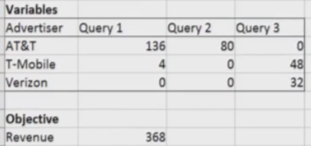

So we see the greedy approach ("the common sense" approach) is indeed worse than what is offered by linear optimization, 368$ vs. 428$, a 16% difference. So linear optimization in online advertising is indeed significant.

Sensitivity analysis on the optimization problem above

Ex 1: Suppose we change the CTR of AT$T/Query 1 from 0.1 to 0.5. If we rerun the analysis we get the following solution:

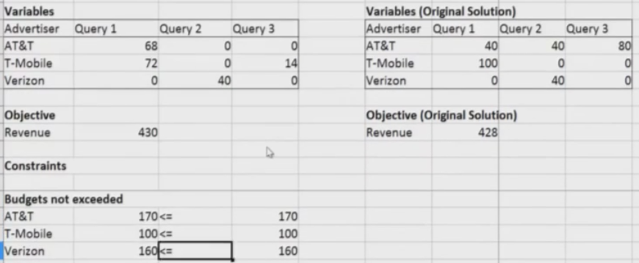

Notice the Revenue of 430$ is the highest that Google can hope to achieve because this is the sum of the budgets.

Ex 2: Suppose we change the budget of AT&T from 170$ to 200$. Recall from the optimal solution in the original example that only 168$ of the 170$ of AT&T's budget is being used in the original solution, so when the budget is increased by a further 30$ the optimal solution doesn't change. (Potential problem with this to generalization: perhaps in the original optimal solution more of the budget wasn't used because the 2$ difference is too small for one additional unit, but the 32$ difference in the new case is not.)

Conclusion:

We considered a very simplified version of how AdWords works, which can be extended in several ways.

* In reality a query can display more than one ad (on a "slate"), and the order of the display of ads on this slate makes a difference.
* Displayed ads can be personalized based on the user's profile, given by information such as geographic location of the user (given by their IP address) as well as previous Google searches and browser activity, gender, age, etc.
* We can create our decision variables to take into account the above, for example treat XAT&T-Verizon-Profile 3-Query1 differently than XVerizon-AT&T-Profile 3-Query1 with the order of Verizon and AT&T signifying which order they appear on that slate with people of profile Ottawa for Query 1. The profiles and information can become more detailed than this.
* For each Google query there may be hundreds or thousands of bidders trying to get their ads on there.
* Google's total revenue from advertising in 2012 was $40 billion, so 16% makes a huge difference.

_____________________________________________________________________________________

Unit 8 Homework 1

A **stock** is a fraction of ownership of a company. When you sell stock you have to pay a transaction fee plus taxes on any gains. A **share** is one unit of the total capital of a company (e.g. if the company has a total capital of 1000$ and is divided into 1000 units then 1 share is 1$). A stock consists of many shares. In this problem we use linear optimization to decide how many shares of different stocks to sell to make a purchase and to maintain a strong portfolio of stocks.

**Transaction cost:** If you sell any shares then you have to pay a fee of 1% of the amount sold.

**Capital-gains tax (30%):** If you sell shares above their original purchasing price then you have to pay a 30% on the profit of the sale relative to their original purchasing price.

**Cashflow:** The amount of cash you gain in a transaction by selling stock.

**Portfolio**: Refers to how many shares of various types of stock (e.g. stocking in Microsoft, Yahoo, etc.)

e.g. If you sell 200 shares at 50$ each which you originally bought for 30$ each then you pay a transaction cost of 100$ and a capital-gains tax of 1200$. The cashflow would then be 8700$.

From the first part of Assignment 1 Unit 8 below notice that the solution the course uses does not insist on the number of shares sold, shown in blue, be an integer, but if we need it to be then we can add this in Constraints. Also, because the problem insists that the person needs $10000 for an investment on their home this makes the cashflow restriction to be at least $10000 (not precisely equal to).

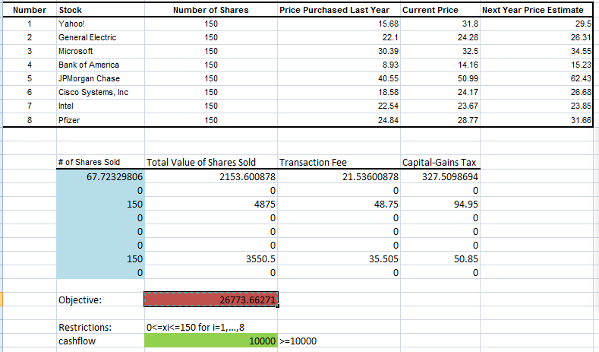

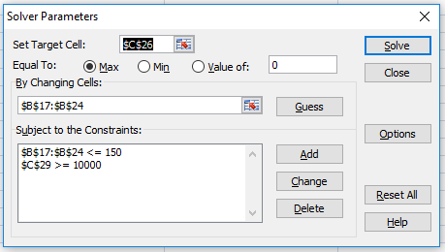

In the above below example we see we sold all shares of 2 of our stocks, but as an investor we like to have a portfolio that is more diversified. So suppose now that we restrict our linear optimization problem so that we cannot sell more than 75 shares of any given stock. Then we get the following:

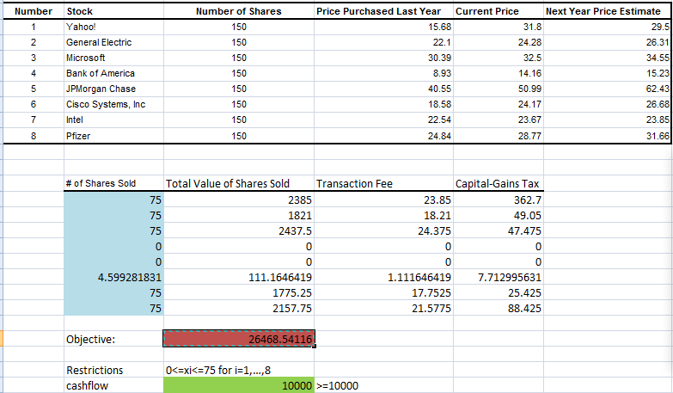

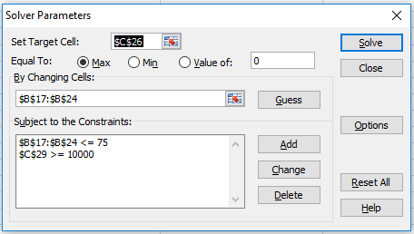

So although our investment is worth a bit less next year than in the original case, our portfolio is also more diversified, which can help in the long run.

To make this problem more realistic we could use regression to make the predictions for the future stock prices.

This assignment can be found in the investment.xlsk folder.

Assignment 2 Unit 8

Here we are given two cost/kg tables which we must add to get total cost/kg. From this we can construct our objective, which is to minimize total costs, found by SUMPRODUCTing the Decisions Variables (kg produced of each type of fabric by each company) by the total cost/kg table. The Demand constraints are found by summing the columns in Decision Variables to get how much of each fabric type is needed and comparing to the Demand table; the Production capacity constraints are found by SUMPRODUCTing the rows in the hours/kg table by the rows in the kg table and comparing to the Production Capacity table.

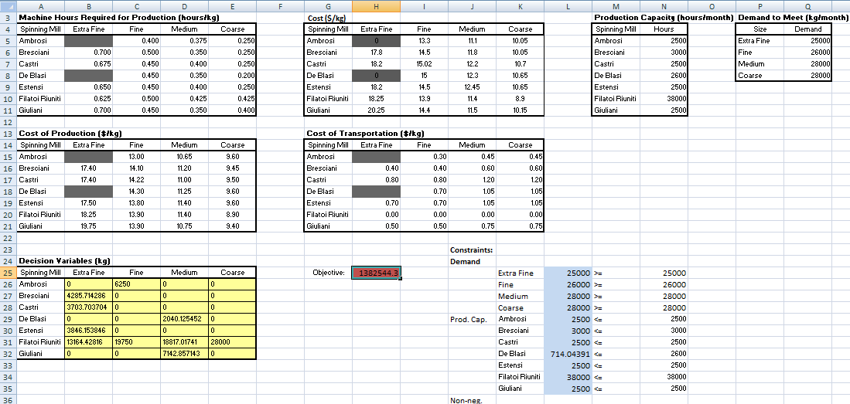

Sensitivity analysis:

By increasing Filatoi Riuniti's production capacity by 600h/month the Objective decreases by $1270.60. However to make this increase in production they had to spend 1500$/month to rent an improved machine. So it is not worth it.

For Problem 2.2: Filatoi Riuniti has the option to rent another machine for 3000$/month which would allow FR to increase its production capacity by 300 hours. It is only for spinning medium fabrics and can do so at 0.425hours/kg but 5.70$/h. Should FR do this?

Solution: This would increase the weight of medium fabric produced by FR by 300/0.425 = 705.88kg, which would take away 705.88kg worth of business from De Blasi (the most expensive per kg of the three companies producing medium, 12.30$/kg). FR is saving 705.88($12.3-$5.70) = $4658.81, which is more than the 3000$ cost, so yes they should rent it.

Solution 2: We could increase FR's production capacity by 300h/month and rerun the solver, which outputs a cost value that is 635.26$ less. But we see that FR produced more than 705.88kg of medium fabric meaning that all of that additional 705.88kg was produced by the faster machine. So this 705.88kg as seen by Excel was given a price of 11.40$/kg whereas we know it was only 5.70$/kg, so an additional savings of 705.88kg(11.40$/kg - 5.70$/kg) = $4023.53, for a total savings of $4658.89, which is more than the 3000$ cost, so yes they should rent it. (Differences due to rounding).

Problem 2.3: Suppose the shadow price for the medium yarn demand is 12.30$ with an allowable increase of 5388 units in this variable. (Because this is a minimization problem and this is a lower bound the shadow price refers to how much the objective will increase.) A new client is interested in purchasing up to 5000kg/month of medium yarn. What is the minimum he should be charge per kg?

Solution: For each of those 5000kgs the cost will go up by 12.30$ so he should be charged at least that much to cover increase in costs. (Note for the above problem, these are not arbitrary numbers. If we increase demand for medium yarn by up to 5388 units we find that 12.30$ is indeed the shadow price.)

Problem 2.4: Suppose a client wants to buy 6000kg/month of the medium yarn. What is the minimum he should be charged?

Solution: We rerun the optimization by increasing demand for medium yarn by 6000 and find an increase in cost by 12.45$ per kg, so at least this much so as to cover costs.

Assignment 3 Unit 8: Gasoline Blending

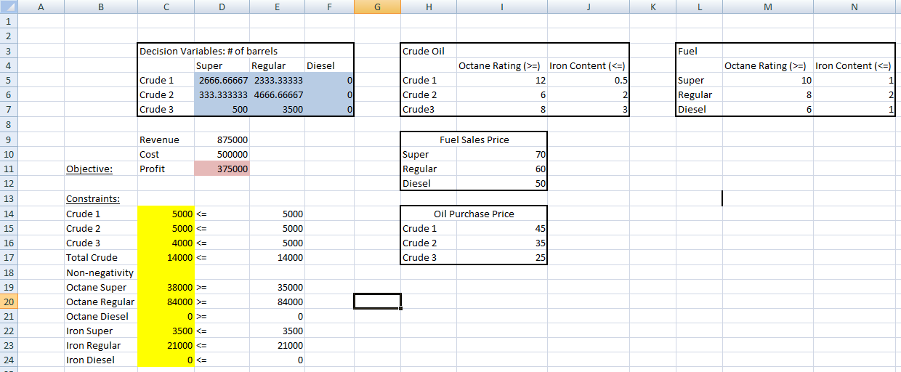

Creating the above in Excel

Note that for a linear optimization problem we cannot have a constraint that looks like 12x+2y/(x+y) >= 7 because this is not linear. We can fix this by writing our constraint as 12x+2y >= 7*(x+y).

Revenue in D9: = I10*SUM(D5:D7) + I11*SUM(E5:E7) + I12*SUM(F5:F7)

Cost in D10: = I15*SUM(D5:F5) + I16*SUM(D6:F6) + I17*SUM(D7:F7)

Profit in D11: = D10 - D9

Crude 1 in C14: = SUM(D5:F5)

Crude 2 in C15: = SUM(D6:F6)

Crude 3 in C16: = SUM(D7:F7)

Total Crude in C17: =SUM(C14:16)

Octane Super in C19, LHS: = SUMPRODUCT(I5:I7,D5:D7)

Octane Regular in C20, LHS: =SUMPRODUCT(I5:I7,E5:E7)

Octane Diesel in C21, LHS: =SUMPRODUCT(I5:I7,F5:F7)

Iron Super in C22, LHS: = SUMPRODUCT(J5:J7,D5:D7)

Iron Regular in C23,LHS: = SUMPRODUCT(J5:J7,E5:E7)

Iron Diesel in C24,LHS: = SUMPRODUCT(J5:J7,F5:F7)

Octane Super in E19, RHS: = M5*SUM(D5:D7)

Octane Regular in E20, RHS: = M6*SUM(E5:E7)

Octane Diesel in E21, RHS: = M7*SUM(F5:F7)

Iron Super in E22, RHS: =N5*SUM(D5:D7)

Iron Regular in E23,RHS: = N6*SUM(E5:E7)

Iron Diesel in E24,RHS: = N7*SUM(F5:F7)

Problem 2.4:

Notice so far there are no demand constraints; we have assumed that all of the produced barrels will be sold. In Problem 2.4 we assume furthermore that the demands for super, regular and diesel are 3000, 2000 and 1000 barrels respectively and we don't want to sell more than the demand. We resolve the problem by adding these constraints add get a new profit value of 150000.

Problem 3:

To calculate the shadow price of any one type of gasoline from the above solution we can increase the demand by 1 and see the change in revenue. We see that super, regular and diesel have shadow prices of 29, 27 and 9 respectively. The **allowable increase** of a shadow price is the maximum amount by which you can increase the RHS of a constraint without changing the shadow price. The problem tells us that the above shadow prices have allowable increases of 1250, 2500 and 1250 respectively.

So if we want to calculate the increase in profit by increasing demand of super by 1250 units or less, then we can multiply the shadow price by the number of units. However, if we increase the demand beyond 1250 units then we need to use the solver with the new demand value.

_____________________________________________________________________________________

Unit 9: Integer Optimization

We use integer optimization to see how to construct sports schedules.

Sports is a huge industry and it is important for a league to establish good schedules. The key revenue for sports teams comes from TV networks who will pay a lot of money to ensure the teams have a good schedule so as to ensure as many fans as possible will be watching on their network. In addition to the TV networks , good sports schedules are important because traveling causes fatigue (reflecting poorly on the team), ticket sales are better on weekends, it's better to play division teams at the end of the season (because they may be competing for spots in the playoffs). So everyone in the sports industry is incentivized to have a good schedule of games.

There are many constraints: TV networks want games occurring at prime times; teams want games on the weekends; cities want games that don't conflict with other major events, etc. This requires many combinations of possibilities. This is already very difficult and time-consuming to do by hand, and if trying to add new constraints then the process has to be repeated from the beginning. Integer optimization makes this easy.

Scheduling a Tournament Example

* Four teams: A,B,C,D
* Two divisions: One division has A and B, the other has C and D
* Each team plays one game a week for a total of 4 weeks. They play the other team in their division twice and each team in the other team once.
* The team from each division with the most wins will play in the championship.
* Teams prefer to play divisional games later.
* The objective is to maximize the sum of team preferences (divisional games later). If a team plays the other team in its division on the first week then +1, on the second week then +2, on the third week then +4 and on the fourth week then +8.
* Decision variables: Which week should each team play the other teams? We can write xijk where i is one team, j is another team and k is the week that they are playing. This is a **binary decision variable**, equal to 1 if teams i and j play on week k, and 0 if not. This is a new type of decision variable and it is what makes integer optimization different from linear optimization. In **integer optimization** the decision variables can only take integer values. We can think of binary optimization as a type of integer optimization (although the two have explicitly different constraint options in Solver in Excel).
* Constraints:

xAB1 + xAB2 + xAB3 + xAB4 = 2

xCD1 + xCD2 + xCD3 + xCD4 = 2 //play the other team in its division twice

xAC1 + xAC2 + xAC3 + xAC4 = 1

xAD1 + xAD2 + xAD3 + xAD4 = 1

xBC1 + xBC2 + xBC3 + xBC4 = 1

xBD1 + xBD2 + xBD3 + xBD4 = 1 //play each of the teams in the other division once

xAB1 + xAC1 + xAD1 = 1 //a team plays 1 game per week; repeat this 16 times (for each team and each week)

* Objective: maximize xAB1 + 2xAB2 + 4xAB3 + 8xAB4 + xCD1 + 2xCD2 + 4xCD3 + 8xCD4

(Note: Due to symmetry the objective is actually double this, but it does not change the values of xijk in the optimal solution, which is what we are interested in.)

Solution in Excel:

We solve this in Excel just as we would with previous optimization problems with the difference that we must add the constraint **bin** for the decision variables. Make sure to click linear optimization (but non-negativity seems to be irrelevant since bin guarantees that they are 0 or 1 and therefore non-negative). If instead we used the **int** constraint then our decision variables can be any integer (positive/negative/0).

A couple notes:

i) When I run this in Excel the values for 0 in the decision variables table are actually written as tiny numbers in scientific notation, such as 2.2204E-16.

ii)If we run the solver then delete the values for the decision variables and run the solver again then we should get the same values. However, if we don't delete the values but run the solver again then the values change. This is ok; these new values just correspond to a different solution that give the same objective value. They always change to the same values after running the solver n times if we don't delete along the way. If we use a different software we may get a different solution but the same objective value.

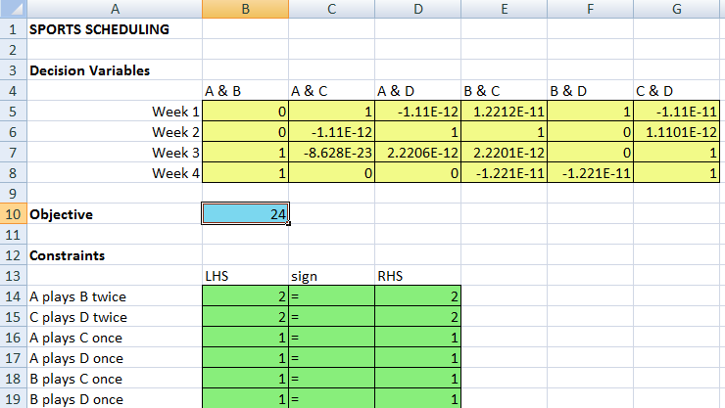

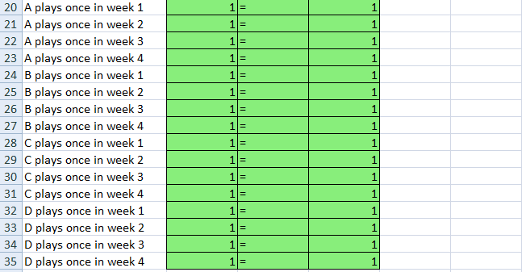

* A nice quality about binary decision variables is that they allow us to model **logical constraints**.
* E.g. A and B can't play both weeks 3 and 4: xAB3 + xAB4 <= 1
* E.g. C and D must play in weeks 1 or 2 (or both): xCD1 + xCD2 >=1
* E.g. If A and B play week 4 then they must play week 3: xAB4 <= xAB3

If we add these constraints we get a new objective of 20 rather than 24 before. So a schedule maker would have to weigh the decreased value of the objective to the desire/need to impose these new constraints.

We were able to solve our scheduling problem with 4 teams easily because there are few decision variables and constraints. However, this problem size grows rapidly. For the MLB schedule there are over 100k decision variables and over 200k constraints, which would be impossible to solve in Excel.

So how are large integer optimization models solved in practice? One way is to reformulate the problem. Another is using **heuristics**, solutions that are good although not necessarily optimal; the benefit is that they are easier to find. There are also general purpose optimization solvers such as CPLEX used for large optimization problems.

Optimization softwares offer easily updated constraints or changes, and now professional sports and college/university sports use them.

_____________________________________________________________________________________

eHarmony

Analytics is at the core of eHarmony; it has successfully leveraged the power of analytics. It makes a lot of money and is responsible for a lot of marriages. One distinguishing feature is that eHarmony only suggests matches to users rather than allowing them to browse freely.

Example with 3 men and 3 women (assuming heterosexuality)

Suppose the men and women are labeled 1,2,3.

Between each man/woman pair there is a

* compatibility score wij from 1 to 5, determined by eHarmony based on the similarities between users' answers to a questionnaire (5 is most compatible); in our convention i represents the man and j represents the woman.
* decision variable: binary variable xij which is 1 if eHarmony will match man i and woman j, 0 else.

Objective: maximize total compatibility

x11w11 + x12w12 + x13w13 + x21w21 + x22w22 + x23w23 + x31w31 + x32w32 + x33w33

Constraints:

x11 + x12 + x13 = 1

x21 + x22 + x23 = 1

x31 + x32 + x33 = 1 //each man is matched with exactly one woman

x11 + x21 + x31 = 1

x12 + x22 + x32 = 1

x13 + x23 + x33 = 1 //each woman is matched with exactly one man

We can extend this for example to top 2 matches by changing the 1 in a constraint to 2.

As mentioned above, eHarmony's compatibility scores are determined by similarities to users' answers to a questionnaire ("Opposites attract, then they attack." -Neil Clark Warren).

To predict whether two users will be compatible or not here we treat the compatibility variable as binary (so not from 1 to 5 like above). It represents whether not a match suggested by eHarmony is successful.

* Start with a public data set containing questionnaire features (e.g. height, location, etc.) for 275000 users and the compatibility variable (0 or 1).
* Feature names for each user and user names are hidden to protect privacy.
* Logistic regression is used on differences in features to predict whether or not pair recommendations made by eHarmony will be successful.
* To reduce the size of the problem they trimmed the data down to just 1475 pairs and trained a logistic regression model, using the questionnaire features as independent variables and the outcome variable is the probability that the pair is compatible.
* If a threshold of 0.2 is used then the classification matrix shows that FP=227 and TP=92, meaning that of the 319 predictions for a compatible match, 29% would indeed be compatible matches (which is high for online dating).

Other potential techniques include clustering (user segmentation), text analytics (users' profiles), trees (non-linear relationships between the variables), etc.

_____________________________________________________________________________________

Unit 9 Recitation: Mount Sinai Hospital Operating Room Scheduling

* Hospitals have limited operating rooms (ORs).
* Weekly schedules need to be made to schedule different departments of a hospital to different ORs.
* This needs to be done efficiently because it costs about 100$/minute of an OR usage.
* The surgeons are often paid per surgery, so changing the hours directly affects their income.
* The schedule must strike a balance between all the departments in the hospital.
* ORs are scheduled in 8 hour blocks; at most 1 surgery per block.
* Each department sets their weekly target number of hours, which may not be an integer. (I think we should view this as an average target and not a fixed target per week; not sure.)
* Departments may have daily and weekly requirements.

Our example: The operating room manager would like to give each department as many hours as possible up to their weekly target allocation hours.

Decision variables: xjk, how many operating rooms to assign to department j on day k

Objective: Max sum (8*xOph,k / 39.4 + 8*xGyne,k / 117.4 + 8*xOral,k / 19.9+ 8*xOtol,k / 26.3 + 8*xGen,k / 189) over all k. Note that a given term such as 8*xOph,k / 39.4 over all k represents the proportion of target hours a given department receives in the week; it measures the proportion of how much the department got what it wanted.

Constraints:

* Daily: For each of the decision variables take the minimum from the two daily tables below in the middle, which turns out to be the left table and the corresponding decision variable is less than or equal to that value. So for example xoph,M <= 2.
* Weekly: For ophthalmology we have three restrictions:

xOph,M + xOph,T + xOph,W + xOph,R + xOph,F >=3

xOph,M + xOph,T + xOph,W + xOph,R + xOph,F <=6

xOph,M + xOph,T + xOph,W + xOph,R + xOph,F <=39.4 / 8

We repeat this for the other 4 departments.

* Days of the week: Because any one particular OR can have at most one booking per day and there are 10 ORs total that means the sum over and day must be 10. So for Monday for example we have xOph,M + xGyne,M + xOral,M  + xOtol,M + xGen,M <=10.
* Integer optimization
* Non-negativity

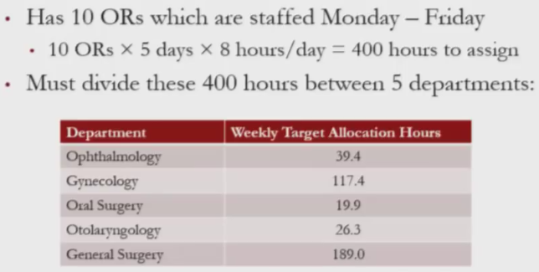

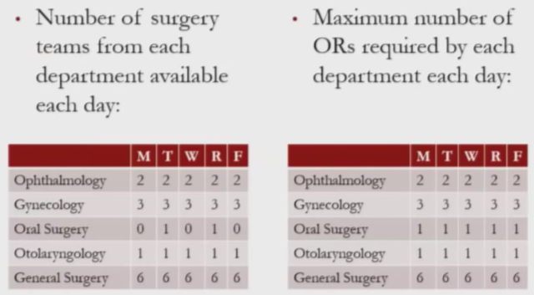

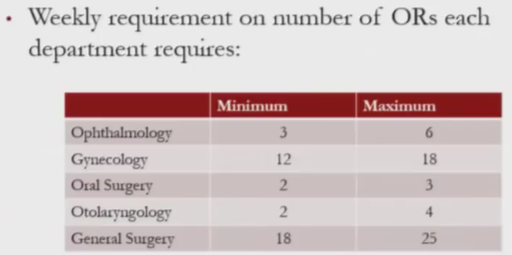

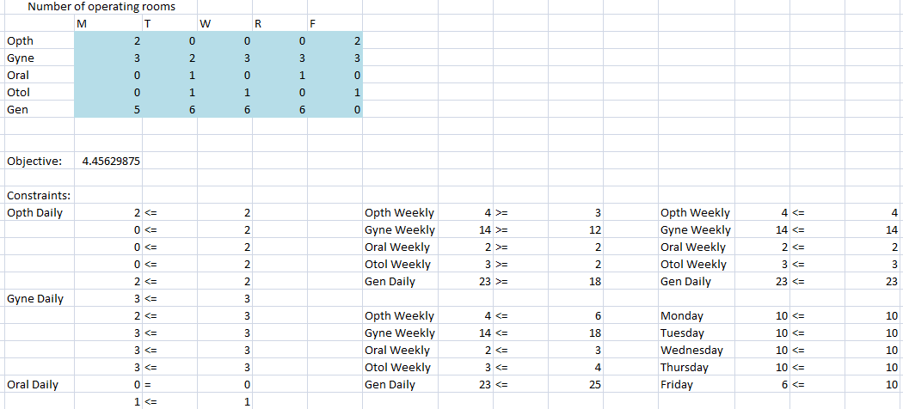

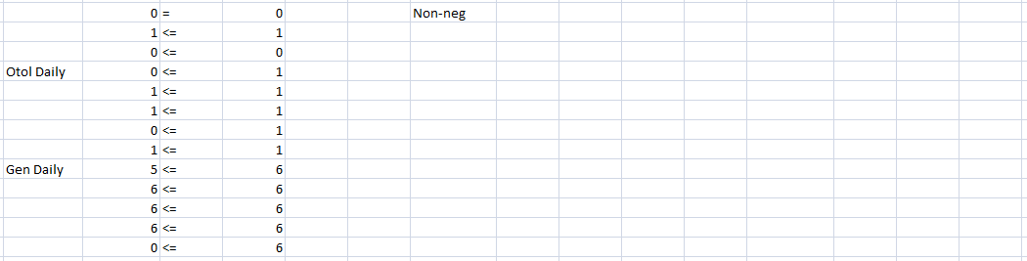

Once we are done creating this schedule we will bring it to the departments to see if they are satisfied with this schedule. If not then we can add more constraints. For example, the Gen department has 5 or 6 surgeries every day except for Friday, so they might want to balance this by making sure there are at least 4 surgeries per day. Furthermore, the Opth department might want to balance their schedule by making sure there is at most 1 surgery per day. If we rerun this in the solver with these new constraints we find the objective is exactly the same, meaning that in the original solution there was some wiggle room.

Also notice that opth is only ever going to be assigned at most 32 out of 39.4 of their target hours with the above solution, so 81%. We could adjust it so that some weeks they work an extra 0.6hours and therefore get one more extra surgery so that over the long run their average % target is something more than 81% (but still less than 100%).

We have seen that by using integer optimization with human judgment we can create a great solution.

I'm pretty sure that the "linear" in "linear optimization" refers to the fact that the exponents of all the decision variables in the objective function are 1.

_____________________________________________________________________________________

Unit 9 Assignment 1

(Quick and easy: no notes needed)

Unit 9: Assignment 2

This spreadsheet was saved in Assignment2Unit9.

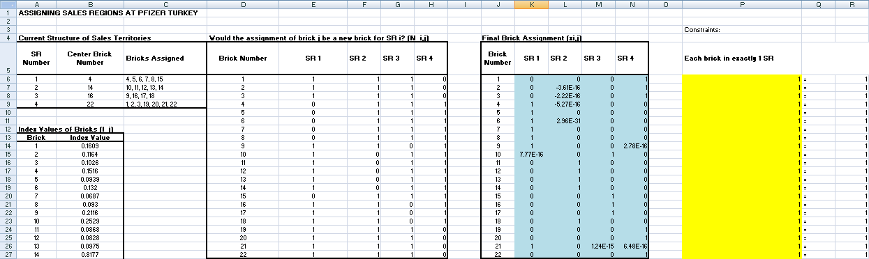

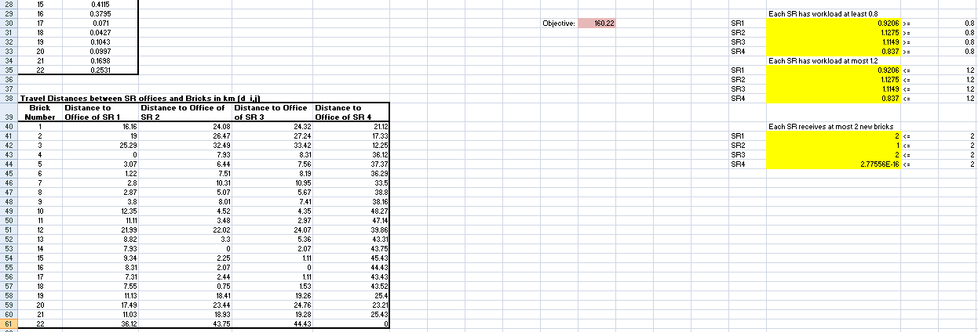

Unit 9: Assignment 3

This spreadsheet was saved in Assignmen3Unit9. This is the final solution, with all of the constraints added along the way.

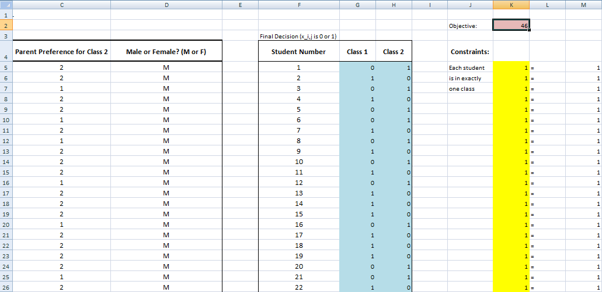

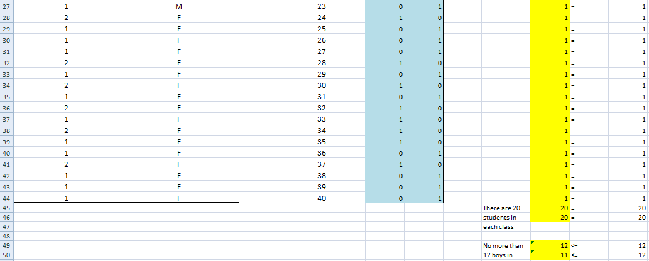

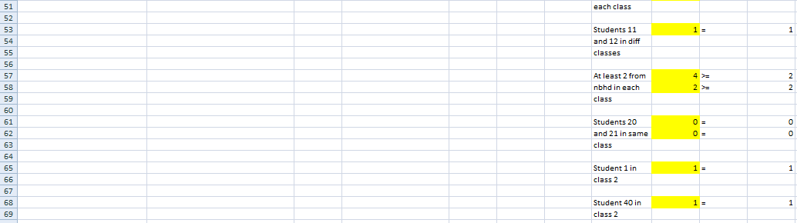

In binary and integer optimization problems the decision variables are typically in a table.

If we have another table corresponding to a different variable for each object and each binary decision and we only want to extract the values that correspond to the choice of the decision variable then we can SUMPRODUCT() the row for a given object in the two tables. This will multiply the desired value by 1 and the undesired value by 0 before adding.

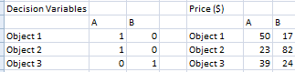

Here if are computing prices using SUMPRODUCT() we would get 50, 23, 24.

How do we know if using the -variable will work for a model? If it is a numerical variable. If a factor variable then we might get problems when applying to the test set.

nonvars = c("year", "songtitle", "artistname", "songID", "artistID")

train = train[ , !(names(train) %in% nonvars) ]

test = test[ , !(names(test) %in% nonvars) ]

log = glm(Top10~., data=train, family=binomial)

Note that dendrogram = hclust(dist, method="euclidean") is a model, so maybe give it a different name like hmodel.